**Shaping the future**

**Check out how we are delivering Future Transport 2056 – the vision for the next 40 years of transport in NSW**

<https://future.transport.nsw.gov.au/>

From 2020, a minimum of ten percent of new government fleet vehicles will be electric or hybrid

**Project Highlights**

Focus on a selection of initiatives set out in the Services and Infrastructure Plans (SIPs)

[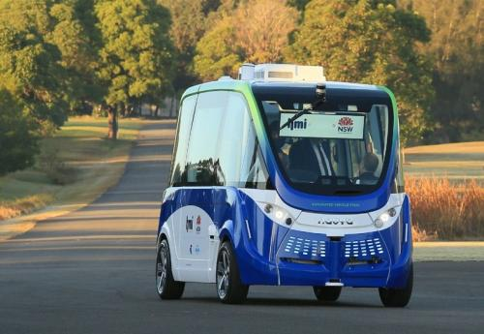](https://future.transport.nsw.gov.au/projects/connected-and-automated-vehicles-cav)

[**Connected and Automated Vehicles (CAV)**](https://future.transport.nsw.gov.au/projects/connected-and-automated-vehicles-cav)

CAVs are transforming transport systems around the world and bringing a smarter future for passenger and freight mobility

[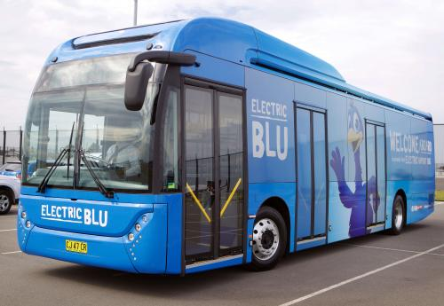](https://future.transport.nsw.gov.au/project-highlights/electric-vehicles)

[**Electric Vehicles**](https://future.transport.nsw.gov.au/project-highlights/electric-vehicles)

Decisions we make today will build a future transport system that is sustainable and affordable

[**Fairer Fares**](https://future.transport.nsw.gov.au/projects/fairer-fares)

Transport should enable everyone to get the most out of life, wherever they live and whatever their age, ability or personal circumstances

[**View more project highlights**](https://future.transport.nsw.gov.au/project-highlights)

**Future Transport 2056 Progress Updates**

Future Transport 2056 Services and Infrastructure Plans (SIPs) set out more than 300 initiatives to be delivered in the first 10 years of the 40 year vision – 197 in Regional NSW and 107 in Greater Sydney.

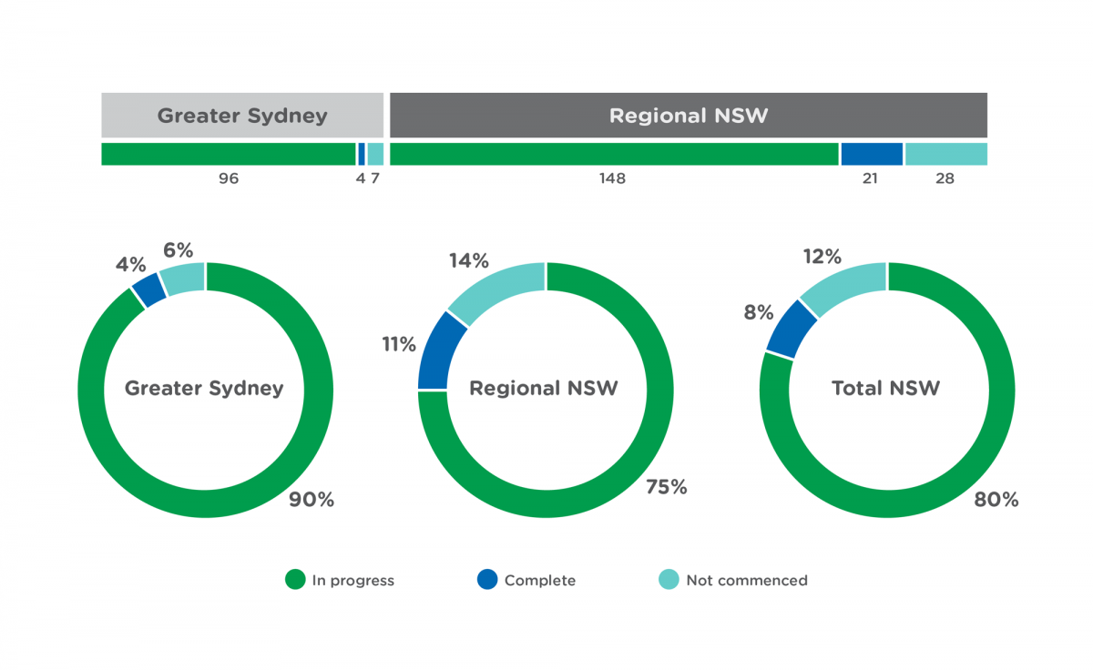

**There are 300+ initiatives across Greater Sydney and Regional NSW**

Greater Sydney Service and Infrastructure Plan

[View progress updates](https://future.transport.nsw.gov.au/delivering-future-transport-2056#greater-sydney)

Regional Service and Infrastructure Plan

[View progress updates](https://future.transport.nsw.gov.au/delivering-future-transport-2056#regional)

**Future Transport Strategy**

Our strategy and plans have been developed with extensive community feedback and collaboration across government

[Read more](https://future.transport.nsw.gov.au/plans/future-transport-strategy)

**Technology Roadmap**

From personalising the customer experience to automated vehicle trials, see how our Roadmap is being delivered today

[Read more](https://future.transport.nsw.gov.au/technology/roadmap-in-delivery)

**Supporting plans**

* [Connected and Automated Vehicles Plan](https://future.transport.nsw.gov.au/plans/connected-and-automated-vehicles-plan)
* [NSW Electric and Hybrid Vehicle Plan](https://future.transport.nsw.gov.au/plans/nsw-electric-and-hybrid-vehicle-plan)
* [Older Persons Transport and Mobility Plan 2018 2022](https://future.transport.nsw.gov.au/plans/older-persons-transport-and-mobility-plan-2018-2022)
* [NSW Freight and Ports Plan 2018-2023](https://future.transport.nsw.gov.au/plans/nsw-freight-and-ports-plan-2018-2023)
* [Greater Newcastle Future Transport Plan](https://future.transport.nsw.gov.au/plans/greater-newcastle-future-transport-plan)
* [Tourism and Transport Plan](https://future.transport.nsw.gov.au/plans/tourism-and-transport-plan)
* [Road Safety Plan 2021](https://future.transport.nsw.gov.au/plans/road-safety-plan-2021)
* [Maritime Safety Plan 2017 - 2021](https://future.transport.nsw.gov.au/plans/maritime-safety-plan-2017-2021)
* [Disability Inclusion Action Plan 2018 - 2022](https://future.transport.nsw.gov.au/plans/disability-inclusion-action-plan-2018-2022)

# A Metropolis of Three Cities - Highlights

## <https://www.planning.nsw.gov.au/Plans-for-your-area/A-Metropolis-of-Three-Cities/A-Metropolis-of-Three-Cities/Highlights>

## Liveability, productivity and sustainability

A Metropolis of Three Cities will transform land use and transport patterns, boosting Greater Sydney’s liveability, productivity and sustainability by spreading the benefits of growth to all its residents.

A Metropolis of Three Cities – the Greater Sydney Region Plan, Future Transport 2056 and the State Infrastructure Strategy respond to and build on the directions for a Greater Sydney, ensuring integrated land use planning and infrastructure delivery.

### There are 10 directions for Greater Sydney

[1. A city for supported by infrastructure](https://www.planning.nsw.gov.au/Plans-for-your-area/A-Metropolis-of-Three-Cities/A-Metropolis-of-Three-Cities/Highlights#collapse_b813cd00679a4b73b48539db2b7e47c8)

#### [2. A collaborative city](https://www.planning.nsw.gov.au/Plans-for-your-area/A-Metropolis-of-Three-Cities/A-Metropolis-of-Three-Cities/Highlights#collapse_9a4293e1ece04de5888b5e02eb9a3fea)

#### [3. A city for people](https://www.planning.nsw.gov.au/Plans-for-your-area/A-Metropolis-of-Three-Cities/A-Metropolis-of-Three-Cities/Highlights#collapse_3af70fd852cd459182c113401393179f)

#### [4. Housing the city](https://www.planning.nsw.gov.au/Plans-for-your-area/A-Metropolis-of-Three-Cities/A-Metropolis-of-Three-Cities/Highlights#collapse_5e0dc6e00df344e7a0a40c97193ccae0)

#### [5. A city of great places](https://www.planning.nsw.gov.au/Plans-for-your-area/A-Metropolis-of-Three-Cities/A-Metropolis-of-Three-Cities/Highlights#collapse_c833dabf1f9646aa9c8b2c1df8afb941)

#### [6. A well connected city](https://www.planning.nsw.gov.au/Plans-for-your-area/A-Metropolis-of-Three-Cities/A-Metropolis-of-Three-Cities/Highlights#collapse_9d5316bf2c734057aa207f82851e0b42)

#### [7. Jobs and skills for the city](https://www.planning.nsw.gov.au/Plans-for-your-area/A-Metropolis-of-Three-Cities/A-Metropolis-of-Three-Cities/Highlights#collapse_18e25554eb0c46ba85f5f454316b79c7)

#### [8. A city in its landscape](https://www.planning.nsw.gov.au/Plans-for-your-area/A-Metropolis-of-Three-Cities/A-Metropolis-of-Three-Cities/Highlights#collapse_84dc88cedb284e3e977ef72cd4793263)

#### [9. An efficient city](https://www.planning.nsw.gov.au/Plans-for-your-area/A-Metropolis-of-Three-Cities/A-Metropolis-of-Three-Cities/Highlights#collapse_e92be01088ac4c4cb73075a71b1c9056)

#### [10. A resilient city](https://www.planning.nsw.gov.au/Plans-for-your-area/A-Metropolis-of-Three-Cities/A-Metropolis-of-Three-Cities/Highlights#collapse_ae7de60422a449adbddd0134db78a162)

#### [Implementation](https://www.planning.nsw.gov.au/Plans-for-your-area/A-Metropolis-of-Three-Cities/A-Metropolis-of-Three-Cities/Highlights#collapse_bf2b9d27500b44d89a040998ef669fea)

A Metropolis of Three Cities was informed by significant community feedback and technical input on a range of topics. To download documents please visit [background material](https://www.greater.sydney/background-material) at the Greater Sydney Commission website.

# Lucy Turnbull unveils plan for three Sydneys

<https://www.smh.com.au/national/nsw/lucy-turnbull-unveils-plan-for-three-sydneys-20171022-gz5un4.html>

Two-thirds of Sydneysiders will be able to commute between their jobs, homes and key services within 30 minutes, but they may have to wait 40 years to do so, under new long-term strategies that will divide Sydney into three interconnected cities.

The NSW government claimed a "historic", "first time" collaboration between its planning and infrastructure auspices as it released two 40-year strategies to transform Sydney into a tripartite metropolis with eastern, central, and western cities by 2056.

The three are a western parkland city, west of the M7, a central river city around greater Parramatta, and an eastern harbour city.

Flanked by the government's Transport and Planning ministers, Greater Sydney Commissioner Lucy Turnbull on Sunday formally handed the government the commission's new strategy – the Draft Greater Sydney Region Plan 2017 – for achieving the three, 30-minute cities.

"Never before has planning and transport come together to actually map out a 40-year vision to make sure we grow properly in the future," Transport Minister Andrew Constance said on Sunday, as he released a corresponding transport strategy.

Mrs Turnbull described the commission's report as a "landmark" blueprint designed to dovetail with "a once-in-a-century period of Sydney's infrastructure boom", as Sydney expanded from its current population of 4.6 million to 6 million in 20 years, to 8 million in 2056 with most of the growth taking place in the west.

"This is particularly exciting for Sydney's west, with an entirely new city to emerge west of the M7, where the new western Sydney airport and the surrounding aerotropolis will support tens of thousands of jobs."

Currently, only 39 per cent of Sydney's population can access jobs and services from their homes within 30 minutes. The government said the twin strategies would enable 70 per cent of people to access a "30-minute city" by 2056.

Planning Minister Anthony Roberts said the plans also provided the government with the blueprint to deliver "infrastructure to communities as they grow or before they grow".

"[The plans show] what we need to do as a government over the next 20 to 40 years to ensure those hospitals and schools [are built]," he said.

"We needed a plan like this a generation ago."

Complementing the commission's strategy, Mr Constance unveiled the government's 40-year transport plan.

"You cannot build these three cities without having appropriate mass transit connections," he said.

The strategy consolidated existing transport projects, such as the government's signature Sydney Metro West project, which will put a Metro train line between Sydney's CBD and Parramatta via the Bays Precinct at Rozelle, to be completed by the second half of next decade

Mr Constance said the Metro West was "a game changer in terms of connecting the three cities".

The strategy also identified for the first time, although without detail, potential future mass-transit projects. The minister singled out for future investigation a train link between Parramatta and Kogarah, which would eliminate the need to travel via the Sydney CBD.

A future plan to link Norwest and Parramatta by train was also foreshadowed.

However, the plans have already generated criticism.

Liverpool City Council chief executive officer Kiersten Fishburn said she was disappointed a transport link between Leppington Spur and the new airport was listed as "for investigation" over the next decade, while the Metro extension from Bankstown to Liverpool was listed in the 20-plus years' timeframe.

"The NSW government talks a good game about the 30-minute city. That might be true for those in the CBD or Parramatta. But under this strategy people in Liverpool will have to wait until 2050 to join the 30-minute city."

Opposition planning spokesman Michael Daley seized on the lack of granular detail in the plans, criticising the twin strategies as "600 pages of photos and gloss and blur".

"It's no wonder the government wants to talk about what is happening decades into the future because what's happening in Sydney and NSW today is a mess. We've got a government that's been in power now for seven years and they've not cut a ribbon on a single infrastructure project yet."

The Draft Greater Sydney Region Plan and the Draft Future Transport Strategy are on public exhibition until December.

# City of Perth launches bold City Planning Strategy vision that would transform our capital

[Kim Macdonald](https://thewest.com.au/profile/kim-macdonald)The West Australian

Wednesday, 12 June 2019 9:29AM

<https://thewest.com.au/business/commercial-property/city-of-perth-launches-bold-city-planning-strategy-vision-that-would-transform-our-capital-ng-b881223437z>

A high-rise primary school, a train station apartment development and six villages connected by underground mass transit are part of a bold vision for Perth.

City of Perth’s inaugural City Planning Strategy seeks to strengthen the capital as WA’s economic, social, cultural and civic centre.

The strategy says residential growth must be the council’s core objective if it is to meet infill targets of 15,910 new dwellings by 2050.

The local member for Perth, John Carey, praised the council’s new focus on population, but said any change must be financed by private enterprise, rather than the public purse.

“If we want vibrancy, if we want a night-time economy, if we want support for small business, if we want foot traffic, if you want more buzz, we need more people in the city,” he said.

“This is a signal change for the City of Perth because under the old regime there wasn’t an acknowledgement for a city of neighbourhoods.”

The council strategy has identified six village-like neighbourhoods within the 14sqkm city area — Central Perth, Northbridge, East Perth, Claisebrook, West Perth and Crawley-Nedlands — and has vowed to boost diversity by attracting families, students, the elderly and social housing.

The plan calls for capital city agreements with the State Government to investigate infrastructure works, including future-proofing land for an underground transit system to link the six neighbourhoods to the metropolitan area.

It also wants to work with government to redesign the convention centre precinct, potentially making the venue bigger and including apartments, and to investigate moving the East Perth rail shunting yards and the “long-term opportunity to cap the railway line east of Perth train station ... to unlock redevelopment potential.”

The council has pegged these areas as future population growth precincts.

An agreement with the State Government would also be needed for the council’s call for a city primary school within five years — potentially in a high-rise in East Perth — and the possibility of a secondary school in the long run.

The strategy forecasts the city could accommodate 15,200 to 18,550 new dwellings. The growth areas have been identified east of Beaufort Street, particularly around Claisebrook and McIver train stations, and also around Wellington Square and Queens Gardens.

It plans for dense living around City West train station and along King’s Park Road, south of the QEII Medical Centre in Nedlands and Crawley and around the convention centre at Elizabeth Quay.

The plan would address congestion that would come with extra residents, with car-free zones in some parts of Northbridge on Friday and Saturday nights, and an extension of areas were carparking bays were not required.

This could lead to more apartments built without car bays, such as the Paragon building on Hay Street. The plan calls for possibly extending ferry services to Waterbank, Point Fraser and to the University of WA, and for extra CAT buses, particularly around McIver and Claisebrook train stations.

It wants better cycle networks, and will consider an east-west cycle route along St Georges Terrace, Mounts Bay Road and Wellington Street, and north-south along Victoria Avenue to McIver station.

Consulting firm Urbis’ associate director Sean Morrison said the strategy provided a foundation for investment, redevelopment and planning. He praised the focus on population, pedestrians and cyclists. “There are three solutions to many of the city’s problems — people, people and people,” Mr Morrison said.

“The great cities of the world are those which are a great place to live. The City has acknowledged that better streets, better connectivity across the inner city, more distinct neighbourhoods and more facilities (like schools) are the key ingredients to enabling this growth.”

Public feedback closes on July 19.

## A VISION FOR PERTH 2019-2029

**Central Perth, the centre of commerce and administration:** Protect as office hub, protect heritage, redesign convention centre, work with State Government on using land around PCEC and between Royal Perth and Claisebrook station for residential and also alternative sites for Elizabeth Quay busport, identify underground rail stations, extra cycle routes.

**Northbridge, the entertainment capital:** Encourage student residential hub in Northbridge East, encourage local amenities and services, a masterplan for Russell Square, support entertainment events, consider moving railway line east of current Perth station for apartments, consider car-free zones weekend nights, extra playgrounds.

**East Perth, diversity by the river:** Work with State Government on masterplan for the Swan River, prioritise people over cars, increase residential density, encourage additional aged-care facilities, extra cycle routes and reduced traffic speeds, ferries to Waterbank and Point Fraser, investigate using city-owned car parks for other developments.

**Claisebrook, a place for families:** Work with State Government for a new primary school, extra affordable housing, extra playgrounds, support Perth City Farm, consider new cycles route from Matagarup Bridge to Royal St, extra CAT buses, higher density living north of Claisebrook Cove and around train stations.

**West Perth, a leafy village:** Support housing in Watertown and Hamilton precincts, along King’s Park Rd and around City West station, support aged care facilities, new cycle routes from Perth to King’s Park, improved CAT services, consider incentives for a supermarket on Hay St, consider pop-up businesses in vacant spaces.

**Crawley-Nedlands, the knowledge community:** Support the UWA and QEII as a knowledge hub, work with State Government to identify housing sites, support a medi-hotel, support Broadway and Hampton Rd, improve cycle routes and public transport with extra buses from Perth and Shenton Park and ferries to UWA.