**What the Rest of the World Can Learn From the Australian Economic Miracle**

Neil Irwin 6 April 2019 (excerpt from NYT article)

As Americans worry about the potential end of a 10-year expansion, it’s worth studying the Aussies, whose winning streak is about to turn 28.

Credit...Illustration by Alvaro Dominguez; Photographs by Getty Images



Image

Credit...Illustration by Alvaro Dominguez; Photographs by Getty Images

Is Australia a unique case, a beneficiary of some good economic luck that cannot be replicated in the rest of the world? Or is the nation onto something, and are there lessons in economic policy that are applicable everywhere?

When I landed there in mid-March, in the waning days of the Australian summer, that’s what I hoped to figure out.

## Good luck and good policy

Ask Australian economists about this golden run, and almost all will say it has been driven partly by good luck and partly by good policy.

The luck part can’t be minimized. Beneath the ground of large stretches of Australia are the iron ore and coal that have been the raw materials behind China’s long economic boom. Above ground lies the wheat and cattle that have helped feed China’s rapidly growing middle-class population.

China’s growth, in other words, has created a tailwind that has boosted Australia’s economy for much of this period. And if the Chinese economy ever truly tanks, even the most skilled policymakers in Australia will have a hard time preventing a recession.

But China’s gravitational pull can explain only so much. For one thing, other countries nearby have had recessions, some severe, in recent decades. And there are a long list of policy choices that enabled the long Australian boom even as otherwise similar economies sank.

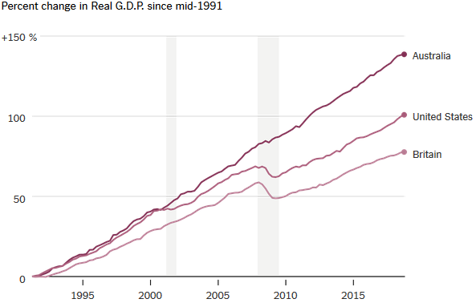

One episode is particularly telling. In 1997, an East Asian financial crisis walloped the economies of countries like South Korea, Thailand and Indonesia. These nations were major buyers of Australian exports. The value of the Australian dollar started to fall on global currency markets, putting the expansion at risk only six years in.

On the other side of the Tasman Sea, New Zealand’s central bank responded to the same problem by raising interest rates. After all, a falling New Zealand dollar indicated a lack of confidence in the currency and implied that inflation would soon rise.

At the Reserve Bank of Australia, by contrast, officials concluded that the falling value of the Australian dollar reflected shifting economic fundamentals that were ultimately healthy — part of how the Australian economy could adapt to faltering demand from East Asia.

Rather than raise interest rates to try to prevent a falling currency, they viewed a falling currency as the key to navigating the peril — by making Australian exports more competitive in the United States and Europe, for example.

“The government was uncomfortable if the exchange rate went too low, because it looked like a sign of no confidence,” said Malcolm Edey, who was the central bank’s head of economic research at the time. “We had a good monetary framework in place, we stuck to it, and we didn’t panic when the exchange rate moved around along the way.”

Sure enough, New Zealand fell into recession in 1997 and 1998, while Australia endured only a period of subpar growth. Good policy, it turns out, has a way of creating good luck. And it wasn’t the only time.

## Boring banking and avoiding the global financial crisis

If you had looked around the world circa 2006, you would have seen a number of countries where housing prices had soared into potential bubble territory, including the United States, Britain and Australia.

But two years later, while the United States and Britain were in a severe recession and financial crisis, Australia experienced only a single quarter of contraction. Why the difference?

The answer seems to be how the financial industries of those countries were structured and regulated. To understand that better, I sought out a tutor, one who turned out to have an unlikely background: David Morgan, a former child actor and professional Australian Rules Football player who later became one of the country’s leading bankers.

After a wave of deregulation in the 1980s, Australian banks took on ever-more-risky lending, especially for commercial real estate, and got into new business lines overseas in which they had no obvious competitive advantage. When that asset bubble popped and a recession arrived, the banks came near failure, and there was a wholesale firing of top bank executives.

It was a matter of “going through the furnace, and coming out tempered by experience,” said Mr. Morgan, who was chief executive of Westpac, one of Australia’s major banks, during the crisis. “We were adamant that we would go into the next shock with the least risk and the most resilience,and would not engage in any more offshore frolics.”

The banks — with prodding from regulators — reformulated themselves to take a more conservative and domestically focused approach to lending. After that near-death experience, there remained the “Big Four” banks that together control about 80 percent of deposits; they are not allowed to merge with each other.

The banks also did not engage in the kind of expansionist strategy that had gotten them in trouble in 1991. They did not open huge offices in Hong Kong, London or New York, nor get in the business of creating the complex mortgage securities that were the nexus of the financial crisis.

Good regulation was part of it. “They were good quality regulators; the public sector was getting good people,” Mr. Morgan said. Both major political parties have tended to be tough on banks, and there is a single powerful regulator rather than a patchwork of them as in the United States.

But just as important was the sense among bank leaders that they would need to be ready when the next downturn came.

It’s not as if Australia’s banks are perfect actors. A [royal commission](https://financialservices.royalcommission.gov.au/Pages/default.aspx) established to examine the industry found widespread misconduct, including abuses of customers, in a report issued this year.

But they have focused on lending to Australians, especially for home mortgages, and held those loans on their own books. No doubt Australia has missed out on some opportunities by not hosting the big, complicated banks that operate worldwide and do more sophisticated forms of finance. Sydney does not have the concentration of high-paying finance jobs that London and Hong Kong do.

But having a conservative, domestically focused, highly concentrated banking system meant that Australia wasn’t stuck importing other countries’ financial contagions when crises hit.

During the global financial crisis, Australia suffered from plummeting demand for its products. But a nicely designed fiscal stimulus — combined with a falling Australian dollar and an assist from aggressive stimulus by China — helped the country regain its footing rapidly and avoid the mass economic pain found in so much of the world.

## The pessimism of 2019

If there’s anyone you would expect to be bullish, it might be the young adults entering the work force, who have never lived through a recession. But among them — as with other Australians who don’t occupy the halls of government or financial power — you find angst and uncertainty rather than boom-time optimism.

“I think there will be a recession within the next 10 years,” said George Ye, 25, who is studying for a master’s degree in data science at the University of Sydney. “I feel like sentiment is, we might have gotten to a peak. Things have gone so well for so long that the things we need to buy are getting more and more expensive,” especially housing. “I think the generation of people born 10 years prior to me are much more confident than I am.”

“I’m pessimistic,” said Freya Zemek, 24, an employee at the university. “I think we’re probably looking at a recession in 2020. Consumer confidence isn’t very high. The signs aren’t looking great, and I think it’s the sort of tightrope situation where we could be next for a recession. It’s only a matter of time. Nothing goes on forever.”