**South Australia's Virtual Power Plant**

[**https://virtualpowerplant.sa.gov.au/**](https://virtualpowerplant.sa.gov.au/)

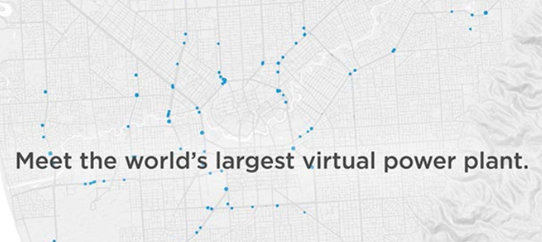

**Generate clean power and lower your bills**

Join over a thousand households in South Australia who are already making clean energy, sharing it and lowering their power bills. Take your energy costs into your own hands by registering to join South Australia's Virtual Power Plant today:

**VIRTUAL POWER PLANT REACHES 1,100 HOMES**

Tesla with support from the South Australian Government is developing a network of potentially 50,000 home solar PV and Powerwall battery systems across South Australia – all working together to form the world’s largest virtual power plant.

The virtual power plant is designed to:

* lower energy prices
* increase grid stability
* provide protection during a grid outage
* increase customers’ visibility of their energy use
* support South Australia’s transition to a renewables-based economy.

Beginning with trial phases involving 1,100 Housing SA households, home energy systems – each comprising a solar PV system, Tesla Powerwall battery and a smart meter – are being installed across the state.

Phase I has been delivered as planned, with 100 home energy systems successfully installed on Housing SA properties.

The installation of the additional 1,000 Phase II home energy systems is underway, with all systems scheduled to be operational by the end of 2019.

Energy retailer Energy Locals is the official Phase II retail partner, selected by Tesla and the South Australian Government.

All households participating in the trial will enjoy the exclusive VPP Program Offer, which is more than 20 per cent cheaper than the standard electricity price (known as the Default Market Offer) in South Australia.

Phase II will test the systems operating together as a virtual power plant and their ability to generate the additional energy to provide the same Program Offer to an extra 320 Housing SA households.

The participation of households without home energy systems will help us to demonstrate the viability of the project in reducing energy prices for all SA Housing tenants and potentially other residents across the state.

Private households interested in purchasing a Tesla Powerwall and enrolling their home energy system in the Virtual Power Plant are able to do so by signing up to the Telsa Energy Plan from September 2019. To find out more about the Tesla Energy Plan visit: <https://www.tesla.com/en_AU/tesla-energy-plan>.

Subject to the trials’ success, program financing, and the satisfaction of both Tesla and the government in the final program design, the full program could be rolled out to a further 49,000 properties later this year.

Since its launch, the program has received more than 41,000 online registrations of interest. If you are interested in participating in the project or receiving updates, please register your interest at the top of the page.