**Mining**

<https://australianjobs.employment.gov.au/jobs-industry/mining>

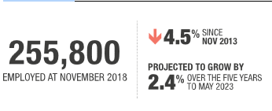

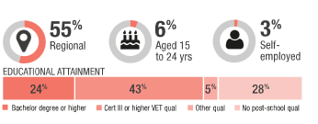

Mining is an important industry in terms of its export revenue, but it is a relatively small employing industry (accounting for around 2% of Australia’s jobs). Mining employment has fallen for much of the past five years, but has recovered strongly over the past year. Full-time work is very common in this industry.

Employment is concentrated in Western Australia and Queensland and a significant share of jobs are located in regional areas. Workers in this industry often travel to remote areas for work, with fly-in, fly-out (FIFO) arrangements common.

Post-school qualifications are often required (43% of workers hold a Certificate III or higher vocational qualification and 24% hold a bachelor degree or higher). More than one third of workers are Machinery Operators and Drivers, 28% are Technicians and Trades Workers and 15% are Professionals.

Mining employment is projected to grow by 2.4% over the five years to May 2023.

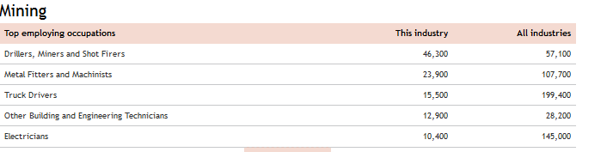

# The future of mining and renewables

18 February 2018

By Terence Jeyaretnam, Partner, Climate Change and Sustainability, EY

Examining the emerging landscape of renewables and how the Australian resources industry is set to transition towards sustainability

The mining sector currently contributes around eight per cent to Australia’s Gross Domestic Product (GDP), and employs around two per cent of the workforce. It is also Australia’s largest export sector, representing over 50 per cent of Australia’s total export earnings with iron ore, coal and liquefied natural gas representing the largest exports by value. Given the local and export income dependency on coal, there has been for the past decade a disagreement of views between the mining and renewables lobby groups in Australia. This culminated most recently with BHP announcing that it is reviewing its memberships of the Minerals Council of Australia, the World Coal Association, as well as the US Chamber of Commerce on the basis of policy conflicts primarily relating to emissions. That notwithstanding, the renewables and mining sectors may be finding themselves strange bedfellows with falling costs of renewables, growth in rare earths needed in renewables production and a more defined and tightening climate policy post the Paris Climate Agreement.

## Growth in renewables

The Clean Energy Council’s Clean Energy Australia Report 2016 said that in 2016, 17.3 per cent of Australia’s electricity came from renewable energy, the highest rate recorded this century. Internationally, the International Energy Agency’s (IEA) Renewables 2017 report noted that in 2016, around 165 gigawatts (GW) of renewables came online – accounting for almost two-thirds of net new power capacity around the world. The IEA also notes that by 2022 the growth in renewable generation will be twice as large as that of gas and coal combined. By then the gap between coal and renewables will have halved to 17 per cent, with renewables expected to continue their march to being the leading energy source globally.

A new report from the IEA, titled Renewable Energy for Industry, finds that the business case for substituting grid electricity with self-generated renewable power for major industrial energy users is proving more and more palatable. The report notes that in Australia ‘the cost of hydro, solar and wind power can fall below $US30/MWh ($A39/MWh) and supply an electricity load with high load factors, particularly when combined.’ The cost of solar has plunged 90 per cent in the last five years, and the cost of battery storage is following a similar trajectory. The cost of grid power, on the other hand, has more than doubled. Indeed, the steelmaker Liberty OneSteel (formerly called OneSteel, which was recently acquired by GFG Alliance) is set to build 1 GW of large-scale solar, battery storage, pumped hydro and demand management for the Whyalla steel works. Benefits of increased renewables in industrial and mining sites include hedging against fuel and grid price volatility, increased productivity, improved reliability and additional revenue opportunities through sales of excess energy to the grid or to others.

Furthermore, the potential for renewables in Australia is extensive. A recent Climate Council Report based on research by EY, titled Renewable Energy Jobs: Future Growth in Australia, cites that Australia’s potential to become a renewable energy ‘superpower’ is high, as it is ranked in the top three nations globally for wind and solar energy resources. The report also found that a 50 per cent renewable electricity scenario in 2030 in Australia will lead to over 28 000 new jobs, nearly 50 per cent more employment than a ‘business as usual’ scenario.

## The world after the Paris Agreement

The international community has recognised the need to limit global warming to <2°C above preindustrial levels after the Paris Agreement. Australia has set a target of 26-28 per cent reduction on 2005 emission levels by 2030. The mining sector contributed around 19 per cent of Australia’s emissions, which is significant given the sector’s contribution of two per cent to GDP. Many of the world’s largest economies have set similar or more stringent decarbonisation trajectories. Given this transition is underway, there are two key implications for the mining sector in Australia resulting from global climate policy: 1. the Australian mining sector needs to reduce its own emissions in line with Australian climate policy and targets 2. the increased deployment of renewables globally has significant opportunities for Australian minerals that are needed in the production of renewable energy, and there is even the potential to export renewable energy into Asia via subsea cables.

## Decarbonisation

The amount of renewables in the mining sector’s electricity mix is low at approximately 2.5 per cent of the renewable energy used globally. The mining sector accounts for roughly ten per cent of Australia’s total energy use. Its energy is mainly supplied by diesel (41 per cent), natural gas (33 per cent) and grid electricity (21 per cent). Energy is primarily consumed as electricity for operations and as diesel for vehicles and machinery. Yet renewable resources have the potential to provide a large portion of the energy consumed by the mining sector at or below the cost of traditional diesel generators or grid power. This represents an opportunity to both reduce costs and reduce the carbon footprint of the sector. A white paper by the Australian Renewable Energy Agency (ARENA) released in 2017, titled Renewable Energy in the Australian Mining Sector, suggests that renewable energy can greatly benefit the mining industry and should help to shape the future of the mining sector in Australia. Some of ARENA’s early work was in remote area renewables. One such example is Sandfire’s DeGrussa mine, 900 km north of Perth, which installed a hybrid solar/battery system that is the largest of its kind in the world.

## Tech metals

A third consecutive year of falling coal consumption and a renewable energy spending spree is accelerating China’s climate transition. Figures from China’s National Bureau of Statistics revealed a 4.7 per cent fall in coal consumption in 2016. The country has also embarked on a A$474 billion renewable energy program. Similarly, India is now starting to turn to renewables as the costs drop significantly. Accordingly, the Australian mining industry is following a global boom in so-called ‘tech metals’. Tech metals are rare earth and other minerals and metals that are used in what is referred to as the ‘new economy’ – essential to making high technology componentry such as mobile phones, solar cells, autonomous vehicles, batteries needed to store power from renewable sources and lightweight engines replacing traditional combustion engines. The Australian CleanTech Index has outperformed the ASX200 by 46 per cent, giving weight to the argument of a new mining boom. Companies in the CleanTech Index include lithium, cobalt and graphite explorers and miners.

## Conclusion

Global climate policy and markets are changing the way Australian mining companies view and use renewable energy technologies. Although there are challenges ahead in a world with a new energy mix, there are also significant opportunities for Australia and its mining sector to make the most of its extensive natural resources.

The views expressed in this article are the views of the author, not Ernst & Young. This article provides general information, does not constitute advice and should not be relied on as such. Professional advice should be sought prior to any action being taken in reliance on any of the information. Liability limited by a scheme approved under Professional Standards Legislation.

# Miners see 50% renewables as standard, but are aiming for 100%

[Giles Parkinson](https://reneweconomy.com.au/author/giles/) [21 June](https://reneweconomy.com.au/miners-see-50-renewables-as-standard-but-are-aiming-for-100-100/) 2019

Consider this statistic. An average size off grid mine with a 30MW power plant will likely burn about $1.4 billion of diesel fuel over a 20-year period, at current prices. That’s about one third of the total cost of the mine.

Now, the Australian mining industry has suddenly discovered that there is a cheaper, cleaner and smarter way to power their operations, and the sector is now emerging as the unlikely source of the next boom in renewables investment.

I used the word unlikely, because the Australian mining industry is not usually regarded as the go-to cohort for the push into clean energy and emissions abatement, if their lobbying groups and peak bodies are anything to go by.

But while the likes of the Minerals Council of Australia spend enormous resources pushing for new coal generators and even nuclear, [and promoting these ideas through their close links with the government,](https://reneweconomy.com.au/lobbyist-who-provided-morrisons-lump-of-coal-joins-pms-advisory-team-93806/) the industry itself now find themselves at the forefront of the transition to renewable energy.

Which makes the principal theme at this week’s Energy and Mines conference in Perth all the more extraordinary. If there was consensus among the 300-strong people in attendance, it could possibly be best summed this way: More than 50 per cent renewable share at Australian mine sites should now be considered the norm, and 100 per cent renewables will follow soon enough.

ARENA CEO Darren Miller, in announcing support for two ground-breaking projects combining wind, solar and batteries at the Agnew gold mine and the GMA garnet mine near Kalbarri, says the cost reductions in renewables are game changing.

“It is not a case of whether we replace fossil fuels with renewables, but how we integrate them.” And he says the opportunity goes beyond stationary energy, thanks to the emergence of batteries and hydrogen, and into transport as well.

“We will see rapid and ongoing cost reductions in battery costs, and mining companies moving to battery vehicles and hydrogen.”

All the more striking was the mood that this was more than just a change in electricity supply. It could preface a fundamental re-think about the nature of mining in australia.

Low cost renewable electricity means mining companies will no longer just shovel ore into shipping containers to export it for value-adding overseas, they will now look at establishing refining, processing and smelting industries considered impossible up to now.

“I think there is a huge opportunity for industry, and for the refining and processing of copper, lead, zinc, and manganese. says Justin Brown, the executive director of Element 25, [which is looking to source a minimum 50 per cent and up to 90 per cent renewables for the 100MW supply needed at it Butcherbird manganese project in the Pilbara.](https://reneweconomy.com.au/australias-biggest-manganese-metals-project-may-go-90-renewables-55385/)

The Butcherbird project is looking to export value-added manganese plate, now that wind and solar has provided cheap power to enable Australian companies to compete with Chinese producers. And the Australian project will have the added advantage of being low-carbon.

“It can be a viable alternative to just shipping the ore out,” Brown says, suggesting that the renewable hydrogen export story should be supplement by the side of exporting zero carbon products such as steel, alumina and others. “Why not?” he asks.

It’s not exactly what I expected when I took the plane in Sydney to cross the Nullabor. The political and mainstream media talk in the eastern states is dominated by scare stories that renewables will be the death of Australia’s economy, kill manufacturing and destroy jobs.

The mining industry here think that sort of talk is just nuts. Luckily for them, they can pretty much ignore the federal government and its neanderthal approach to energy and emissions.

[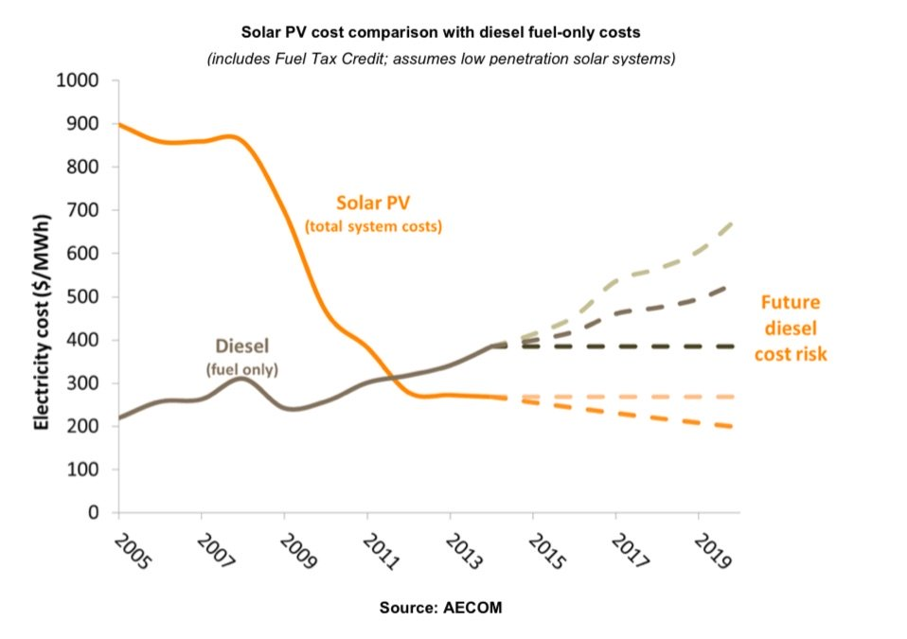](https://reneweconomy.com.au/wp-content/uploads/2019/06/deisel-costs.jpg)

It has taken the mining industry a while to get to this point, however, as they are conservative bunch. This five-year old graph (above) – produced for an ARENA report – highlights the fact that solar PV has been beating diesel costs since around 2012.

Miners and other off grid users pay a whopping $250-$400/MWh for electricity, and solar PV prices have slumped even further than that assumed in this graph, to well below $100/MWh.

Part of the problem was that miners were not convinced that solar, or wind, could be absorbed easily into an off-grid location without affecting reliability.

Numerous pilot projects have proved this is not the case, and the rapid improvement in battery technologies, integration and control system has now given the confidence that this technology is both cheaper and more reliable than what they have now.

Having recognised the opportunity, the mining industry is unlikely to muck around. After all, on off grid sites, they don’t have to stuff around with policies, and regulators and rule makers can’t get in their way.

Consider the potential. According to Juwi, the global mining industry consumers around 400TWh of electricity a year, about twice the consumption of Australia’s entire grid.

Stephen Hanson, the chief operating officer of Juwi, which built the ground-breaking solar and battery storage facility at the Degrussa copper mine in W.A. says the global mining industry consumes around 400TWh of electricity a year, about twice the consumption of Australia’s entire grid.

Yet, at the moment, just 0.1 per cent of that supply comes from wind and solar, with just 2,240MW of wind and solar PV installed in mining sites. That’s up from just 77MW in 2013, but it remains a tiny fraction of the opportunity.

“I see a tremendous opportunity here,” Hanson says.

Will Rayward-Smith, the general manager of Sunshift, says Australia’s off-grid mining sector’s demand is around 12TWh a year, about six per cent of Australia’s total consumption.

“I think it is realistic to expect that these mines will transition to 50% renewable energy contribution over the next 10 years – similar to the Agnew project that we see being announced today,” Rayward-Smith says.

“This therefore requires more than 6TWh to come from renewable energy. If we were to assume a ratio of wind:solar of 80:20 (in-line with the Agnew project) and capacity factors of 36 per cent for wind and 23 per cent for solar, then this would require  more than 400MW of solar PV and more than 1.6GW of wind.

“That’s likely to be more than $3 billion of capital works to address this market.”

That’s a view supported by EDL, which has been delivering [70 per cent renewables to the off-grid mining town of Coober Pedy](https://reneweconomy.com.au/coober-pedy-powered-by-100-per-cent-renewables-most-of-the-time-80275/) in South Australia, and which will build t[he Agnew mine project with a mix of wind, solar and batteries to provide 60 per cent of its power needs.](https://reneweconomy.com.au/wind-solar-and-battery-microgrid-at-w-a-gold-mine-an-australian-first-21075/)

“Fifty per cent renewables will be considered the norm, and 100 per cent renewables will be attainable with more battery storage and hydrogen,” says Todd Gordon, the business development manager, renewables, at EDL. And this will be done without the heavy subsidies that supported the initial Coober Pedy project.

It’s not just off grid mines turning to renewables. [BHP has put out its energy contracts to tender,](https://reneweconomy.com.au/bhp-energy-tender-could-deliver-game-changing-shift-to-renewables-96107/) including the Olympic Dam mine in South Australia, and expects offers including renewables to “change the game” for its electricity supply.

It is also looking at adding wind and or solar to its W.A. mines, and [Alinta has already revealed plans to add 60MW of solar to help power huge mines operated by Gina Rinehart and Fortescue Metals.](https://reneweconomy.com.au/alinta-plans-60mw-solar-farm-to-slash-energy-costs-for-pilbara-mining-giants-36470/)

And the emergence, after decades of promise, of the so-called hydrogen economy could take things to a different scale altogether.

Warner Priest, a hydrogen expert and head of emerging technologies at Siemens, says at the smaller level, hydrogen storage could be used to take  smaller off grid locations to 100 per cent renewables, and then to use hydrogen for transport fuel – another cost burden for

mines and remote communities.

Indeed, electrification of transport, and particularly getting rid of diesel vehicles in underground operations, is a main priority for just about every miner – for cost, health and safety reasons, as well as security of fuel supply.

This takes us back to that 30MW diesel power plant cited at the start of this story. Priest says that is equivalent to around 38c/kWH – or $380/MWh for diesel.

Under a whole different bunch of scenarios that he presented, that remote site could be “hybridised” with around 42MW of wind, say 17MW of solar, and with the excess going into a 12MW/4MWh battery. There was the option of also spilling that excess capacity using an 8.75MW electrolier with 1.5MW of fuel cells to electricity the transport.

Broadly, under a couple of different scenarios using a mix of wind, solar and batteries, or with the hydrogen addition, the cost of power could be slashed to just 23c/kWh.

“Any new greenfield mine in 10-100MW size and greater today would be considering integration of hydrogen in production – because there is so much uncertainty about gas prices and diesel,” Priest says. “There is the potential to go 100% renewables.”

And that is exactly what CWP Renewables, along with Macquarie Group and Vestas, intend to do on another scale, with their 11GW of wind and solar planned for the Pilbara, to underpin local manufacturing and value added industries of the sort planned by Element 25, and also to export “green hydrogen” to Asia.

“Our project will be 2/3 wind and one third solar,” CWP’s Andrwe Dickson told the conference. “By combining the two and over building cheap generation, we can deliver capacity factor of 70%.”