Infrastructure

<https://www.infrastructureaustralia.gov.au/about-us>

**Overview**

Infrastructure Australia is the nation’s independent infrastructure advisor.

We were established in 2008 to advise governments, industry and the community on the investments and reforms needed to deliver better infrastructure for all Australians.

Our governing legislation, the *Infrastructure Australia Act 2008*, defines our role and responsibilities in guiding nationally significant infrastructure investment and reform.

Useful Links: National

* [Department of Infrastructure and Regional Development](http://infrastructure.gov.au)
* [Department of the Prime Minister and Cabinet](http://www.dpmc.gov.au/)
* [Department of Finance](http://www.finance.gov.au)
* [Department of the Environment](http://www.environment.gov.au)
* [Department of Communications](http://www.communications.gov.au)
* [Department of Industry and Science](http://www.industry.gov.au)
* [Australia & New Zealand Infrastructure Pipeline](http://infrastructurepipeline.org/)
* [Australian Bureau of Agriculture and Resource Economics](http://www.agriculture.gov.au/abares)
* [Australian Bureau of Statistics](http://www.abs.gov.au)
* [Australian Transport Safety Bureau](http://www.atsb.gov.au/)
* [Australian Competition and Consumer Commission](http://www.accc.gov.au)
* [Australian Rail Track Corporation](http://www.artc.com.au)
* [Australian Trade Commission (Austrade)](http://www.austrade.gov.au/)
* [Bureau of Infrastructure, Transport and Regional Economics](http://www.bitre.gov.au)
* [Council of Australian Governments (COAG)](http://www.coag.gov.au/)
* [Moorebank Intermodal Company](http://www.micl.com.au)
* [Murray-Darling Basin Authority](http://www.mdba.gov.au/)
* [National Infrastructure Construction Schedule (NICS)](https://www.nics.gov.au/)
* [National Transport Commission](http://www.ntc.gov.au)
* [NBN Co.](http://www.nbnco.com.au)
* [Productivity Commission](http://www.pc.gov.au)
* [Regional Development Australia](https://rda.gov.au/)
* [The Treasury](http://www.treasury.gov.au)
* [Tourism Australia](http://www.tourism.australia.com/)

# Six recommendations for Australia's infrastructure industry

22 October 2019 Consultancy.com.au

<https://www.consultancy.com.au/news/1268/six-recommendations-for-australias-infrastructure-industry>

In light of the disruptive environment that currently prevails in Australia’a infrastructure sector, management consultancy McKinsey & Company has put forth six recommendations on how the sector can navigate change and improve its track record of delivery.

Infrastructure is among the most important sectors in the Australian economy, contributing more than 10% in gross value added, and accounting for a substantial share of employment. Australia ranks as a world leader in infrastructure development – driving innovation and scale – although a rapid increase in population coupled with significant changes in the mobility landscape are forcing the infrastructure sector to dig deep.

In the face of [these emerging issues](https://www.consultancy.com.au/news/1164/mckinsey-australias-infrastructure-sector-gearing-up-for-change), there is an urgent imperative for players in Australia’s infrastructure sector – government agencies, construction companies, engineer firms and more – to innovate across six dimensions, according to a new report from [McKinsey & Company](https://www.consultancy.com.au/firms/mckinsey-company).

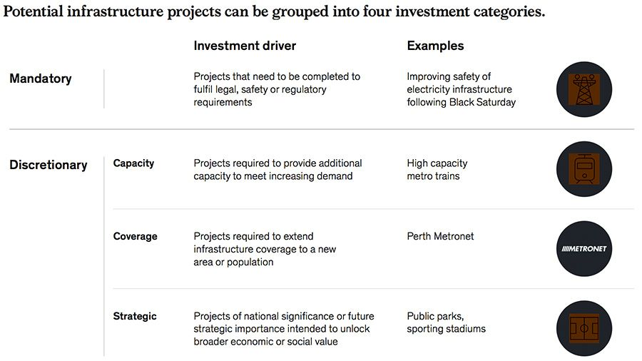

Voor Mandatory en Discretionary, kantel ze 90 graden zodat minimale ruimte neemt. Schuif dan titel naar rechts om daarmee uit te lijnen.= grotere leesbaardere foto

The first recommendation is to focus on making any investment in the sector future proof, particularly in the context of technology. This translates to major changes in urban planning, wherein the share of infrastructure allotted to various means of transport accounts for the sea of new mobility options that are likely to boom in the future. Following the planning phase, investing in state-of-the-art technology such as vehicle charging infrastructure and smart-city tech is essential.

The second recommendation is to increase a degree of agility into infrastructure planning and implementation, so as to prepare the sector to respond to more immediate needs. The new mobility landscape is likely to throw up a host of unforeseen challenges, which will require quick response and implementation times to tackle.

Driving value through design is the third recommendation made by McKinsey. Given that the complexity and scale of projects is likely to increase in under the [new mobility landscape](https://www.consultancy.com.au/news/1058/new-mobility-could-add-up-to-92-billion-to-economy-by-2050), more attention to detail and innovation at the design phase of operations is a suitable way of avoiding extra costs and unforeseen challenges.

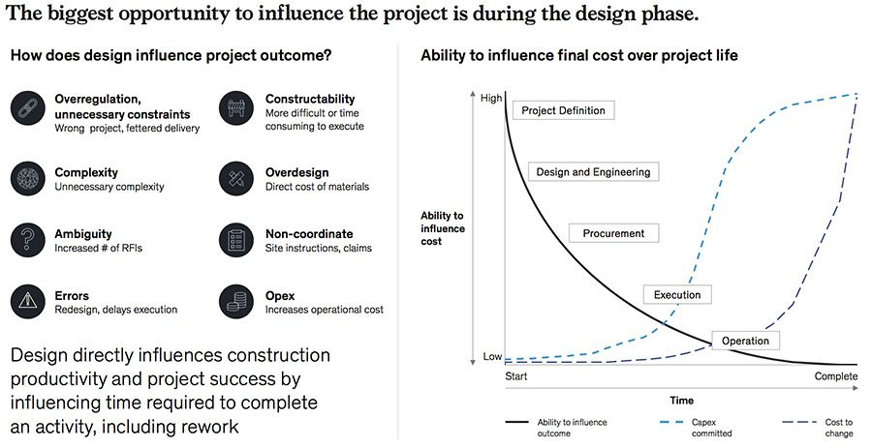

The increased cost and risk associated with new infrastructural models gives rise to the fourth recommendation, which calls for innovation in funding models. Collaboration and more relaxed regulations are crucial to ensure that backers are not put off investing in infrastructure projects – a trend that is increasingly visible in Australia.

The management [consulting firm](https://www.consultancy.com.au/firms) also reports that the growing demand for infrastructure development is not being matched by the size of the workforce in infrastructure. According to McKinsey, somewhere between 260,000 and 385,000 additional workers are needed to meet the demanded scale, all of whom need to be equipped with new age skills. Investment in talent development is of the essence in this scenario.

Lastly, while investing in tech-based infrastructure is important, so is investing in tech to improve the development process itself. Tools such as artificial intelligence and data analytics can significantly enhance productivity and efficiency in the construction process, which will cut down on time and costs in the long run.

# Emerging Trends in Infrastructure 2019

This will be a year of data-driven enlightenment for the infrastructure sector. It is the year where data and analytics matures in the sector; it is the year where evidence-based decision-making starts to become commonplace; it is the year where all organisations begin to uncover new insights that lead to new opportunities and – ultimately – important choices.

It is not surprising, perhaps, that one of the key themes throughout this year’s edition of Emerging Trends in Infrastructure is the new focus on data and analytics. As we note, governments and infrastructure authorities are starting to recognise the true value of their data in driving insights, operational performance and broader innovation. This year, we expect to see adoption spread – across sectors, ecosystems and life cycles.

We believe that many of the opportunities facing infrastructure authorities over the coming year will influence the world order for decades to come. Technology is providing the scope for radically different solutions to infrastructure needs, and often much more cost effectively. In fact, in some cases, the answer may not involve any civil engineering or building at all. As a result, there is significant potential for emerging markets to leapfrog the developed world. What a change.

Those that are able to stay on top of the emerging trends and understand their broader implications will be well placed to make the choices they need to drive their future success. And that is what this edition of Emerging Trends in Infrastructure is all about.