**Health Care and Social Assistance**

<https://australianjobs.employment.gov.au/jobs-industry/health-care-and-social-assistance>

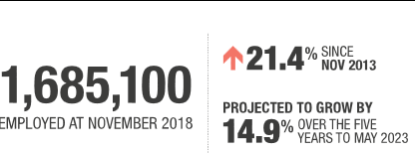

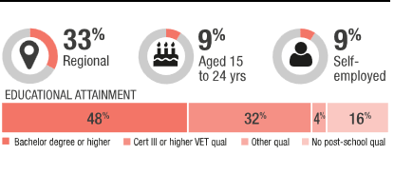

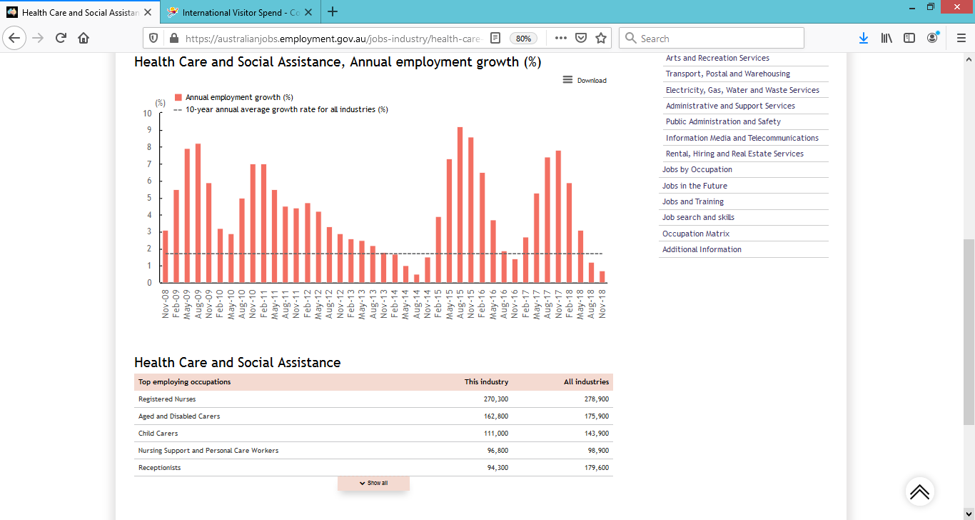

# Aged and Disabled Carers

# <https://joboutlook.gov.au/Occupation?search=Career&code=4231>

Health Care and Social Assistance is Australia’s largest and fastest growing industry, with a significant number of new jobs added over the past decade. Large shares of workers in this industry are employed as Professionals (42%) or Community and Personal Service Workers (31%). This industry has a relatively old workforce.

Post-school education is commonly required in this industry, and there has been a strong rise in the number of people studying Health. In 2017, there were 216,000 university enrolments in Health (almost doubling over the past decade) and 221,000 in the Vocational Educational and Training sector.

Health Care and Social Assistance is projected to have the strongest employment growth of any industry over the five years to May 2023, supported by the implementation of the National Disability Insurance Scheme and Australia’s ageing and growing population.

The number of people working as Aged and Disabled Carers (in their main job) grew very strongly over the past 5 years and is expected to grow very strongly over the next 5 years:  
from **175,800 in 2018** to **245,000 by 2023**.  
Job openings can come from new jobs being created, but most come from turnover (workers leaving).  
There are likely to be around **179,000 job openings over 5 years** (that's about 35,800 a year).

* **Size**: This is a very large occupation.
* **Unemployment:** Unemployment was below average in 2018.
* **Location:** Aged and Disabled Carers work in many regions of Australia.
* **Industries:** Most work in Health Care and Social Assistance; Public Administration and Safety; and Administrative and Support Services.
* **Earnings:** Full-time workers on an adult wage earn around $1,265 per week (below the average of $1,460). Earnings tend to be lower when starting out and higher as experience grows.
* **Full-time:** Less than half work full-time (33%, less than the average of 66%), showing there are many opportunities to work part-time.
* **Hours:** Full-time workers spend around 43 hours per week at work (compared to the average of 44 hours).
* **Age:** The average age is 47 years (compared to the average of 40 years). Many workers are 45 years or older (56%).
* **Gender:** 80% of workers are female (compared to the average of 48%).

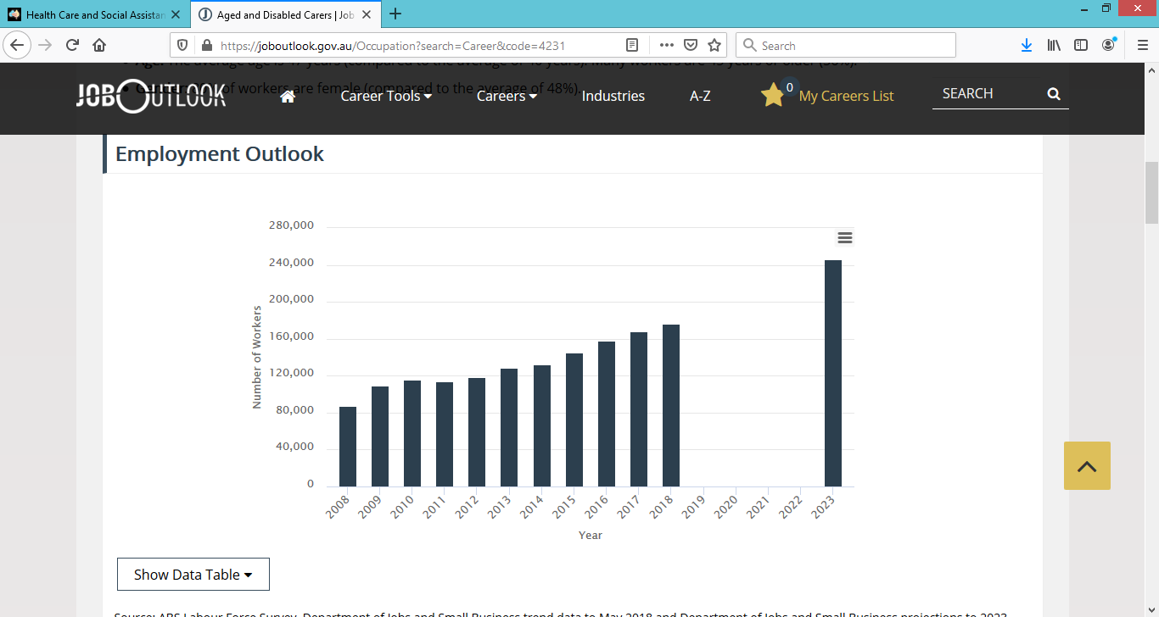

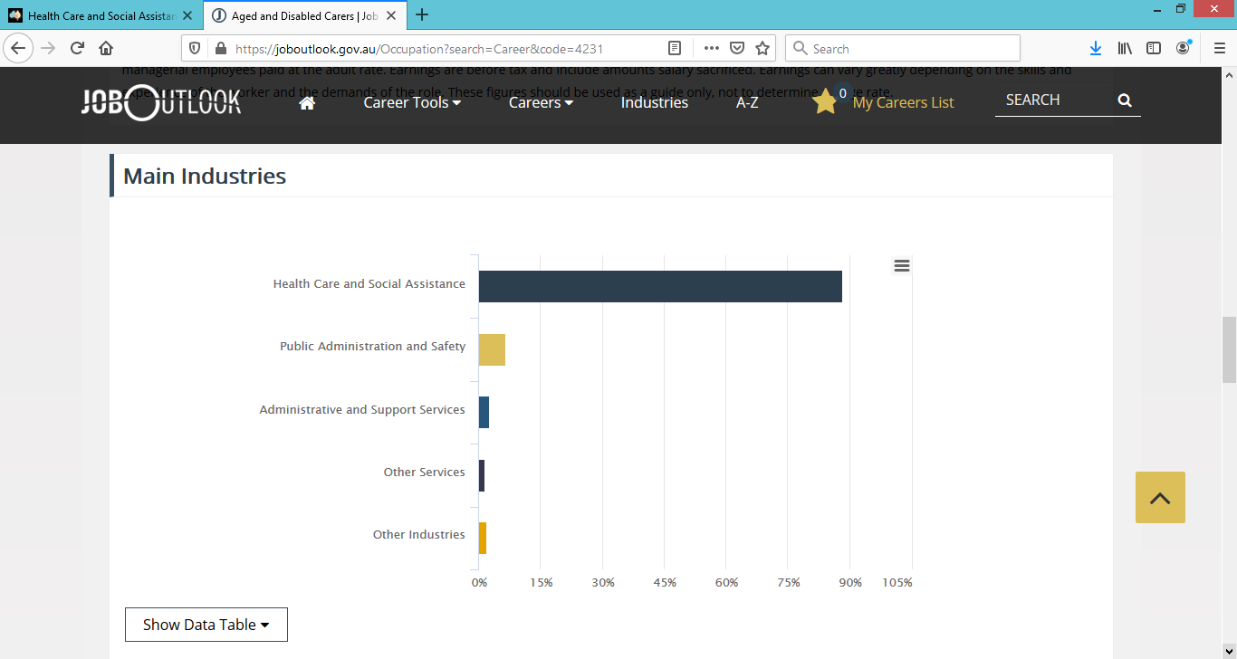



# Demand for personal care workers growing

<https://www.employment.gov.au/newsroom/demand-personal-care-workers-growing>

Australia’s ageing population and the introduction of the National Disability Insurance Scheme is increasing the demand for personal care workers.

Finding suitable applicants in an environment of increasing demand and high recruitment activity is a key challenge for employers in the aged and disability care sectors.

The Department of Jobs and Small Business undertook an extensive survey of employers, looking at their experiences recruiting and retaining personal care workers.

The department’s labour market analyst, Ivan Neville, said Australia’s ageing population and the introduction of the NDIS were responsible for a substantial growth in the sector over the past decade.

“Our projections to 2023 suggest that employment for personal care workers will increase by 80,600, or nearly 30 per cent over that five year period,” Ivan said.

“Aged and disabled carers are projected to increase by 69,200 jobs while nursing support and personal care workers are projected to increase by 11,400 over the period. This compares with the department’s projected growth of 7.1 per cent for all occupations.”

The survey revealed high recruitment activity with nine out of 10 employers having recruited in the preceding six months.

“Three quarters of all vacancies in employers’ most recent recruitment round were filled,” Ivan said.

“The most common reason for unfilled vacancies was a lack of suitable applicants. Aside from a lack of qualifications and experience, many employers said that applicants’ lack of communication skills and availability for work were an issue.”

Employers in the industry used a diverse range of recruitment methods. While recruitment websites were most commonly used, there was also a high reliance on less formal recruitment methods, such as word-of-mouth, job seekers approaching employers and social media.

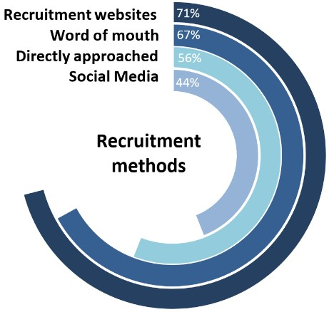

Employers were more likely to say that personal qualities, such as people skills, work ethic and communication skills, were more important than either qualifications or experience when considering applicants for their positions.

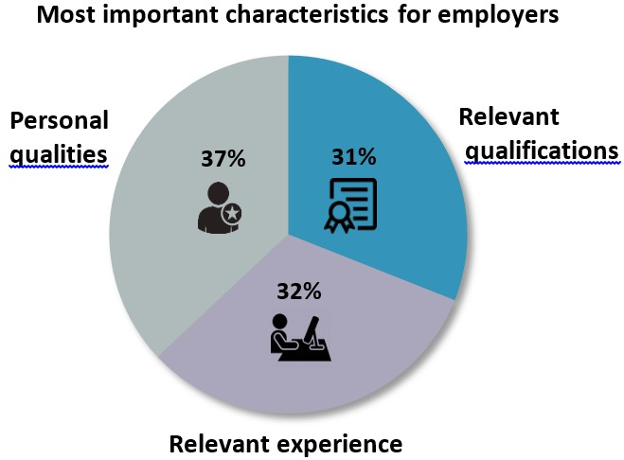

The survey was conducted across Australia in September-October 2017.

# Child Carers

<https://joboutlook.gov.au/Occupation?code=4211>

The number of people working as Child Carers (in their main job) grew very strongly over the past 5 years and is expected to grow very strongly over the next 5 years:  
from **156,300 in 2018** to **183,900 by 2023**.  
Job openings can come from new jobs being created, but most come from turnover (workers leaving).  
There are likely to be around **184,000 job openings over 5 years** (that's about 36,800 a year).

* **Size**: This is a very large occupation.
* **Unemployment:** Unemployment was average in 2018.
* **Location:** Child Carers work in many regions of Australia.
* **Industries:** Most work in Health Care and Social Assistance; Education and Training; and Other Services.
* **Earnings:** Full-time workers on an adult wage earn around $953 per week (lower than the average of $1,460). Earnings tend to be lower when starting out and higher as experience grows.
* **Full-time:** Around half work full-time (47%, less than the average of 66%), showing there are many opportunities to work part-time.
* **Hours:** Full-time workers spend around 41 hours per week at work (compared to the average of 44 hours).
* **Age:** The average age is 33 years (compared to the average of 40 years). Many workers are under 25 years of age (27%).
* **Gender:** 95% of workers are female (compared to the average of 48%).

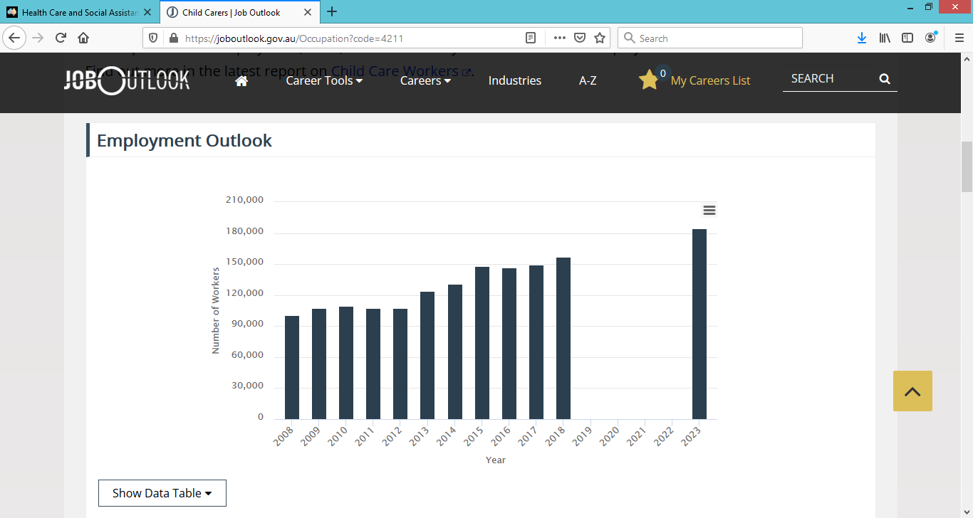

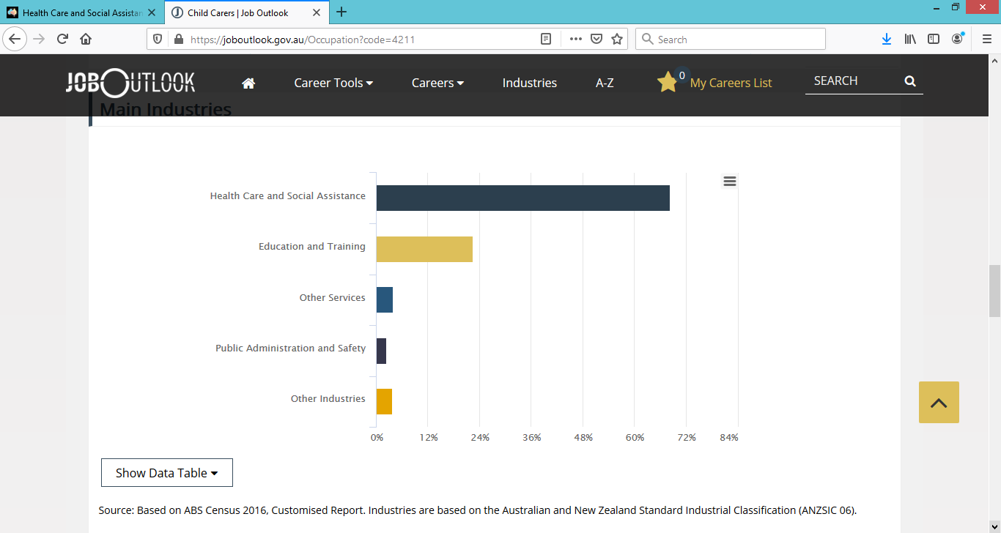

# Counsellors

<https://joboutlook.gov.au/Occupation?code=2721>

The number of people working as Counsellors (in their main job) grew very strongly over the past 5 years and is expected to grow very strongly over the next 5 years:  
from **25,900 in 2018** to **30,500 by 2023**.  
Job openings can come from new jobs being created, but most come from turnover (workers leaving).  
There are likely to be around **22,000 job openings over 5 years** (that's about 4,400 a year).

* **Size**: This is a large occupation.
* **Unemployment:** Unemployment was below average in 2018.
* **Location:** Counsellors work in many regions of Australia.
* **Industries:** Most work in Health Care and Social Assistance; Education and Training; and Public Administration and Safety.
* **Earnings:** Full-time workers on an adult wage earn around $1,584 per week (similar to the average of $1,460). Earnings tend to be lower when starting out and higher as experience grows.
* **Full-time:** Around half work full-time (51%, less than the average of 66%), showing there are many opportunities to work part-time.
* **Hours:** Full-time workers spend around 41 hours per week at work (compared to the average of 44 hours).
* **Age:** The average age is 45 years (compared to the average of 40 years). Many workers are 45 years or older (51%).
* **Gender:** 77% of workers are female (compared to the average of 48%).

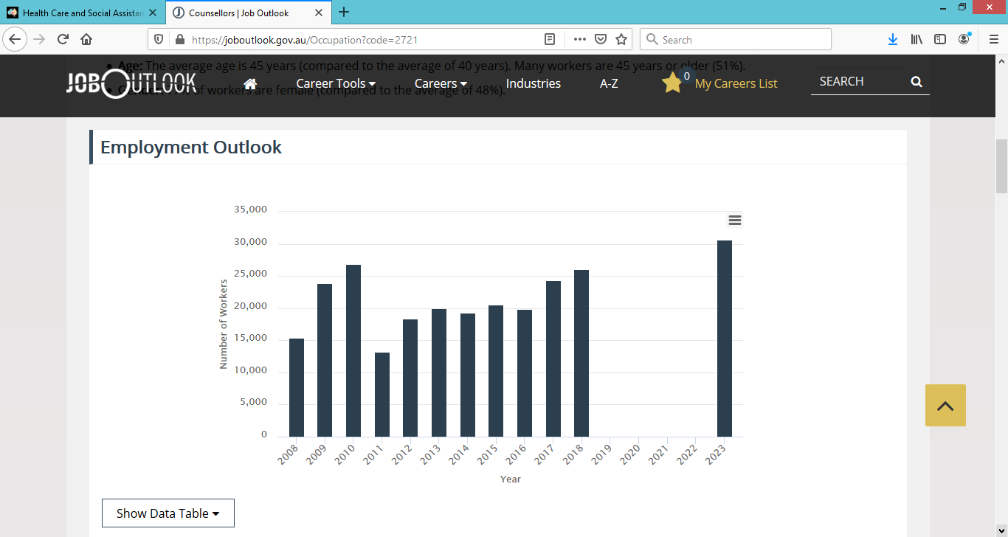

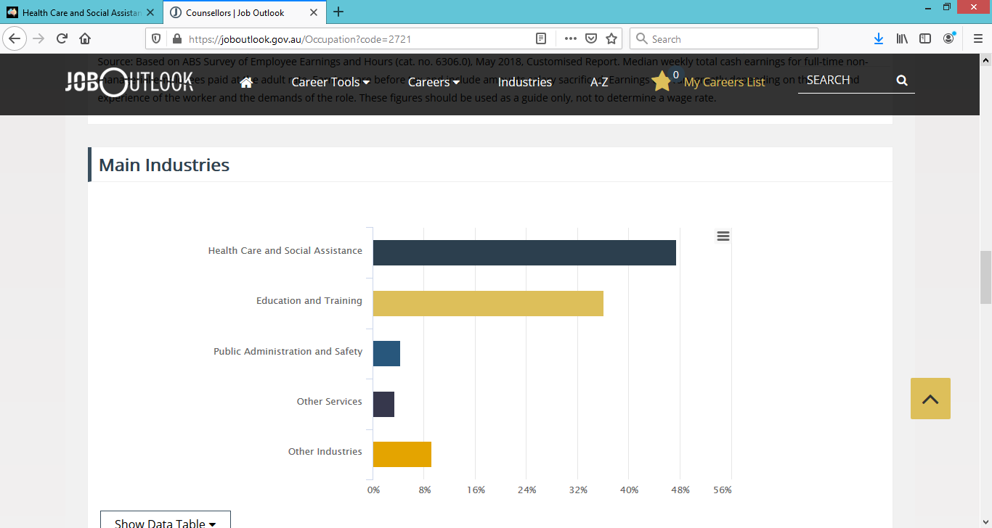

# Psychologists and Psychotherapists

<https://joboutlook.gov.au/Occupation?search=alpha&code=2723>

The number of people working as Psychologists and Psychotherapists (in their main job) grew very strongly over the past 5 years and is expected to grow very strongly over the next 5 years:  
from **37,500 in 2018** to **48,800 by 2023**.  
Job openings can come from new jobs being created, but most come from turnover (workers leaving).  
There are likely to be around **38,000 job openings over 5 years** (that's about 7,600 a year).

* **Size**: This is a large occupation.
* **Unemployment:** Unemployment was below average in 2018.
* **Location:** Psychologists and Psychotherapists work in many regions of Australia.
* **Industries:** Most work in Health Care and Social Assistance; Education and Training; and Public Administration and Safety.
* **Earnings:** Full-time workers on an adult wage earn around $1,857 per week (higher than the average of $1,460). Earnings tend to be lower when starting out and higher as experience grows.
* **Full-time:** Around half work full-time (52%, less than the average of 66%), showing there are many opportunities to work part-time.
* **Hours:** Full-time workers spend around 43 hours per week at work (compared to the average of 44 hours).
* **Age:** The average age is 44 years (compared to the average of 40 years).
* **Gender:** 80% of workers are female (compared to the average of 48%).

