

**Education and Training**

[**https://australianjobs.employment.gov.au/jobs-industry/education-and-training**](https://australianjobs.employment.gov.au/jobs-industry/education-and-training)

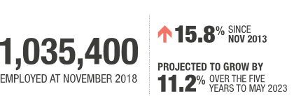

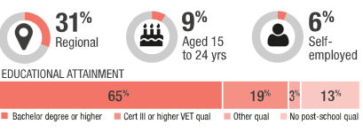

Education and Training is a large and fast growing industry. A significant share is female (72%) and part-time work is common (39% of jobs). Almost two thirds of workers in this industry are Professionals (62%).

This workforce is highly educated and university education is often required. Just 9% of workers are aged 15 to 24 years, due largely to the time taken to gain the required qualifications.

Education and Training employment is projected to increase strongly over the five years to May 2023, influenced by growth in the school aged population, continued strength in international education and the growing demand for adult and community education. In addition, the relatively large share of workers who are aged 55 years or older (22%) indicates that retirements will create opportunities in the industry over the next decade.

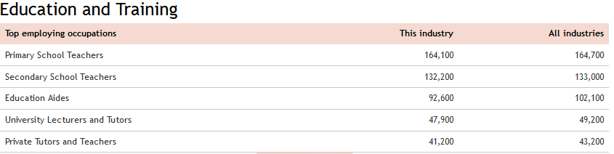

# Growth and opportunity in Australian international education

Austrade commissioned Deloitte Access Economics and EduWorld to explore the opportunity for the future growth of the international education sector. [Growth and Opportunity in Australian International Education](https://www.austrade.gov.au/ArticleDocuments/6722/DAE%20EduWorld%20Austrade%20Report.pdf.aspx) (PDF, 1.64MB) seeks to form an evidence base for potential growth in both onshore education delivery and borderless delivery (in-market and online). The research considers 29 markets, with the summary findings set out below.

The research considers ‘how’ opportunity might emerge, highlighting that the challenge now is to refine that opportunity into its most prospective form for Australia based on relative size and sector, and to create the right supply-side conditions to enable the sector to pursue these opportunities. Austrade is taking forward this refinement of opportunities as part of work under AIE2025. The findings of the report may help to stimulate the sector to consider their own target markets and opportunities for further growth and/or diversification.

## Key conclusions of the report

* Australia’s onshore international education sector is forecast to grow from 650,000 enrolments today to 940,000 by 2025 (which equates to a compounding annual growth rate of 3.8 per cent).
* The international education sector’s contribution to export earnings is expected to almost double to in excess of $33 billion by 2025.
* The top eight source markets for onshore international learner enrolments across all sectors in 2025 are expected to be China, India, Vietnam, Thailand, Nepal, Malaysia, Brazil and South Korea. Much of the growth in onshore learner enrolments will be driven by Asia – in particular China, India, Nepal, Vietnam and Thailand.
* Over the period to 2025, the fastest growing sectors in onshore international education are expected to be higher education and VET (in percentage terms). By 2025, these two sectors are expected to account for 72 per cent of all onshore international learner enrolments.
* China is set to remain Australia’s largest source market for onshore enrolments in 2025 and is expected to occupy the largest number of higher education, schooling and ELICOS enrolments. The largest number of VET onshore enrolments in 2025 are forecast to come from India (16 per cent), Thailand (eight per cent) and South Korea (seven per cent).

<https://www.austrade.gov.au/Australian/Education/Services/Australian-International-Education-2025/growth-and-opportunity>

Media Release

Date: 5 February 2019

# Continued growth in international education sector

Ministers:

[The Hon Dan Tehan MP](https://ministers.dese.gov.au/tehan)

Minister for Education

Australia’s world-class international education sector contributed $34 billion to the local economy last year, an increase of 15.3 per cent.

Minister for Education Dan Tehan said Australia hosted a record 690,000 international students in 2018 who paid tuition fees and spent money on living costs.

"Over decades of investment, hard work and the commitment of world-class scholars, teachers and administrators, Australia has established a global reputation as a leader in higher education," Mr Tehan said.

"Australia has a vibrant and high-performing international education sector, so much so the British-based Centre for Global Higher Education predicts Australia will leapfrog the UK to become the world’s second most popular destination for international students this year.

"Our Government is working to promote regional Australia as a destination for international students, so our regional communities can also enjoy the economic and cultural benefits that international students bring.

"Only the Morrison Government will keep our economy strong and allow our export industries to thrive."

The data is from the Australian Bureau of Statistics International Trade in Goods and Services, Australia, Dec 2018: <http://www.abs.gov.au/ausstats/abs@.nsf/mf/5368.0>

**Australia’s international education booming, new figures show**

by Brett Henebery 27 Nov 2019

<https://www.theeducatoronline.com/he/news/australias-international-education-booming-new-figures-show/268472>



New ABS figures show international education contributed $37.6 billion to the Australian economy last financial year – a $5bn increase.

According to the figures, released last week, the economic contribution of the nation’s international education sector had grown by 15%.

Federal Education Minister, Dan Tehan, said the figures confirmed Australia was a “world-leading study destination”.

“International education has experienced its fifth year of consecutive double digit growth, highlighting the strength of Australia’s higher education system,” Tehan said.

“Australians should be proud of our innovative international education sector. It is our largest service-based export and supports 240,000 jobs, business opportunities and economic growth.”

The Organisation for Economic Co-operation and Development’s (OECD) Education at a Glance 2019 report showed that Australia is among the countries with the largest share of foreign student intake.

The report also showed international students – especially those from Asia – are still attracted to Australian tertiary education despite forecasts of a drop in Chinese students and concerns about high tuition fees.

Last year, China brought in 152,591 students to Australia, or 38.3% of all the international students who enrolled in 2018. Second was India, which contributed 18% of international students last year.

Tehan said the Federal Government continues to focus on the sustainable growth of the sector and attracting more international students to study in the regions, through the Destination Australia program and changes to student visa work rights.

“We want to ensure the benefits of our international education sector are shared throughout the country,” he said.