[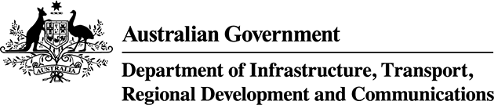](https://www.communications.gov.au/)

Top of Form

Bottom of Form

# Australia's art sector is sustainable, innovative and strong and enabling growth in creative activities across Australia

### Results

Table 2.11 Results for measures related to benefit sought 2.3

|  | **2017–18 results** |
| --- | --- |
| 2.3.1   Analysis of contribution of the arts and cultural education to employment outcomes |  |
| ABS data shows that over 1 million people were employed in Australia's creative sector in 2014–15 and that there were approximately 160,000 creative businesses in operation. There has been substantial growth in employment in the creative sector — nearly twice the rate of the total Australian workforce. |
| 2.3.2   Analysis of contribution of arts and culture to the economy | **In progress** |
| The creative sector is significant to Australia's economy. Estimates based on ABS data show that cultural and creative activity contributed approximately $106 billion (equivalent to over 6%) to Australia's gross domestic product in 2014–15. |

### Analysis

We assist the creative sector in building sustainability and resilience and identifying opportunities for innovation. We support the creative industries to be sustainable, innovative, strong and an important contributor to our nation's cultural life and economy. A creative economy contributes to cultural diversity, social inclusion, knowledge building and technological advancement. Creativity is key to innovation, driving sustainability and prosperity. Our support is through effective and efficient management and oversight of policy and programs, including the film tax offsets, Location Incentive grants, Resale Royalty Right for Visual Artists Act 2009 and associated scheme, and the lending rights programs.

Australia is home to a wide range of creative arts and industries, from world-class screen production, to visual and performing arts, to book publishing and the games sector. Australia has a vibrant arts and entertainment community which is known internationally for its unique style and its reflection of Australia's rich Indigenous cultures. Australia also plays a key role in the education, training and development of future leaders across all arts and creative industries.

The work of the department and our portfolio agencies to support the creative industries also contributes to Australia's efforts to achieve the United Nations' Sustainable Development Goals. This work contributes directly to Goal 9 — Industry, Innovation and Infrastructure: Build resilient infrastructure, promote inclusive and sustainable industrialisation, and foster innovation.

#### Analysing the contribution of arts and culture to the economy and employment

As digital disruption reshapes the Australian economy and workforce, Australians will need to have the necessary skills to embrace the future world of work. Creative skills are likely to be particularly important with creativity critical to innovation, and therefore to productivity, living standards and wellbeing.

We are developing our evidence base about the importance of creative skills and cultural and creative activity to the economy.

#### Initiatives to support creative industries' contribution to the economy

Our programs and policies support Australia's creative industries in producing original, compelling and accessible content.

* **Location Offset, and Post, Digital and Visual Effects (PDV) Offset**  
  The Location Offset provides a 16.5% rebate on productions that spend at least $15 million on qualifying Australian production expenditure. The PDV Offset provides a 30% rebate on the qualifying post, digital and visual effects expenditure of productions that spend at least $500,000 on qualifying Australian expenditure, including productions not necessarily shot in Australia. In 2017–18, the Minister issued 111 final certificates to applicants for the Location Offset and PDV Offset. The Film Certification Advisory Board issued a further 34 provisional certificates for these offsets. The qualifying Australian production expenditure of these productions totalled $573.63 million, with an estimated rebate payable to these productions of $137.64 million.
* **Resale Royalty Scheme**  
  Under the Resale Royalty Scheme, visual artists are entitled to a royalty payment of 5% of the resale price for eligible works of art resold commercially for $1,000 or more. At 30 June 2018, the scheme had generated more than $6.305 million in royalties for 1,621 artists from 17,042 resales.
* **Public and Educational Lending Rights schemes**  
  In 2017–18, through the lending rights schemes, we made over 17,200 payments totalling $22.3 million, to Australian creators and publishers. These funds compensate writers, illustrators and publishers for income lost through the free use of their books in public and educational lending libraries and meet the objective of supporting the growth and development of Australian writing.
* **Artbank**  
  Artbank's core objectives are to provide direct support to Australian contemporary artists through the acquisition of their work and to promote the value of Australian art to the broader public. Artbank funds its operations through the leasing of artworks from its collection and aims to increase the sustainability and accessibility of Australian art, to support artists, and to encourage engagement with and appreciation of Australian contemporary art by the broader community. In 2017–18, Artbank purchased 181 new works and rented 4,632 works to 553 clients.

# ****An exploding creative economy shows innovation policy shouldn’t focus only on STEM****

March 22, 2018 12.44pm AEDT

<https://theconversation.com/an-exploding-creative-economy-shows-innovation-policy-shouldnt-focus-only-on-stem-93732>

Stuart Cunningham

Australians in creative industries [have grown](https://research.qut.edu.au/dmrc/wp-content/uploads/sites/5/2018/03/Factsheet-1-Creative-Employment-overview-V5.pdf) from 3.7% of the workforce in 1986 to 5.5% in the latest census.

Creative services, a subset of the creative economy that includes software and digital content (including web design and games) and social media management and marketing, are growing as much as three times the rate of the overall workforce.

These findings make it imperative that Australian governments develop policies that don’t fixate on what NSW Education Minister Rob Stokes [calls](https://www.brisbanetimes.com.au/politics/nsw/stem-has-become-a-buzzword-and-a-fad-nsw-education-minister-20180321-p4z5iw.html) the STEM “buzzword”.

The government should focus on education and training that combines the acquisition of both technical and non-technical skills. This will support the sustainability of creative industries.

***Read more:*** [***We can rebalance Australia's economy with creative industries***](https://theconversation.com/we-can-rebalance-australias-economy-with-creative-industries-23458)

Altogether 600,000 people work in Australia’s creative economy, which combines cultural production (film and broadcasting, music and performing arts, publishing and visual arts) with creative services (advertising and marketing, architecture and design, creative software and digital content).

It also includes “support professionals” who work in these creative industries such as technicians, accountants, lawyers or salespeople, as well as “embedded” creatives who work outside the creative industries, across the rest of the economy.

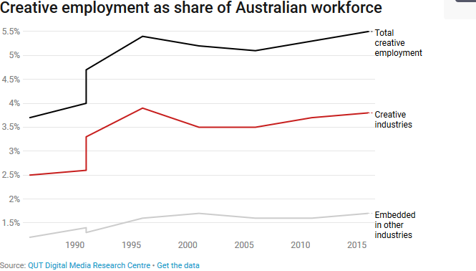

The creative economy is a job-intensive sector. It immerses human talent in meaningful, creative, well-remunerated activity at a scale few other sectors can offer.

The creative economy as a whole is growing at a rate nearly twice that of the Australian workforce as a whole and it is highly likely to continue to grow into the future.

Compare that to sectors that are [shedding jobs](https://theconversation.com/explaining-the-figures-why-we-shouldnt-worry-about-the-loss-of-23-000-mining-jobs-1705) through automation, such as mining, or whose contribution to employment in Australia has been trending down for decades, such as agriculture.

In 2013, [one study](https://www.oxfordmartin.ox.ac.uk/downloads/academic/The_Future_of_Employment.pdf) estimated that 47% of jobs in the United States were at risk of being automated.

But [every serious study](http://www.real-world-futures.qut.edu.au/The_future_of_employment.pdf) since then has dialled back on that dramatic prediction, with [the latest study](https://www.nesta.org.uk/publications/future-skills-employment-2030) offering a much more granular account of what we can expect in skills for jobs of the future.

It found that creative skills are some of the most likely to grow in employability. The report says that “artists”, for example, possess skill sets that entail high-level, subtle decision making that are less susceptible to machine substitution.

But the creative economy is experiencing some disruption.

While digital creative services grow rapidly, publishing (this is mostly newspapers and magazines) has continued its downward spiral. And workers in music, performing arts and visual arts, earn well below the Australian mean income – and their relative situation is stagnant or deteriorating.

On the other hand, creative services workers command wages 30% higher than the Australian average, with software and digital content professionals earning the highest incomes of the whole sector.

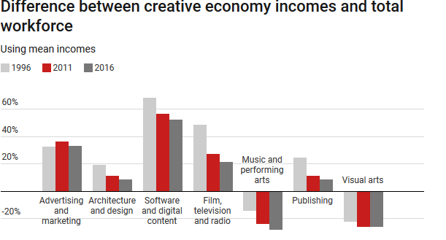

## What this means for policy

When Prime Minister Malcolm Turnbull came to power he [stated](https://www.facebook.com/malcolmturnbull/posts/10153698142356579) “there has never been a more exciting time to be an Australian”.

But the electorate didn’t buy it. Its anxiety that innovative responses to technology-driven change was all about inner city start ups and tech love-ins contributed to the Coalition’s near death experience in the 2016 election.

The government [soon shifted](https://www.theaustralian.com.au/national-affairs/innovation-for-all-businesses-says-greg-hunt/news-story/d914fda12d2ec2981aae2b0e6067d154) to talking about “innovation for all businesses”, and innovation has been put away in the bottom drawer ever since.

Australian does need an innovation policy, but it needs to be broader than STEM (science, technology, engineering and maths) fields. Creative jobs are transforming the Australian economy.

Instead, research tells us that the most innovative Australian enterprises all thoroughly [mix](https://acola.org.au/wp/saf10/) STEM with business, creative, and communication skills, and that digital literacy skills are far wider than what is encompassed in a STEM definition of technology.

The government should focus on education and training that combines both technical and non-technical skills and support the sustainability of creative industries.

That way, we can begin to set the country on an innovation path that is holistic and takes better account of where some of the strongest growth in job creation is occurring.

# ****We can rebalance Australia’s economy with creative industries****

February 20, 2014 4.17pm AEDT

<https://theconversation.com/we-can-rebalance-australias-economy-with-creative-industries-23458>

Roy Green (Dean of UTS Business School, University of Technology Sydney) and Lisa Colley (centre Director)

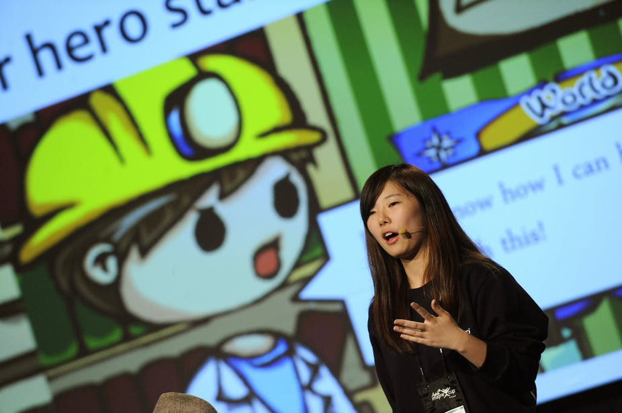

Australia’s economic challenge is now starkly apparent. In the wake of a [diminishing](https://theconversation.com/after-the-boom-where-will-growth-come-from-17358) contribution to our national income by primary commodity exports (think iron ore, coal), we need to “rebalance” the economy with new sources of growth and productivity.

One potential source of growth is internationally traded services, currently dominated by tourism and education, but with professional services increasingly part of the mix. Another major source, perhaps surprisingly in the light of [recent events](https://theconversation.com/car-manufacturing-numbers-just-dont-stack-up-23093) in Australian car manufacturing, is [advanced manufacturing](http://en.wikipedia.org/wiki/Advanced_Manufacturing) (the use of innovative technology to improve products) with opportunities for “[smart specialisation](http://www.oecd.org/sti/inno/smartspecialisation.htm)” in global value chains.

What these high potential growth activities have in common is an increasing emphasis in their business strategies on creativity and design innovation and, consequently, a deepening interdependence with Australia’s newly emerging creative industries.

Last week [Justin O'Connor](https://theconversation.com/profiles/justin-oconnor-11847/profile_bio) [argued](https://theconversation.com/abs-data-suggests-cultural-and-creative-wont-save-australia-23114) on The Conversation that these “industries of the future” have “run out of steam”. In which case, we should be worried.

But they have not run out of steam.

Even if we were to allow that [Australian Bureau of Statistics (ABS) data](http://www.abs.gov.au/ausstats/abs@.nsf/mf/5271.0?OpenDocument) on the Cultural and Creative Activity Satellite Accounts may have overstated the direct contribution to Gross Domestic Product (GDP) of the creative sector at A$86.7 billion, a new report, [Valuing Australia’s Creative Industries](http://www.creativeinnovation.net.au/business/ciic-resources/creative-economy) (which the co-author here, [Lisa Colley](https://theconversation.com/profiles/lisa-colley-117319/profile_bio), worked on) demonstrates the far-reaching indirect contribution made by those employed in creative industries to a range of activities across the economy.

The report drills down into the data, finding that at least 43% of the creative workforce consists of “embedded creatives” – in other words, creative practitioners in “non-creative” industries such as manufacturing, financial services and healthcare. This marks an increase of 151% since 2006.

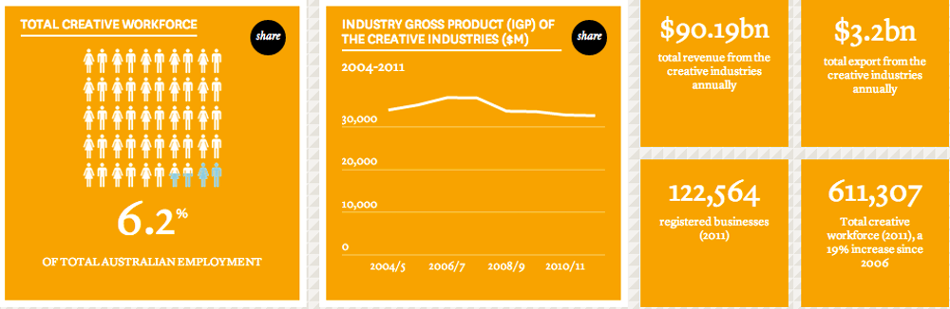

Creative Industries Innovation Centre

## “Creative intensity” methodology

The report applies a [methodology](http://www.nesta.org.uk/publications/dynamic-mapping-uks-creative-industries) first used by the UK’s [National Endowment for Science, Technology and the Arts](http://www.nesta.org.uk/) (NESTA), based on the degree of “creative intensity” of creative occupations.

This approach gets around the problem of determining what is and what is not a “creative industry” by adopting a new definition based on the recognition that digital technologies have created a “new class of business”, combining creative talent and software design.

NESTA [proposes](http://www.nesta.org.uk/sites/default/files/a-manifesto-for-the-creative-economy-april13.pdf) that creative industries are:

those sectors which specialise in the use of creative talent for commercial purpose.

The implication is that the juxtaposition of creative industries with other supposedly “non-creative” industries is superseded by the value of deploying creative talent across the whole spectrum of industries and services.

This requires a more integrated approach which recognises that a printing company is now only competitive if it brings in a full suite of digital and graphic design services; that a clothing manufacturer will need to connect materials science with high design values; and that design agencies must increasingly apply the principles of [lean manufacturing](http://en.wikipedia.org/wiki/Lean_manufacturing).

There is much to be learned from such cross-fertilisation of skills and capabilities across these industry sectors.

## Skill integration

Future economic success will not be achieved by a simplistic delineation of industries but rather a sophisticated understanding of how to integrate, innovate and apply multiple skills within ever-changing business models.

We are beginning to see a more nuanced debate about these issues, from last year’s report on [Smarter Manufacturing](http://www.innovation.gov.au/Industry/Manufacturing/Taskforce/Documents/SmarterManufacturing.pdf) to last week’s [media story](http://www.smh.com.au/business/australia-needs-to-smarten-up-its-act-with-manufacturing-exports-20140214-32ref.html) in the Sydney Morning Herald recommending:

creating things that are faster, lighter and more efficient and simply better than those already provided by mass-manufacturers – thus providing a competitive edge.

The skills to reposition our manufacturing sector include those from the creative industries combined with materials scientists, engineers and computer technicians, all working together.

The role of design applies not only to the design and quality of the product but also its brand, marketing and distribution – the customer experience. The demand for creative expertise is indicative of the growing awareness within businesses for “design thinking”, which offers ways to rethink business models and anticipate customer needs.

[[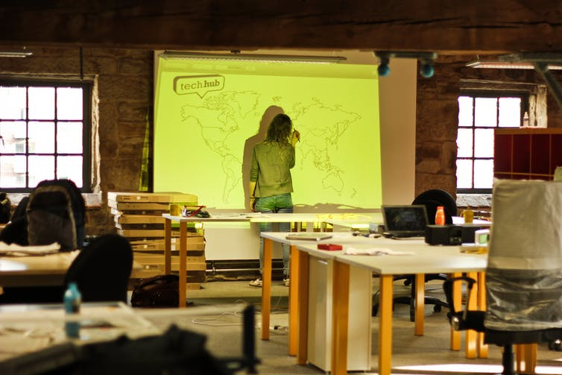](https://images.theconversation.com/files/42027/original/5p4r3m75-1392861229.jpg?ixlib=rb-1.1.0&q=45&auto=format&w=1000&fit=clip)](https://images.theconversation.com/files/42027/original/5p4r3m75-1392861229.jpg?ixlib=rb-1.1.0&q=45&auto=format&w=1000&fit=clip)

Graphic Design TechHub Manchester. University of Salford

A [further finding](http://www.creativeinnovation.net.au/business/ciic-resources/creative-economy) of the Valuing Australia’s Creative Industries report is that software development and interactive content development account for the largest proportion of creative skills overall, with around 200,000 employed both within and outside the formal creative sector. Over half of these consist of support workers and a further quarter “embedded creatives”, primarily in financial and insurance services.

The report also demonstrates a growing demand in industry for “boundary-crossing” skills, such as problem-solving, collaboration and integrative thinking, which build on specialised knowledge.

Around the world, it is increasingly recognised that creative industries, with their associated skills and capabilities, are a [major driver](http://www.nesta.org.uk/publications/vital-growth) of competitive advantage in global markets and supply chains.

## Work to be done …

Other countries have [placed more emphasis](http://www.uts.edu.au/about/uts-business-school/who-we-are/dean/news/australia%E2%80%99s-manufacturing-future) than Australia has on the role of “intangible value” in repositioning their economies for long-term growth and jobs.

We need to understand the best way to grow, sustain and engage small, innovative businesses, and how they can help us reconstruct declining uncompetitive industries and create new ones.

This is now increasingly urgent with the mining boom winding down, the end of car assembly manufacturing and the need to find other sources of growth and productivity to maintain our living standards.

The future success of our trade-exposed industries in a high-cost economy will depend to a large extent on strategic investment and coordination by government, research and business to promote global opportunities for Australia’s emerging “micromultinationals”, particularly in advanced manufacturing.

There is no-one better placed to make this happen than the people who lead and contribute to our creative industries.

**Australia’s creative industries: valuation (SGS Economics and Planning)**

<https://www.sgsep.com.au/projects/australias-creative-industries-valuation>

Client: Creative Industries Innovation Centre, UTS

Location: Australia

Service/s: [Economic analysis](https://www.sgsep.com.au/understand) [Industry analysis](https://www.sgsep.com.au/understand)

### Report reveals that Australian creative industries sector contributes more than $90 billion to the national economy and exports $3.2 billion annually.

We worked with the Creative Industries Innovation Centre (CIIC) to measure and profile Australia’s creative industries. Our study illustrated how pervasive the creative workforce is in Australia. It is widespread and embedded.

Our report found that the creative sector:

* contributes around $90.19 billion to the national economy annually
* adds almost $45.89 billion to Australia’s gross domestic product (GDP)
* helps generate exports of $3.2 billion annually, and
* employs more than 600,000 people in Australia, with 263,563 embedded in non-creative industries. This demonstrates a clear industry demand for cross-disciplinary skills. The Australian creative industries sector also employs many volunteers. Their contribution was not included within our estimates due to insufficient data.

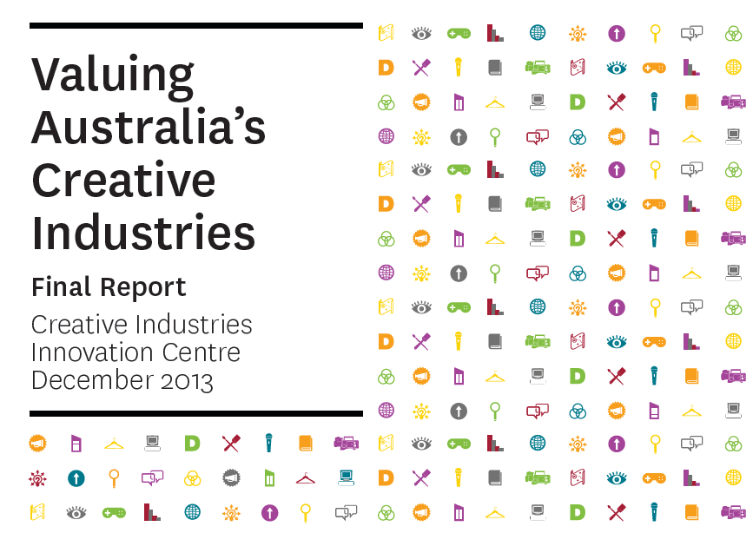

The Director of Enterprise Connect at CIIC, wrote that our report "validates and values the skills and capabilities of the creative industries in economic terms. It has the benefit of being internationally comparable, and clearly shows the increasing demand for creative skills’ sets across all industry sectors in our economy, as evidenced by the growing number of creatives employed within other industries."

Our work represented the first Australian application of the 'NESTA method' to creative industry measurement. This method was pioneered in the UK by the National Endowment for Science, Technology and the Arts (NESTA).

Top of Form

Bottom of Form

# Australian Industry Capabilities: Creative Industries

# Austrade: <https://www.austrade.gov.au/International/Buy/Australian-industry-capabilities/Creative-Industries>

## Industry Capability Reports

• **[Cultural Precincts](https://www.austrade.gov.au/ArticleDocuments/1358/Cultural-Precincts-ICR.pdf.aspx)** (PDF, 3.11MB)  
Australia has one of the most sophisticated arts and creative sectors in the world and an international reputation for designing, building and successfully managing world-leading cultural institutions.

• • [**Digital Games**](https://www.austrade.gov.au/ArticleDocuments/1358/Digital-Games-ICR.pdf.aspx) (PDF, 1.34MB)  
Australia has a dynamic and sophisticated game development industry. With experience developing and marketing products for the largest game publishers in the world, Australia offers the best in creative talent, advanced technology and management experience.

[**Screen Production**](https://www.austrade.gov.au/ArticleDocuments/1358/Screen%20Production%20ICR.pdf.aspx) (PDF, 2.13MB )  
Australia’s screen production industry is acclaimed around the world. Experienced production companies and talented creatives are at its core, supported by sophisticated filmmaking infrastructure, skilled production services and generous financial incentives.

## A thriving arts, culture, media and entertainment industry

Contemporary Australia is home to a wide range of creative arts and industries, from world-class films, visual and performing arts, to publishing and the games industry. Australia has a vibrant arts, culture and entertainment community which is known internationally for its unique cultural style and enriched Indigenous history. Australia also plays a key role in the education, training and development of future leaders across all arts and creative industries.

The Australian government recognises that a creative economy contributes to cultural diversity, social inclusion, environmental sustainability and technological advancement. Creativity is key to innovation, driving sustainability and prosperity. Creativity and innovation play an important role in Australia’s resilience to recent global economic challenges, helping Australia to register 22 years of uninterrupted economic growth.

The arts and creative industries are integral to contemporary Australian values, self-expression, confidence and engagement with the world.

Visit [Australian Stories](http://australia.gov.au/about-australia/australian-stories) to learn more about Australia's history and culture.

## Creative Industry Sectors

### Publishing

Australian writers have achieved huge international readerships, including; Thomas Keneally, Kate Grenville, Nevil Shute, Peter Carey, Bryce Courtenay, Kathy Lette and Nobel Prize winner Patrick White.

An increasing number of independent Australian publishers are taking their works offshore and attending the major book fairs in London, Bologna, Frankfurt, Taipei and Warsaw.

Many smaller independent publishers attend fairs as members of the [Australian Publishers Association (APA)](http://www.publishers.asn.au). The stalls attract overseas agents and publishers to purchase Australian books - or the right to publish them.

### Performing arts

Australia has a vibrant performing arts sector, including; theatre works, orchestras, musicals, physical theatre, outdoor performances, theatre for young audiences and contemporary dance.

The [Australian Performing Arts Market (APAM)](http://www.performingartsmarket.com.au/) is a biennial, five-day event, showcasing Australian dance, music and theatre. International buyers and producers are welcomed at this event to network and purchase the rights to tour Australian performances. ;Festival and venue managers also have the opportunity to view Australian works and meet Australian producers at the [Performing Arts Market in Seoul](http://www.pams.or.kr), [Cinars in Montreal](http://www.cinars.org/), and at the [Association of Performing Arts Presenters Conference in New York](http://www.apap365.org).

### Visual arts

Australia is home to a vibrant community of artists — painters, photographers, potters, printmakers, glassblowers, sculptors, weavers, and digital and multimedia artists — working in a wide variety of genres and styles.

There is global interest in the Australian arts scene. Internationally recognised Australian artists include:

* Tracey Moffatt
* Shaun Gladwell
* John Brack
* Arthur Boyd
* Margaret Preston
* Sidney Nolan
* Brett Whiteley
* Ben Quilty
* Judy Watson.

There is a booming trade in Australian Indigenous art and the works of Indigenous artists such as Emily Kame Kngwarreye, continue to be revered internationally.

There are over thirty academic institutions across Australia offering degrees in art, craft and design.

Australia regularly hosts exhibitions of local and international artists. Australia’s museums hold an estimated 54.9 million artworks and objects displaying a wide variety of genres and representing thousands of domestic and international artists.

The [Australian Commercial Galleries Association](http://www.acga.com.au/) (ACGA) is the lead industry body and is the industry export leader. There are over 50 galleries which are members of the ACGA, representing over 1300 artists.

Overseas buyers can view and purchase Australian art works at world art fairs, including the:

* [Melbourne Art Fair](http://www.melbourneartfair.com.au)
* [Korea International Art Fair](http://www.kiaf.org)
* [Art Basel - Hong Kong](https://www.artbasel.com/en/Hong-Kong)
* [Art Stage Singapore](http://www.artstagesingapore.com).

### Screen production – feature films, television and documentary

The Australian screen industry has achieved global recognition for documentary and commercial TV production.

Actors who have had great international success in TV include; Simon Baker (The Mentalist, The Guardian), Rachel Griffiths (Six Feet Under, Brothers and Sisters), Portia de Rossi (Arrested Development, Ally McBeal) and Anthony LaPaglia (Without A Trace).

Australian actors achieving international success in film, include:

* Eric Bana
* Cate Blanchett
* Toni Collette
* Russell Crowe
* Hugh Jackman
* Nicole Kidman
* Joel Edgerton
* Naomi Watts.

Well-known Australian film directors include:

* Gillian Armstrong (Little Women, Oscar and Lucinda)
* Baz Luhrmann (Moulin Rouge, Australia, The Great Gatsby)
* Robert Luketic (Legally Blonde)
* George Miller (the Oscar-winning Happy Feet 1)
* Peter Weir (Gallipoli, Witness, The Truman Show)
* Bruce Beresford (Breaker Morant, Driving Miss Daisy).

Foreign buyers and commissioning editors of documentary films come together at the [Australian International Documentary Conference](http://aidc.com.au/) in Melbourne. Film & TV producers meet at the annual [Screen Producers Association of Australian Conference](https://screenproducersaustralia.org.au/).

### Screen services and facilities - diverse film locations and state-of-the-art technology

Australia has a sophisticated infrastructure of production, digital post production, special effects (VFX) and technical facilities.

Australia has spectacular and varied filming locations, including:

* futuristic cityscapes
* rugged deserts
* vineyards
* unspoilt coastlines
* ethnic neighbourhoods
* dusty outback towns
* mountain ranges
* sand dunes
* rainforests
* industrial plants
* European-style villages.

Hollywood blockbuster movies filmed in Australia include:

* The Great Gatsby
* The Matrix
* Star Wars II
* Mad Max
* Crocodile Dundee
* Babe
* Mission Impossible II
* Superman Returns
* Happy Feet.

Australia's highly-skilled technical crews and world-class studio facilities make it a popular choice for offshore filming. Reverse seasons and time zones complement northern hemisphere shooting schedules.

Filming costs are lower than in the US, and government support through production and location tax incentives attracts overseas projects.

### Music

Many Australian musicians have achieved considerable success across the world. Global success stories include:

* Gotye
* Kylie Minogue
* Gurrumul
* Keith Urban
* Silverchair
* AC/DC
* Jet
* Savage Garden
* Crowded House
* INXS.

On the classical front, acclaimed artists include:

* Dame Joan Sutherland
* Joan Carden
* Yvonne Kenny
* Emma Matthews.

[Sounds Australia](http://www.soundsaustralia.com.au/) is a national music industry partnership to support Australia’s contemporary music sector at key music markets such as SxSW, The Great Escape, WOMEX, CMJ, Music Matters and Canadian Music Week.

Sounds Australia places Australia’s musical talents on the world map promotion the nation as a truly creative cultural hub. Sounds Australia facilitates export-focused networking and business brokering opportunities at domestic music market events. Export training, resources and tailored information are also delivered as a component of the Sounds Australia inbound strategy.

## Useful links

### Visual arts/crafts and indigenous art

* Australian Commercial Galleries Association – [www.acga.com.au](http://www.acga.com.au/)
* Australia Council for the Arts – [www.australiancouncil.gov.au](http://www.australiacouncil.gov.au)
* Australian Indigenous Art Trade Association – [www.arttrade.com.au](http://www.arttrade.com.au/)
* National Association for the Visual Arts – [www.visualarts.net.au](http://www.visualarts.net.au)
* Melbourne Art Fair - [www.melbourneartfair.com.au](http://www.melbourneartfair.com.au)

### Film and TV

* Screen Australia – [www.screenaustralia.gov.au](http://www.screenaustralia.gov.au)
* Screen Producers Association of Australia – [www.spaa.org.au](http://www.spaa.org.au)
* ASTRA – [www.astra.org.au](http://www.astra.org.au/)
* Ausfilm - [www.ausfilm.com.au](http://www.ausfilm.com.au)

### Music

* Sounds Australia - [www.soundsaustralia.com.au](http://www.soundsaustralia.com.au)
* Australasian World Music Expo – [www.awme.com.au](http://www.awme.com.au)
* Big Sound - [www.bigsound.org.au](http://www.bigsound.org.au)
* Australian Independent Record Labels Association – [www.air.org.au](http://www.air.org.au/)
* Australian Record Industry Association – [www.aria.com.au](http://www.aria.com.au/)
* International Music Managers’ Forum – [www.immf.com](http://www.immf.com/)
* Australasian Performing Rights Association and Australasian Mechanical Copyright Owners Society - [www.apra-amcos.com.au](http://www.apra-amcos.com.au/)

### Publishing

* Australian Publishers Association – [www.publishers.asn.au](http://www.publishers.asn.au/)
* Australian Society of Authors – [www.asauthors.org](http://www.asauthors.org/)

### Performing arts

* Australian Performing Arts Market – [www.performingartsmarket.com.au](http://www.performingartsmarket.com.au/)
* Live Performance Australia - [www.liveperformance.com.au](http://www.liveperformance.com.au)
* Australian Major Performing Arts Group - [www.ampag.com.au](http://www.ampag.com.au)
* Ausdance – [www.ausdance.org.au](http://www.ausdance.org.au)
* Australian Circus & Physical Theatre Association – [www.acapta.org.au](http://www.acapta.org.au)

### Digital Games

* Game Developers’ Association of Australia – [www.gdaa.com.au](http://www.gdaa.com.au)
* Interactive Games & Entertainment Association - [www.igea.net](http://www.igea.net)
* Australian Interactive Media Industry Association - [www.aimia.com.au](http://www.aimia.com.au)

## Site Information

Top of Form

The Australian Trade and Investment Commission (Austrade) is the Australian Government’s international trade promotion and investment attraction agency.

We generate market information and insights, promote Australian capability, and facilitate connections through our extensive global network.