[](http://www.auscleantech.com.au/)

[http://www.auscleantech.com.au/images/twitterIcon.png](https://twitter.com/intent/follow?screen_name=@jkwob)[http://www.auscleantech.com.au/images/fbIcon.png](https://www.facebook.com/AusCleanTech/)[http://www.auscleantech.com.au/images/liIcon.png](https://www.linkedin.com/company-beta/7728246/)

[**http://www.auscleantech.com.au/pages/ACT_Australian_Cleantech_Index.php**](http://www.auscleantech.com.au/pages/ACT_Australian_Cleantech_Index.php)

**Australian CleanTech Index**

The Australian CleanTech Index is now published by [Deloitte's Energy Transition](https://www2.deloitte.com/au/en/pages/energy-and-resources/articles/cleantech-index.html) team. All reports from FY20 will be published there as as well as on this website.  
  
The Australian CleanTech Index provides a measure of the performance of the Australian listed stocks in the Cleantech sector. With over 90 companies following under the coverage of the index and with a combined market capitalisation of over $50Bn, the index presents the only picture of the industry’s growth in a single measure.

[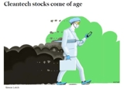](http://www.afr.com/markets/equity-markets/cleantech-stocks-come-of-age-20160608-gpeeov)[[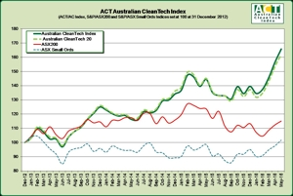](http://www.auscleantech.com.au/forms/australianindex.php)](http://www.auscleantech.com.au/forms/australianindex.php)

[*'Cleantch Stocks come of age'*](http://www.afr.com/markets/equity-markets/cleantech-stocks-come-of-age-20160608-gpeeov) - Australian Financial Review, June 2016  
  
[*Renewable Energy Stocks put in a Shining Performance*](http://www.auscleantech.com.au/PDF/other/press/160709-Australian%20Article2.pdf) - The Australian, July 2016  
  
[Clean tech stocks continue to outperform market](http://www.thefifthestate.com.au/articles/clean-tech-stocks-continue-to-outperform-market-or-why-no-one-is-listening-to-canberra/88461) - The Fifth Estate, February 2017

**2019-20 Index Performance Reports**

2Q19 DACT Performance Report  
[1Q19 DACT Performance Report](http://www.auscleantech.com.au/PDF/index/DACT/1909-DACT_Quarterly_Report-PUBLISHED.pdf)