**CEFC Case studies**

<https://www.cefc.com.au/case-studies/>

Bottom of Form

[[](https://www.cefc.com.au/case-studies/qualitas-launches-1-billion-fund-to-boost-sustainable-rental-stock-in-emerging-build-to-rent-market/)](https://www.cefc.com.au/case-studies/qualitas-launches-1-billion-fund-to-boost-sustainable-rental-stock-in-emerging-build-to-rent-market/)

[Housing, Property, National, Energy efficiency](https://www.cefc.com.au/case-studies/qualitas-launches-1-billion-fund-to-boost-sustainable-rental-stock-in-emerging-build-to-rent-market/)

[Qualitas launches $1 billion fund to boost sustainable rental stock in emerging build-to-rent market](https://www.cefc.com.au/case-studies/qualitas-launches-1-billion-fund-to-boost-sustainable-rental-stock-in-emerging-build-to-rent-market/)

[[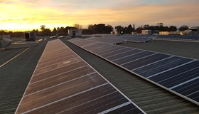](https://www.cefc.com.au/case-studies/stockland-chases-cleaner-greener-property-portfolio-in-bid-for-net-zero-emissions-by-2030/)](https://www.cefc.com.au/case-studies/stockland-chases-cleaner-greener-property-portfolio-in-bid-for-net-zero-emissions-by-2030/)

[Housing, Property, Sustainable Cities, National, Renewable energy](https://www.cefc.com.au/case-studies/stockland-chases-cleaner-greener-property-portfolio-in-bid-for-net-zero-emissions-by-2030/)

[Stockland chases cleaner, greener property portfolio in bid for net zero emissions by 2030](https://www.cefc.com.au/case-studies/stockland-chases-cleaner-greener-property-portfolio-in-bid-for-net-zero-emissions-by-2030/)

[[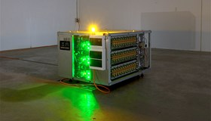](https://www.cefc.com.au/case-studies/relectrify-technology-extends-battery-life-and-reduces-battery-storage-costs/)](https://www.cefc.com.au/case-studies/relectrify-technology-extends-battery-life-and-reduces-battery-storage-costs/)

[Innovation Fund, Storage, National, Renewable energy](https://www.cefc.com.au/case-studies/relectrify-technology-extends-battery-life-and-reduces-battery-storage-costs/)

[Relectrify technology extends battery life and reduces battery storage costs](https://www.cefc.com.au/case-studies/relectrify-technology-extends-battery-life-and-reduces-battery-storage-costs/)

[[](https://www.cefc.com.au/case-studies/bank-australia-offers-discount-rates-to-people-who-buy-or-build-energy-efficient-homes/)](https://www.cefc.com.au/case-studies/bank-australia-offers-discount-rates-to-people-who-buy-or-build-energy-efficient-homes/)

[Property, National, Renewable energy, Low emissions, Energy efficiency](https://www.cefc.com.au/case-studies/bank-australia-offers-discount-rates-to-people-who-buy-or-build-energy-efficient-homes/)

[Bank Australia offers discount rates to people who buy or build energy efficient homes](https://www.cefc.com.au/case-studies/bank-australia-offers-discount-rates-to-people-who-buy-or-build-energy-efficient-homes/)

[[](https://www.cefc.com.au/case-studies/australia-s-second-energy-from-waste-plant-will-reduce-landfill-and-generate-more-clean-energy/)](https://www.cefc.com.au/case-studies/australia-s-second-energy-from-waste-plant-will-reduce-landfill-and-generate-more-clean-energy/)

[Bioenergy, Western Australia, Renewable energy](https://www.cefc.com.au/case-studies/australia-s-second-energy-from-waste-plant-will-reduce-landfill-and-generate-more-clean-energy/)

[Australia’s second energy from waste plant will reduce landfill and generate more clean energy](https://www.cefc.com.au/case-studies/australia-s-second-energy-from-waste-plant-will-reduce-landfill-and-generate-more-clean-energy/)

[[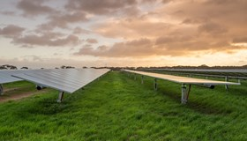](https://www.cefc.com.au/case-studies/infradebt-ethical-fund-focuses-on-smaller-renewable-energy-utilities/)](https://www.cefc.com.au/case-studies/infradebt-ethical-fund-focuses-on-smaller-renewable-energy-utilities/)

[Infrastructure, Solar, Wind, National, Renewable energy](https://www.cefc.com.au/case-studies/infradebt-ethical-fund-focuses-on-smaller-renewable-energy-utilities/)

[Infradebt Ethical Fund focuses on smaller renewable energy utilities](https://www.cefc.com.au/case-studies/infradebt-ethical-fund-focuses-on-smaller-renewable-energy-utilities/)

[[](https://www.cefc.com.au/case-studies/sustainability-features-help-new-calvary-adelaide-hospital-manage-energy-consumption/)](https://www.cefc.com.au/case-studies/sustainability-features-help-new-calvary-adelaide-hospital-manage-energy-consumption/)

[Property, Sustainable Cities, South Australia, Energy efficiency](https://www.cefc.com.au/case-studies/sustainability-features-help-new-calvary-adelaide-hospital-manage-energy-consumption/)

[Sustainability features help new Calvary Adelaide Hospital manage energy consumption](https://www.cefc.com.au/case-studies/sustainability-features-help-new-calvary-adelaide-hospital-manage-energy-consumption/)

[[](https://www.cefc.com.au/case-studies/solar-helps-juice-company-ease-the-squeeze-on-power-costs/)](https://www.cefc.com.au/case-studies/solar-helps-juice-company-ease-the-squeeze-on-power-costs/)

[Solar, New South Wales, Renewable energy](https://www.cefc.com.au/case-studies/solar-helps-juice-company-ease-the-squeeze-on-power-costs/)

[Solar helps juice company ease the squeeze on power costs](https://www.cefc.com.au/case-studies/solar-helps-juice-company-ease-the-squeeze-on-power-costs/)

[[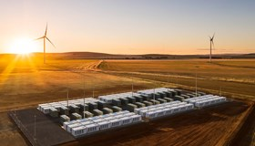](https://www.cefc.com.au/case-studies/neoen-expands-hornsdale-power-reserve-big-battery/)](https://www.cefc.com.au/case-studies/neoen-expands-hornsdale-power-reserve-big-battery/)

[Storage, South Australia, Renewable energy](https://www.cefc.com.au/case-studies/neoen-expands-hornsdale-power-reserve-big-battery/)

[Neoen expands Hornsdale Power Reserve big battery](https://www.cefc.com.au/case-studies/neoen-expands-hornsdale-power-reserve-big-battery/)

[[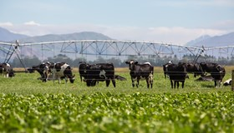](https://www.cefc.com.au/case-studies/tenacious-ventures-fund-seeds-clean-energy-ag-tech-potential/)](https://www.cefc.com.au/case-studies/tenacious-ventures-fund-seeds-clean-energy-ag-tech-potential/)

[Agriculture, Innovation Fund, National, Renewable energy, Low emissions, Energy efficiency](https://www.cefc.com.au/case-studies/tenacious-ventures-fund-seeds-clean-energy-ag-tech-potential/)

[Tenacious Ventures fund seeds clean energy ag tech potential](https://www.cefc.com.au/case-studies/tenacious-ventures-fund-seeds-clean-energy-ag-tech-potential/)

[[](https://www.cefc.com.au/case-studies/cefc-works-with-community-housing-providers-to-supply-energy-efficient-homes/)](https://www.cefc.com.au/case-studies/cefc-works-with-community-housing-providers-to-supply-energy-efficient-homes/)

[Housing, Sustainable Cities, New South Wales, Victoria, Energy efficiency](https://www.cefc.com.au/case-studies/cefc-works-with-community-housing-providers-to-supply-energy-efficient-homes/)

[CEFC works with Community Housing Providers to supply energy efficient homes](https://www.cefc.com.au/case-studies/cefc-works-with-community-housing-providers-to-supply-energy-efficient-homes/)

[[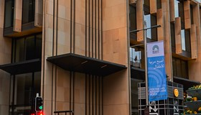](https://www.cefc.com.au/case-studies/sixty-martin-place-reaches-new-sustainability-heights/)](https://www.cefc.com.au/case-studies/sixty-martin-place-reaches-new-sustainability-heights/)

[Property, New South Wales, Energy efficiency](https://www.cefc.com.au/case-studies/sixty-martin-place-reaches-new-sustainability-heights/)

[Sixty Martin Place reaches new sustainability heights](https://www.cefc.com.au/case-studies/sixty-martin-place-reaches-new-sustainability-heights/)

[[](https://www.cefc.com.au/case-studies/pro-invest-shoots-for-5-star-hotels-with-a-difference/)](https://www.cefc.com.au/case-studies/pro-invest-shoots-for-5-star-hotels-with-a-difference/)

[Property, National, Renewable energy, Energy efficiency](https://www.cefc.com.au/case-studies/pro-invest-shoots-for-5-star-hotels-with-a-difference/)

[Pro-invest shoots for 5-star hotels with a difference](https://www.cefc.com.au/case-studies/pro-invest-shoots-for-5-star-hotels-with-a-difference/)

[[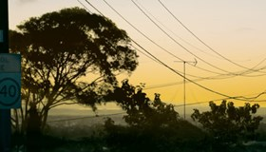](https://www.cefc.com.au/case-studies/australian-infrastructure-platform-targets-emissions-reductions/)](https://www.cefc.com.au/case-studies/australian-infrastructure-platform-targets-emissions-reductions/)

[Infrastructure, National, Renewable energy, Energy efficiency](https://www.cefc.com.au/case-studies/australian-infrastructure-platform-targets-emissions-reductions/)

[Australian infrastructure platform targets emissions reductions](https://www.cefc.com.au/case-studies/australian-infrastructure-platform-targets-emissions-reductions/)

[[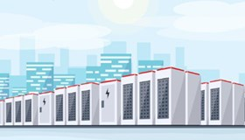](https://www.cefc.com.au/case-studies/finance-program-aims-to-boost-battery-storage/)](https://www.cefc.com.au/case-studies/finance-program-aims-to-boost-battery-storage/)

[Storage, National, Renewable energy](https://www.cefc.com.au/case-studies/finance-program-aims-to-boost-battery-storage/)

[Finance program aims to boost battery storage](https://www.cefc.com.au/case-studies/finance-program-aims-to-boost-battery-storage/)

[[](https://www.cefc.com.au/case-studies/cefc-injects-energy-efficiency-into-barwon-healthcare-portfolio/)](https://www.cefc.com.au/case-studies/cefc-injects-energy-efficiency-into-barwon-healthcare-portfolio/)

[Property, National, Energy efficiency](https://www.cefc.com.au/case-studies/cefc-injects-energy-efficiency-into-barwon-healthcare-portfolio/)

[CEFC injects energy efficiency into Barwon healthcare portfolio](https://www.cefc.com.au/case-studies/cefc-injects-energy-efficiency-into-barwon-healthcare-portfolio/)

[[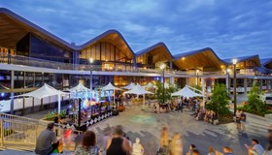](https://www.cefc.com.au/case-studies/qic-shopping-centres-use-world-first-green-bond-to-reduce-emissions-improve-sustainability/)](https://www.cefc.com.au/case-studies/qic-shopping-centres-use-world-first-green-bond-to-reduce-emissions-improve-sustainability/)

[Climate Bonds, National, Renewable energy, Energy efficiency](https://www.cefc.com.au/case-studies/qic-shopping-centres-use-world-first-green-bond-to-reduce-emissions-improve-sustainability/)

[QIC shopping centres use world-first green bond to reduce emissions, improve sustainability](https://www.cefc.com.au/case-studies/qic-shopping-centres-use-world-first-green-bond-to-reduce-emissions-improve-sustainability/)

[[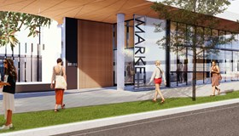](https://www.cefc.com.au/case-studies/curtin-university-exchange-development-to-deliver-on-sustainability/)](https://www.cefc.com.au/case-studies/curtin-university-exchange-development-to-deliver-on-sustainability/)

[Housing, Universities, Western Australia, Renewable energy, Energy efficiency](https://www.cefc.com.au/case-studies/curtin-university-exchange-development-to-deliver-on-sustainability/)

[Curtin University Exchange development to deliver on sustainability](https://www.cefc.com.au/case-studies/curtin-university-exchange-development-to-deliver-on-sustainability/)

[[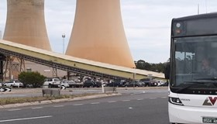](https://www.cefc.com.au/case-studies/new-hybrid-bus-fleet-helps-drive-change/)](https://www.cefc.com.au/case-studies/new-hybrid-bus-fleet-helps-drive-change/)

[Sustainable Cities, Transport, Victoria, Energy efficiency](https://www.cefc.com.au/case-studies/new-hybrid-bus-fleet-helps-drive-change/)

[New hybrid bus fleet helps drive change](https://www.cefc.com.au/case-studies/new-hybrid-bus-fleet-helps-drive-change/)

[[](https://www.cefc.com.au/case-studies/seniors-living-village-creates-a-new-model-of-sustainability/)](https://www.cefc.com.au/case-studies/seniors-living-village-creates-a-new-model-of-sustainability/)

[Housing, Property, Sustainable Cities, Australian Capital Territory, Renewable energy, Energy efficiency](https://www.cefc.com.au/case-studies/seniors-living-village-creates-a-new-model-of-sustainability/)

[Seniors’ living village creates a new model of sustainability](https://www.cefc.com.au/case-studies/seniors-living-village-creates-a-new-model-of-sustainability/)

[[](https://www.cefc.com.au/case-studies/warada-joint-venture-creates-integrated-developer-and-fund-manager/)](https://www.cefc.com.au/case-studies/warada-joint-venture-creates-integrated-developer-and-fund-manager/)

[Solar, Wind, National, Renewable energy, Energy efficiency](https://www.cefc.com.au/case-studies/warada-joint-venture-creates-integrated-developer-and-fund-manager/)

[Warada joint venture creates integrated developer and fund manager](https://www.cefc.com.au/case-studies/warada-joint-venture-creates-integrated-developer-and-fund-manager/)

[[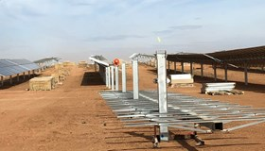](https://www.cefc.com.au/case-studies/major-solar-farm-for-victoria-uses-tech-to-boost-grid-offers-new-ppa-model/)](https://www.cefc.com.au/case-studies/major-solar-farm-for-victoria-uses-tech-to-boost-grid-offers-new-ppa-model/)

[Solar, Storage, Victoria, Renewable energy](https://www.cefc.com.au/case-studies/major-solar-farm-for-victoria-uses-tech-to-boost-grid-offers-new-ppa-model/)

[Major solar farm for Victoria uses tech to boost grid, offers new PPA model](https://www.cefc.com.au/case-studies/major-solar-farm-for-victoria-uses-tech-to-boost-grid-offers-new-ppa-model/)

[[](https://www.cefc.com.au/case-studies/australian-designed-energy-efficient-wi-fi-chips-to-boost-the-internet-of-things/)](https://www.cefc.com.au/case-studies/australian-designed-energy-efficient-wi-fi-chips-to-boost-the-internet-of-things/)

[Innovation Fund, National, Energy efficiency](https://www.cefc.com.au/case-studies/australian-designed-energy-efficient-wi-fi-chips-to-boost-the-internet-of-things/)

[Australian-designed energy efficient Wi-Fi chips to boost the Internet of Things](https://www.cefc.com.au/case-studies/australian-designed-energy-efficient-wi-fi-chips-to-boost-the-internet-of-things/)

[[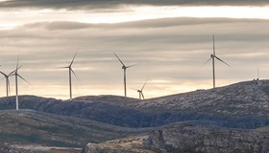](https://www.cefc.com.au/case-studies/technology-firsts-for-collector-wind-farm-in-nsw/)](https://www.cefc.com.au/case-studies/technology-firsts-for-collector-wind-farm-in-nsw/)

[Wind, New South Wales, Renewable energy](https://www.cefc.com.au/case-studies/technology-firsts-for-collector-wind-farm-in-nsw/)

[Technology firsts for Collector Wind Farm in NSW](https://www.cefc.com.au/case-studies/technology-firsts-for-collector-wind-farm-in-nsw/)

[[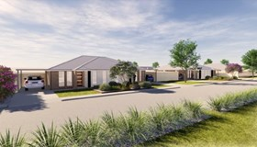](https://www.cefc.com.au/case-studies/low-income-families-in-regional-nsw-benefit-from-clean-energy-housing-program/)](https://www.cefc.com.au/case-studies/low-income-families-in-regional-nsw-benefit-from-clean-energy-housing-program/)

[Housing, Property, Sustainable Cities, New South Wales, Renewable energy, Energy efficiency](https://www.cefc.com.au/case-studies/low-income-families-in-regional-nsw-benefit-from-clean-energy-housing-program/)

[Low income families in regional NSW benefit from clean energy housing program](https://www.cefc.com.au/case-studies/low-income-families-in-regional-nsw-benefit-from-clean-energy-housing-program/)

Showing 24 of 141 case studies