# Five Australian scientific discoveries that changed the world

# <https://www.latrobe.edu.au/our-work/bacteria/scientific-discoveries-that-changed-the-world>



How have Australian scientists impacted modern society? From developing penicillin antibiotics to the bionic ear, Australian scientists have dramatically improved and saved the lives of millions worldwide.

We Aussies are a creative bunch. From the boomerang, fridge, ute and Hills Hoist to Aspro, wi-fi and Google Maps, we’re responsible for countless inventions used in everyday life worldwide.

More importantly, some of our scientists have changed history and dramatically improved – if not saved – the lives of millions worldwide with their discoveries. Here are five of the greatest.

## Penicillin-based antibiotics

Australian scientist Howard Walter Florey was awarded a Nobel Prize in 1945 for his role, alongside Ernest Chain and Alexander Fleming, in the development of penicillin.

Although Fleming is often credited with discovering penicillin, it was Florey who carried out the first clinical trials, demonstrating penicillin’s ability to fight bacterial infections. It’s estimated the trio’s discovery has saved around 200 million lives. Our longest-service Prime Minster, Sir Robert Menzies, called Florey ‘the most important man ever born in Australia’ in terms of ‘improving world well-being’.

## The Bionic Ear

La Trobe University’s Graeme Clarke successfully tested the bionic ear in 1978, which has since gifted over 200,000 deaf people with the power of hearing and speech. The bionic ear is a cochlear implant into the head, which captures sounds, coverts it to digital code and then electronically stimulates the auditory nerve to send the message to the brain where it can be interpreted.

Motivated by his father’s hearing difficulties, Clarke’s groundbreaking achievements garnered him three major scientific awards. He later established Australia’s first university training in audiology – the Bionic Ear Institute, which furthers research into bionic hearing, bionic vision and neurobionics to improve lives.

## Lithium medical treatment

Australian psychiatrist Dr John Frederick Joseph Cade revolutionised mental illness treatment when he discovered lithium carbonate as an effective mood stabiliser for bipolar disorder. Previous to Dr Cade’s 1948 discovery, the common treatment for psychosis was electroconvulsive therapy and lobotomy.

Dr Cade was recognised for his work in the 1970s, when he joined the Distinguished Fellow of American College of Psychiatrist, received the highest psychiatry honour and became an Officer of the Order of Australia.

## Ultrasound

In the 1950s, concern was growing around the effect of X-rays on pregnant women and their unborn babies. Working at the Department of Health, Australian’s David Robinson and George Kossoff built the first commercially practice ultrasound scanner in 1961, which completely changed the way medicine used ultrasound technology. Nowadays, ultrasound technology is used to diagnose problems of the breast, abdomen and reproductive organs as well as monitor the health and development of foetuses.

## Black box flight recorder

‘How or why did the plane crash?' This question largely remained a mystery until 1958, when chemist David Warren invented the durable black box flight recorder, which records flight data and cockpit conversations. If a plane comes down, the recordings of the black box could be used to work out the cause and to apply preventative measures to future aircrafts. Warren’s invention is now installed in every commercial plane in the world – of course, the device is now coloured orange, not black.

# 20 Australian inventions that changed the world

Australians can be an ingenious bunch. Here are some of the best inventions to have come out of the nation.

By AG staff • June 18, 2010

<https://www.australiangeographic.com.au/topics/history-culture/2010/06/australian-inventions-that-changed-the-world/>

## 1. Black box flight recorder

The black box flight recorder has helped make commercial air travel the world’s safest form of travel. It was [invented by Australian scientist Dr David Warren](http://www.australiangeographic.com.au/blogs/on-this-day/2016/03/on-this-day-the-black-box-was-born), who lost his own father to an aircraft tragedy in 1934 when the Miss Hobart crashed into the Bass Strait.

This remarkable device is virtually indestructible and records the final moments of a crashed plane’s last flight. While it is a box, it’s not black – it’s bright orange colour is called ‘international orange’, making it easier to find in crash-site rubble.

David Warren first had the black box idea in the 1950s when he was part of a Melbourne research team exploring why the commercial jet aircraft known as the Comet had suffered a series of deadly crashes. He thought it would help investigators fix what was wrong if they had a recording of the last conversations between crew and other sounds inside the plane before it crashed.

A black box is now installed on every commercial plane around the world, but it was in Australia that they were first made compulsory for all commercial flights.

## 2. Spray-on skin

In 1999, Perth-based plastic surgeon Professor Fiona Wood patented her spray-on skin technique. The innovation involves taking a small patch of the victim’s healthy skin and using it to grow new skin cells in a laboratory. The new skin cells are then sprayed on the victim’s damaged skin. This process significantly reduces recovery time and scarring.

Fiona and her spray-on skin technique played a key role in treating burns victims from the 2002 Bali bombings. Fiona and her team are credited with saving the lives of 28 people.

**RELATED:**[**Australia’s best innovators awarded**](http://www.australiangeographic.com.au/news/2014/05/australias-best-scientists-2014-clunies-ross)

## 3. Electronic pacemaker

Australian doctor Mark Lidwill and physicist Edgar Booth developed the first artificial pacemaker in the 1920s. Now, more than three million people worldwide rely on pacemakers to keep their hearts beating properly.

Artificial pacemakers send small electric charges into the heart to help it maintain a regular beat. Since the late 1960s, these have been implanted inside the body; the first of these was developed in Sydney by Lidwell and Booth. Lidwill used the invention in 1928 to revive a stillborn baby – small pulses of electicity were sent through a needle directly into the child’s heart. After 10 minutes, the equipment was switched off, the heart continued to beat and the infant made a full recovery.

## 4. Google Maps

Danish brothers Lars and Jens Rasmussen developed the platform for Google Maps in Sydney in the early 2000s. Along with Australians Neil Gordon and Stephen Ma, they founded a small start-up company called Where 2 Technologies in 2003. The following year it was bought by internet giant Google, which also hired the four men, and the technology was turned into what we now know as Google Maps.

## 5. Medical application of penicillin

In 1939, Australian scientist Howard Florey purified penicillin from a special strain of mould. The team demonstrated penicillin’s ability to fight bacterial infection in mice and, later, humans. The antibiotic was mass produced and used to aid victims of World War II. Penicillin has been used around the world saving many lives through the combating of infection by common bacteria. Today, it is still widely used in combating infections, but its efficacy is at risk from the growing resistance to the antibiotic.

**RELATED:**[**Australia’s Nobel Prize winners**](http://www.australiangeographic.com.au/topics/science-environment/2015/08/australias-nobel-prize-winners)

## 6. Polymer bank notes

Plastic bank notes were developed in a combined effort by the Reserve Bank of Australia and CSIRO in the 1980s. The first plastic bank note to be put into circulation was the $10 note, released in 1988 to celebrate the bicentenary. In 1996, we became the first country to have a complete set of plastic currency.

Traditionally, bank notes are made from paper, cloth fibres or a combination of both. Our bank notes are made from a special polymer which, along with a series of in-built security devices, makes them almost impossible to counterfeit. They also last about 10 times longer than traditional bank notes.

**RELATED:**[**The new $5 note**](http://www.australiangeographic.com.au/news/2016/04/were-getting-a-new-$5-note)

## 7. Cochlear implant (bionic ear)

Professor Graeme Clark invented the first bionic ear Melbourne University in the 1970s – the first prototype was implanted in a person in 1978.

Cochlear implants are devices that are implanted into the head to electronically stimulate the auditory nerve. Graeme’s motivation to advance hearing loss technology was spawned from his own father’s inadequate hearing. So far, the Cochlear implant has brought hearing to more than 180,000 deaf and partially deaf people worldwide.

## 8. Electric drill

DIY-enthusiasts can thank an Aussie for this indispensible piece of equipment. In 1889, Australian electrical engineer Arthur James Arnot patented the world’s first electric drill with his colleague William Brain. The invention was originally designed to drill rock and dig coal, and although it was a long way from the portable hand-drills used today throughout the world, the underlyng technology was the same.

## 9. Winged keel

Ben Lexcen, an Australian yachtsman and marine architect, invented the winged keel – a nearly horizontal foil, or wing, at the base of a sailing boat keel. They are typically found on high-performance sail boats. The winged keel made its debut in [1983 in America’s Cup on Australia II](http://www.australiangeographic.com.au/topics/history-culture/2013/09/looking-back-the-1983-americas-cup-win).

## 10. Permaculture

In 1972, Bill Mollison had the epiphany which led to the development of permaculture, a concept that uses a natural approach to designing self-sufficient human settlements and agricultural systems.

Today permaculture is an alternative to chemical-based agriculture which can be harmful to humans and the environment

## 11. Wi-Fi technology

In 1992 John O’ Sullivan and the CSIRO developed Wi-Fi technology, used by more than a billion people around the world today. The core parts of the technology came out of research in the mid-1970s in the field of radio astronomy, when John and his colleagues at the CSIRO were originally looking for the faint echoes of black holes.

As a result of this work, the CSIRO has held key patents for Wi-Fi technology since the mid-1990s, bringing the organisation millions of dollars in royalties every year.

**RELATED:** [**Wi-Fi creator CSIRO wins $220m lawsuit**](http://www.australiangeographic.com.au/news/2012/04/wi-fi-creator-csiro-wins-$220m-law-suit-)

## 12. Ultrasound scanner

In 1976 Ausonics commercialised the ultrasound scanner. Studying ultrasound from 1959 onwards, the Ultrasonics Research Section of the Commonwealth Acoustrics Laboratories Branch (later to become the Ultrasonic Institute) discovered a way to differentiate ultrasound echoes bouncing off soft tissue in the body and converting them to TV images. This discovery forever changed pre-natal care as it gave expecting parents a window to the foetus without x-ray exposure. Ultrasound technology is also used in the diagnoses of medical problems of the breast, abdomen, and reproductive organs.

## 13. Plastic spectacle lenses

In 1960 Sola Optical released the first scratch-resistant plastic lens for glasses. The technology was further developed to create the first plastic bifocal, trifocal, and progressive-focus lenses. Plastic lenses are used throughout the world due to their many benefits including safety, their light weight, and durability.

## 14. Inflatable escape slide and raft

In 1965 Jack Grant, an employee of Qantas, invented the inflatable aircraft escape slide, which is now mandatory safety equipment on all major airlines. The slides can also be used as a flotation device if the aircraft lands on water.

**RELATED:**[**On this day: The birth of Qantas**](http://www.australiangeographic.com.au/blogs/on-this-day/2015/11/on-this-day-the-birth-of-qantas)

## 15. Permanent-crease clothing

In 1957, CSIRO developed a process called Si-Ro-Set. The technique uses chemicals to permanently alter the structure of wool fibres so they can be set with heat. This technology allowed for fashion innovations such as permanently pleated skirts.

**RELATED:** [**100 years of CSIRO**](http://www.australiangeographic.com.au/blogs/on-this-day/2016/03/on-this-day-100-years-of-the-csiro)

## 16. Gardasil and Cervarix cancer vaccines

In 2006, Brisbane-based medical researchers Professor Ian Frazer and Dr Jian Zhou developed the world’s first anti-cancer vaccine. Known by the commercial name, Gardasil, the vaccine protects women against four strains of a virus called human papillomavirus (HPV), known to cause three-quarters of all cervical cancers. As cervical cancer is the second-leading cause of cancer death in women, the vaccination has huge implications for the prevention of cancer. Since 2008, the vaccine has been approved for use in more than 120 countries.

## 17. Frazier lens

In 1993, Australian inventor Jim Frazier’s deep-focus lens was patented in the United States. His innovative lens allowed for both the subject and background to be in focus at the same time. It also has the ability to rotate without the movement of the camera. The lens is now commonly used in movies and film throughout the world. Jim won an Academy Award in 1998 for his contribution.

**RELATED:** [**Innovation is the Australian way**](http://www.australiangeographic.com.au/topics/science-environment/2010/12/innovation-is-the-australian-way)

## 18. Triton Workcentre

In 1976, a 27-year-old television journalist named George Lewin appeared on ABC TV’s The Inventors program with his new invention, the Triton Workcentre. The day after the show, his multi-purpose workbench which stabilises and improves the accuracy of portable power tools had more than 1000 orders. It is estimated that 10 per cent of Australian households with a garage now have a Triton Workcentre.

## 19. Racecam

In 1979, Channel 7 introduced live television broadcasting from racing cars, allowing viewers to watch the race from the driver’s perspective. Today the Racecam has been adapted to fit other sporting events such as snow skiing, basketball and cricket.

## 20. Tank-bred tuna system

In 2008, German-born but South Australian-based Hagen Stehr may have saved the southern blue fin tuna from extinction. The clean-seas system fools the tuna in a tank into thinking they are swimming out of the Australian Bight and into their breeding grounds.

[](https://www.csiro.au/)

# Our top 10 inventions

<https://www.csiro.au/en/About/History-achievements/Top-10-inventions>

Last updated: 30 April 2019

From household products like Aerogard and Softly to everyday necessities like plastic bank notes and WiFi, here are our top ten CSIRO inventions.

Over nearly a century, we’ve been improving the lives of people everywhere with our inventions. We’ve listed our Top Ten here, but you can find a more extensive inventory in our [CSIROpedia](http://www.csiropedia.csiro.au/display/CSIROpedia/Home).

## 1. WiFi



Our wireless invention lies at the heart of what is now the most popular way to connect computers without wires. It is used in offices, public buildings, homes and coffee shops - often called 'WiFi Hotspots'. The invention came out of our pioneering work in radioastronomy.

That work involved complex mathematics known as 'fast Fourier transforms' as well as detailed knowledge about radio waves and their behaviour in different environments. Indoor environments are particularly difficult for the rapid exchange of large amounts of data using radio waves.

We solved these problems in a unique way at a time when many of the major communications companies around the world were trying, but with less success, to solve the same problem.

## 2. Plastic banknotes

A polymer prototype: the CSIRO $7 banknote.

Australia's introduction of plastic bank notes with optically variable devices (OVDs), developed by CSIRO, was a world's first and represented a paradigm shift towards a currency secure against forgery. This was one of our longest  and most successful research initiatives.

The research began in 1968 following a request from the Reserve Bank of Australia for a scientific solution to combat forgeries of the new decimal currency. Our solution was to have a see-through panel and hologram embedded in the note and to use plastic. In addition to their inability to be forged, the new notes were also more durable, more environmentally friendly and less likely to carry dirt and disease.

## 3. Equivac HeV: Hendra virus vaccine

From 1994-2010 14 clusters of Hendra virus infection were recorded in horses.  ©lillisphotography

Equivac® HeV was the first vaccine to protect Australian horse owners and the equine industry against the deadly Hendra virus. The Hendra virus that was first identified in horses in 1994 is a Bio-Safety Level-4 disease agent, which is the most dangerous level in the world. CSIRO isolated and identified the virus within two weeks of it being reported.

In May 2011 CSIRO announced a prototype vaccine, and along with its collaborators, launched the Equivac® HeV vaccine in November 2012. By March 2013 CSIRO scientists confirmed that horses were immune to a lethal exposure of the Hendra virus six months post vaccination.

## 4. Extended wear contact lenses

Extended wear soft contact lenses can be worn at night.

We developed contact lenses that can be worn for a month at a time as part of an international collaboration in 1991. Popular for their convenience and versatility, consumers wanted contact lenses they could leave in for much longer periods of time. The challenge was creating a material that allowed oxygen to flow through the contact lens to the cornea, allowing the eye to stay healthy.

So our scientists Gorden Meijs and Hans Griesser joined with the University of New South Wales, American contact lens company CIBA Vision and Swiss healthcare company Novartis to develop materials and associated intellectual property for successful extended wear soft contact lenses. The research resulted in the development of CIBA Vision's Focus Night & Day™ (FND) lenses. These lenses, made from a silicone hydrogel called Lotrafilcon A, are suitable for safe continuous 30 day and night wear.

## 5. Aerogard



A biting midge, one of the many insects repelled by Aerogard.

Insect repellent Aerogard has been keeping flying pests at bay since the 1960s. Flies, mosquitoes and other winged insects are not just irritating, they can carry diseases and infect both animals and humans. In 1938, our scientist Doug Waterhouse was working on a repellent to tackle the sheep blowfly, but with the arrival of World War II, he turned his attention to protecting allied troops from mosquitoes.

By 1943, his repellent (referred to by the troops as 'Mary'), had been widely deployed across the Pacific. But it wasn’t until 1963 that the life-saving formula became a household name, when Queen Elizabeth II used the spray before a game of golf, and enjoyed a swat-free game. Australian insecticide company Mortein asked us for the formula, and soon Mortein’s Aerogard was the must-have item at every Australian BBQ.

## 6. Total Wellbeing Diet

Prawn salad from The Total Wellbeing Diet.

The [Total Wellbeing Diet](https://www.totalwellbeingdiet.com/) is a science-based, practical and healthy eating guide in a landscape of diets without scientific foundation. Diets have always gone in and out of fashion, but a rise in the promotion of high protein diets without a reliable body of evidence led a team of our scientists to take up the challenge. As a leading authority in dietary research, our Clinical Research Unit in Adelaide developed a higher protein, low-fat diet that’s nutritious, facilitates sustainable weight loss and is supported by scientific evidence.

Published by Penguin in 2005, The CSIRO Total Wellbeing Diet offers an easy-to-follow structured eating pattern and includes mainstream foods. It's a way to eat less, but eat well without feeling hungry, because it provides the necessary vitamins and nutrients (including dietary fibre).

## 7. RAFT polymerisation

RAFT is a polymerisation technology invented by CSIRO.  ©Stewart Donn

RAFT polymerisation is a new technique for creating plastics that allows a higher degree of control over the way molecules link together. Plastics are essential elements of modern life, created through the process of polymerisation to give them a range of different attributes. CSIRO scientists Ezio Rizzardo, Graeme Moad, San Thang and their colleagues in free radical polymerisation developed a new way of controlling the way plastics are formed to give more control over the end product.

The process is called Reversible Addition-Fragmentation chain Transfer, or RAFT polymerisation. We’ve partnered with global science company DuPont to commercialise the technology, with more than 50 companies already filing more than 200 patents that depend on RAFT polymerisation for applications ranging from adhesives, hydraulic fluids and membranes to cosmetics, biosensors and drug delivery. One of the first commercial applications of RAFT technology is a next-generation environmentally-friendly paint with enhanced flow, adhesion, abrasion resistance and durability which we’re developing with a leading Australian chemical manufacturer.

## 8. BARLEYmax

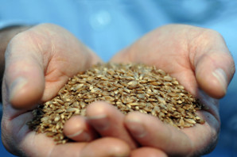

BARLEYmax is high in fibre, particularly resistant starch.

BARLEYmaxTM is an extra nutritious strain of barley, created by regenerating a specific barley grain that had just the right nutritional elements. As Australians increasingly consume a highly processed, low nutrient diet, we began profiling the nutritional benefits of different grains to identify those with the most nutritional value.

After isolating a particular grain of barley with a rare combination of desirable traits, we used GM-free, traditional breeding processes to harvest a crop of a super breed of barley, and so BARLEYmaxTM was born. Boasting four times the resistant starch and twice the dietary fibre of regular grains, the low GI supergrain is now used in a range of commercially available food products, as well as being recognised by international health bodies.

## 9. Self-twisting yarn

CSIRO's patented Repco self-twist spinning machine.

Self-twisting yarn is a process engineered to speed up the rate wool can be spun into yarn, without breaking the wool or reducing the strength of the yarn. The process of spinning wool into yarn is a centuries old craft, with a technique that had barely changed since the invention of the Spinning Jenny in 1764. But on a rainy day in Geelong, Victoria in 1961, our scientist David Henshaw unravelled the challenge that had tied others up in knots.

The speed of spinning had been limited by the strength of the wool, which would break when unspun lengths were twisted around each other faster than 10,000 revolutions per minute. Henshaw developed a process where lengths of unspun wool would be twisted on themselves, not each other, then paired them up and released, with the energy in their twists triggering them to wrap around each other without breaking. The yarn they eventually created was just as strong as conventional yarn, but because only a small section of the wool needed to be rotated to create the twist, they could be spun at virtually limitless speeds. The first generation of new spinning machines, created with manufacturer Repco Ltd, increased the output of yarn from 20 metres a minute to 220 metres and decreased the size of the machine by 80%. In 1970 the Repco Spinner won the Prince Philip Prize for industrial design.

## 10. Softly washing liquid

pH neutral detergent prevents wool being damaged during washing at higher temperatures.

Softly detergent was the first formula to successfully wash wool at high temperatures, killing bacteria while not shrinking the wool. As a nation riding the sheep’s back, wool products were a staple across Australia, including in our hospitals and healthcare system. But the wool industry was threatened when a medical journal published a report in the 1950s suggesting that woollen blankets harboured disease because they couldn’t be washed at high temperatures, triggering proposals that hospitals switch to cotton blankets instead.

Our scientist, Tom Pressley, partnered with the Royal Melbourne Hospital’s Central Linen Service to find a solution. Not only did Pressley develop a high standard procedure for shrink-proofing wool so it could be laundered at high temperatures, he pioneered a pH neutral detergent that would clean the wool without causing damage at high water temperatures. In the 1960s, the detergent was taken up by hygiene and personal care company Unilver, which marketed it as Softly®, a brand that sits on supermarket shelves to this day.

# 25 Famous Australian Scientists and their Contributions

<https://www.famousscientists.org/25-famous-australian-scientists-contributions/>

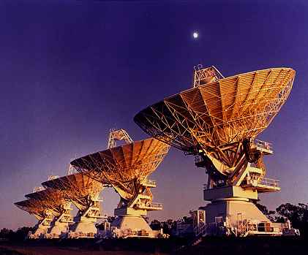

The development of [Australian science](http://www.science.org.au/) in pre-war era was dependent on the individual achievements of a few famous scientists. Several of the famous Australian scientists went abroad for better facilities, better payoffs and more recognition.

Throughout the last two decades, this situation has drastically changed. Appealing rewards have been given to Australian scientists, and research facilities have been greatly improved. What’s more, the great reputation of Australian scientific work is pulling in many foreign scientifics as well.

Today’s article talks about the most famous Australian scientists and inventors throughout history and their extraordinary contributions.

### Elizabeth Blackburn



Biological researcher who helped discover an enzyme called telomerase.

### Isobel Bennett



Marine biologist and prolific author; also known for helping William John Dakin with his book Australian Seashores.

### Dorothy Hill



Geologist and researcher; best known for being the first female professor at an Australian university.

### William Lawrence Bragg and William Henry Bragg

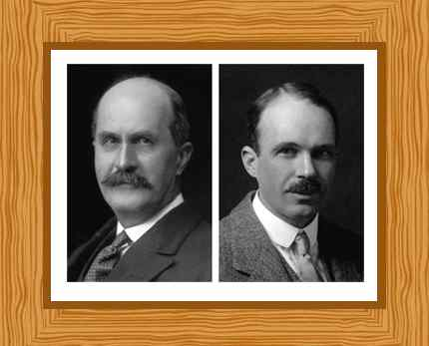

Father and son who successfully constructed the first X-ray spectroscope, revolutionizing the study of X-ray crystallography.

### Frank Macfarlane Burnet

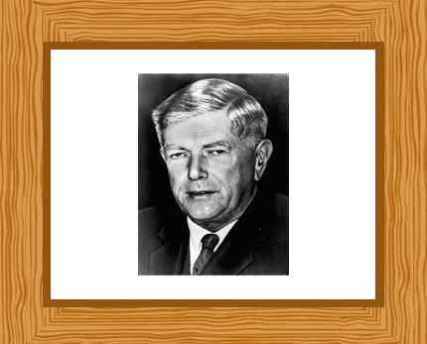

Virologist highly regarded for his contributions to immunology.

### Graeme Clark



Doctor and researcher who helped develop the Bionic Ear.

### Ian Clunies Ross



Highly influential scientist who is also known as the “architect of Australia’s scientific boom”.

### Peter C. Doherty



Veterinary surgeon known for his research in the field of medicine.

### John Eccles

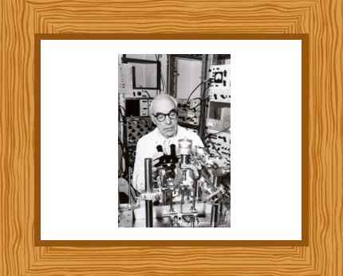

Neurophysiologist who won the 1963 Nobel Prize in Physiology or Medicine for his research on the synapse; the junction between two neurons or a neuron and a muscle.

### Frank Fenner



Virologist known for his work on the prevention of smallpox and the rabbit plague by introducing the Myxoma virus.

### Fred Hollows



Ophthalmologist known for his extraordinary work that helped in restoring eyesight of thousands of people.

### Bernard Katz

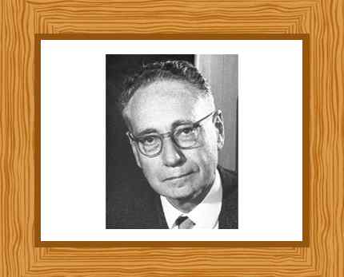

Biophysicist and Nobel laureate known for his work on nerve biochemistry.

### Priscilla Kincaid-Smith



Physician noted for her research work in nephrology.

### Douglas Mawson

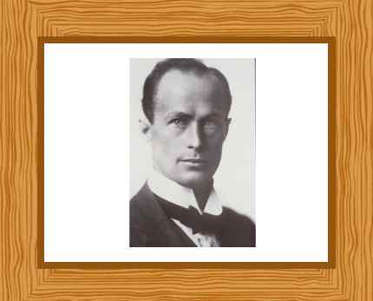

Geologist and explorer who led the Heroic Age of Antarctic Exploration.

### Mark Oliphant

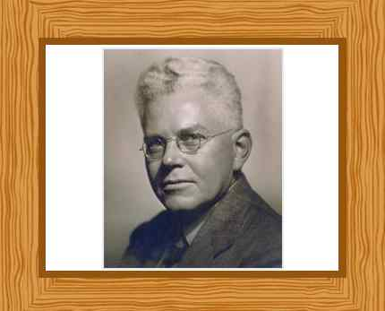

Physicist noted for his work that led to the first public demonstration of nuclear fusion.

### Henry Harris



Professor and researcher noted for his work on cancer and human genetics.

### David Karoly



Researcher known for his work on climate change, stratospheric ozone depletion.

### Bruce Edward Hobbs



Structural geologist and a research fellow at the Commonwealth Scientific and Industrial Research Organisation.

### Basil Hetzel



Nutritionist and researcher known for his work on combating iodine deficiency.

### Alf Howard



Researcher and explorer who is the last surviving participants of the expedition to Antarctica in 1929-1931.

### John R. Philip



Soil physicist highly regarded for his research work on the movement of water, energy and gases.

### Albert Pugsley



Agricultural scientist and highly influential wheat breeder.

### John O. Limb



Engineer and researcher who helped develop digital video communications.

### W. A. S. Butement



Defence scientist best known for his extraordinary contributions in the development of radar in England during World War II.

[](https://stories.scienceinpublic.com.au/)

# [Stories of Australian Science](https://stories.scienceinpublic.com.au/)

# <https://stories.scienceinpublic.com.au/print-editions/>

* [Collections](https://stories.scienceinpublic.com.au/collections/)
  + [Stories of Australian Science](https://stories.scienceinpublic.com.au/stories-of-australian-science/)
    - [2017](https://stories.scienceinpublic.com.au/2017/intro-contents/)
    - [2016](https://stories.scienceinpublic.com.au/stories-of-australian-science-2016/)
    - [2015](https://stories.scienceinpublic.com.au/stories-of-australian-science-2015/)
    - [2014](https://stories.scienceinpublic.com.au/stories-of-australian-science-2014/)
    - [Stories of Australian Astronomy 2012](https://stories.scienceinpublic.com.au/astronomy/)
    - [2012](https://stories.scienceinpublic.com.au/science-2012/)
    - [2011](https://stories.scienceinpublic.com.au/science-2011/)
    - [2010](https://stories.scienceinpublic.com.au/science-2010/)
    - [2007](https://stories.scienceinpublic.com.au/science-2007/)
  + [Stories of European-Australian Research](https://stories.scienceinpublic.com.au/2019/european-australian-innovation/)
  + [Tomorrow’s medicine starts today – Stem Cells Australia](https://stories.scienceinpublic.com.au/2019/tomorrows-medicine-starts-today/)
  + [Stories of French-Australian Innovation](https://stories.scienceinpublic.com.au/2019/fr-contents/)
  + [Australia-Indonesia collaboration](https://stories.scienceinpublic.com.au/indonesia/)
  + [Australia-Japan collaboration](https://stories.scienceinpublic.com.au/japan/)
  + [Australia-China collaboration](https://stories.scienceinpublic.com.au/china/)
  + [US-Australian collaboration](https://stories.scienceinpublic.com.au/usa/)
    - [Innovation today means jobs and prosperity tomorrow](https://stories.scienceinpublic.com.au/usa/overview-innovation-today-means-jobs-and-prosperity-tomorrow/)
    - [Delivering sustainable agriculture and biosecurity](https://stories.scienceinpublic.com.au/usa/delivering-sustainable-agriculture-and-biosecurity/)
    - [Slivers of sun: clean energy and smarter mining](https://stories.scienceinpublic.com.au/usa/slivers-of-sun-clean-energy-and-smarter-mining/)
    - [Science collaboration improves health](https://stories.scienceinpublic.com.au/usa/science-collaboration-improves-health/)
    - [Understanding and responding to changing climate](https://stories.scienceinpublic.com.au/usa/understanding-and-responding-to-changing-climate/)
    - [Traveling at Mach 5: Defense and materials science in action](https://stories.scienceinpublic.com.au/usa/traveling-at-mach-5-defense-and-materials-science-in-action/)
    - [Searching the southern sky, and unchaining the internet](https://stories.scienceinpublic.com.au/usa/searching-the-southern-sky-and-unchaining-the-internet/)
    - [The Australian science and technology system](https://stories.scienceinpublic.com.au/usa/the-australian-science-and-technology-system/)
* [Magazines (PDF)](https://stories.scienceinpublic.com.au/print-editions/)
* [About Us](https://stories.scienceinpublic.com.au/about-us/)
  + [Publication credits](https://stories.scienceinpublic.com.au/about-us/credits/)

# Print versions in PDF format

You can download a pdf of the print version of each of our storybooks.

To read them offline on a tablet, you’ll need a pdf reader like [iBooks](http://itunes.apple.com/au/app/ibooks/id364709193?mt=8) or [Adobe Reader](http://itunes.apple.com/au/app/adobe-reader/id469337564?mt=8).

These files are all under 6MB.

|  |  |  |
| --- | --- | --- |
| [http://1txw3b19wbsr2ibrbg12rbd6-wpengine.netdna-ssl.com/wp-content/uploads/Aus-China-Collaboration-Factsheet-Thumbnail.jpg](https://1txw3b19wbsr2ibrbg12rbd6-wpengine.netdna-ssl.com/wp-content/uploads/6847-China-Fact-Sheets-LR.pdf)Australia-China Collaboration Factsheets 2019 | *[This image has an empty alt attribute; its file name is EU-Stories-Cover.jpg](https://1txw3b19wbsr2ibrbg12rbd6-wpengine.netdna-ssl.com/wp-content/uploads/6867-Stories-of-European-Australian-Research-LR.pdf)*Stories of European-Australian Research | *[This image has an empty alt attribute; its file name is Stem-Cells-Aus-Cover.jpg](https://1txw3b19wbsr2ibrbg12rbd6-wpengine.netdna-ssl.com/wp-content/uploads/6918-Stem-Cells-Australia-Science-Stories-LR.pdf)*Tomorrow’s medicine starts today |
| *[http://1txw3b19wbsr2ibrbg12rbd6-wpengine.netdna-ssl.com/wp-content/uploads/French-Storybook-Cover-Small.png](http://1txw3b19wbsr2ibrbg12rbd6-wpengine.netdna-ssl.com/wp-content/uploads/6901-Stories-of-French-Australian-Innovation-LR.pdf)*Stories of French-Australian Innovation | *[http://1txw3b19wbsr2ibrbg12rbd6-wpengine.netdna-ssl.com/wp-content/uploads/2017-front-snip-2-212x300.jpg](http://1txw3b19wbsr2ibrbg12rbd6.wpengine.netdna-cdn.com/wp-content/uploads/6758-Australian-Science-Stories-2017-online.pdf)*Stories of Australian Science 2017 | *[http://1txw3b19wbsr2ibrbg12rbd6-wpengine.netdna-ssl.com/wp-content/uploads/Indonesia-storybook-cover-small.png](http://1txw3b19wbsr2ibrbg12rbd6-wpengine.netdna-ssl.com/wp-content/uploads/6736-Stories-of-Australia-Indonesia-Innovation-2016_for-online.pdf)*Stories of Australia-Indonesia Innovation |
| *[http://1txw3b19wbsr2ibrbg12rbd6-wpengine.netdna-ssl.com/wp-content/uploads/Stories-2016-212x300.jpg](http://1txw3b19wbsr2ibrbg12rbd6-wpengine.netdna-ssl.com/wp-content/uploads/6636-Stories-of-Australian-Science-2016_web.pdf)*Stories of Australian Science 2016 | *[http://1txw3b19wbsr2ibrbg12rbd6-wpengine.netdna-ssl.com/wp-content/uploads/cover-215x300.jpg](https://1txw3b19wbsr2ibrbg12rbd6-wpengine.netdna-ssl.com/wp-content/uploads/6531-JapanAustralia-Fact-Sheets-web-format.pdf)*Australia-Japan Factsheets 2015 | *[http://1txw3b19wbsr2ibrbg12rbd6-wpengine.netdna-ssl.com/wp-content/uploads/Capture-212x300.jpg](http://1txw3b19wbsr2ibrbg12rbd6-wpengine.netdna-ssl.com/wp-content/uploads/6529-Stories-of-Australian-Science-2015-web-final.pdf)*Stories of Australian Science 2015 |
| *[http://1txw3b19wbsr2ibrbg12rbd6-wpengine.netdna-ssl.com/wp-content/uploads/Stories-of-Aus-Science-2014.png](http://1txw3b19wbsr2ibrbg12rbd6-wpengine.netdna-ssl.com/wp-content/uploads/6279-Stories-of-Australian-Science-2014.pdf)*Stories of Australian Science 2014 | *[http://1txw3b19wbsr2ibrbg12rbd6-wpengine.netdna-ssl.com/wp-content/uploads/Stories-of-Aus-Science-2012-thumb.jpg](https://1txw3b19wbsr2ibrbg12rbd6-wpengine.netdna-ssl.com/wp-content/uploads/Stories-of-Aus-Science-2012.pdf)*Stories of Australian Science 2012 | *[astronomypdfthumbnail](http://1txw3b19wbsr2ibrbg12rbd6-wpengine.netdna-ssl.com/wp-content/uploads/5421-SP-Australian-Astronomy-2012.pdf)*Stories of Australian Astronomy 2012 |
| *[USA-Australia Factsheets PDF](https://1txw3b19wbsr2ibrbg12rbd6-wpengine.netdna-ssl.com/wp-content/uploads/USA-Australia-Factsheets-1-8.pdf)*USA-Australia Factsheets 2011 | *[stories-2011-thumbnail](http://1txw3b19wbsr2ibrbg12rbd6-wpengine.netdna-ssl.com/wp-content/uploads/5832-SP-Aus-Science-Stories-20111.pdf)*Stories of Australian Science 2011 | *[Thirty years of Australia-China scientific cooperation](https://1txw3b19wbsr2ibrbg12rbd6-wpengine.netdna-ssl.com/wp-content/uploads/Australia-China-book-for-upload-1.pdf)*Thirty years of Australia-China scientific cooperation |
| *[stories2010_pdf](http://1txw3b19wbsr2ibrbg12rbd6-wpengine.netdna-ssl.com/wp-content/uploads/Stories-of-Australian-Science-2010.pdf)*Stories of Australian Science 2010 | *[wcsjstories2007_pdf](http://1txw3b19wbsr2ibrbg12rbd6-wpengine.netdna-ssl.com/wp-content/uploads/australian-science-stories-wcsj2007.pdf)*Stories of Australian Science 2007 | *More stories coming soon*More stories coming soon |

Science drives innovation and economic, social and cultural change.

It’s at the heart of the innovations that transform the human condition: vaccines, smart phones, flight and clean energy.

It tells us how our world is changing, and what we can do about it, if we choose to.

It reveals where we, our world, our galaxy, and our Universe came from, and where we’re going.

Stories of Australian Science celebrates discoveries and the people behind them.

Read, share, and use our [hundreds of stories](http://stories.scienceinpublic.com.au/collections/) of Australian Science plus special collections of collaborative work with [China](http://stories.scienceinpublic.com.au/china/), [Japan](http://stories.scienceinpublic.com.au/japan/), [USA](http://stories.scienceinpublic.com.au/usa/), [Indonesia](http://stories.scienceinpublic.com.au/indonesia/), [France](http://stories.scienceinpublic.com.au/2019/fr-contents/), [Europe](https://stories.scienceinpublic.com.au/2019/european-australian-innovation/) and more.  
[](http://www.scienceinpublic.com.au/)

# @AusSciStories on Twitter

# Science in Public

# Browse by state

# Browse by country

# Browse by field of science

# Browse by organisation



[Proudly powered by WordPress](http://wordpress.org/)

# About Us

This compilation of stories illustrating the diversity of Australian science is produced by Science in Public.

[Science in Public](http://www.scienceinpublic.com/blog/) is a science communication company based in Melbourne, Australia. We help scientists and science organisations present their ideas in public space.

We thank the many science organisations who have contributed to Stories. If you would like more information, please use the links and contact details at the end of each story.

#### Our story collection

This site showcases the stories found in our print editions of [*Stories of Australian Science*](http://stories.scienceinpublic.com.au/), our special Stories of Australian Astronomy 2012 magazine, two other publications we’ve done for the Commonwealth Department of Innovation and our stories of Australia’s international collaborations.

Our story collection comprises:

* Australia-China Collaboration fact sheets 2019
* Stories of European-Australian Research (2019)
* Tomorrow’s Medicine Starts Today (Stem Cells Australia, 2019)
* Stories of French-Australian Innovation (2019)
* Stories of Australian Science 2017
* Stories of Australia-Indonesia Innovation (2016)
* Stories of Australian Science 2016
* Stories of Australian Science 2015
* Australia-Japan collaboration fact sheets (2015)
* Stories of Australian Science 2014
* Stories of Australian Science 2012
* Stories of Australian Astronomy 2012
* Stories of Australian Science 2011
* US-Australian Innovation fact sheets: Transforming lives and economies together (2011)
* Stories of Australian Science 2010
* Thirty years of Australia-China scientific cooperation (2010)
* Stories of Australian Science 2007

Within this site you can browse the publications, search on key terms and categories, and download pdfs for print or ipad. Use the Online or PDF menu tabs above to explore our stories.

#### **History**

Stories has grown from our first collection, written in 2007  when journalists met in Melbourne for the 5th World Conference of Science Journalists. Since 2010, we’ve published an annual magazine featuring highlights of Australian Science. They are distributed to contributing agencies and interested Australian government departments and delegations worldwide.

We publish occasional special editions: Stories of Australian Astronomy was an astronomy-themed storybook produced in conjunction with the International Year of Astronomy and the Australian Department of Innovation Industry, Science and Research (DIISR).



# Science and Research Priorities

<https://www.arc.gov.au/grants/grant-application/science-and-research-priorities>

The Australian Government has identified nine Science and Research Priorities and associated Practical Research Challenges. The priorities, developed in consultation with leaders from industry, research and government, are designed to focus Australian Government support for science and research on the most important challenges facing Australia.

The current Science and Research Priorities are:

* Food
* Soil and Water
* Transport
* Cybersecurity
* Energy
* Resources
* Advanced Manufacturing
* Environmental Change
* Health

Each priority is associated with three to four Practical Research Challenges, which aim to guide investment and activity in areas where the Government considers Australia must maintain a strong research and innovation capability.

### **ARC’s role**

The ARC supports the highest-quality fundamental and applied research and research training across all disciplines, including research that is not related to priority areas.

The ARC supports research under the Science and Research Priorities by asking applicants for funding to indicate whether their research proposal relates to one of the priorities and, where relevant, assessing the potential of research proposals to contribute to the priorities.

The ARC reports on the proportion of ARC-funded projects that relate to the Science and Research Priorities.

More information about each of the Science and Research Priorities, and details of the associated Practical Research Challenges, can be found at the [Industry.gov.au website](https://www.industry.gov.au/data-and-publications/science-and-research-priorities).

# CSIRO Our research

<https://www.csiro.au/en/Research>

We are Australia's national science organisation and one of the largest and most diverse scientific research organisations in the world. Our research focuses on the biggest challenges facing the nation. We also manage national research infrastructure and collections.

[](https://www.csiro.au/)

[Skip to content](https://www.csiro.au/en/Research#maincontent) [Skip to search](https://www.csiro.au/en/Research#searchbutton)

* [Home](https://www.csiro.au/en)
* [About](https://www.csiro.au/en/About)
* [Careers](https://www.csiro.au/en/Careers)
* [Events](https://events.csiro.au/)
* [Locations](https://www.csiro.au/en/Locations)
* [Contact](https://www.csiro.au/en/Contact)
* [Our research](https://www.csiro.au/en/Research)
* [Industry solutions](https://www.csiro.au/en/Do-business)
* [Education](https://www.csiro.au/en/Education)
* [Publications](https://www.csiro.au/en/Publications)
* [News](https://www.csiro.au/en/News)
* [Blog](https://blog.csiro.au)

[Show search form](https://www.csiro.au/en/Research)

# Our research

* [Home](https://www.csiro.au/)

[Contact us](https://www.csiro.au/en/Research)

We are Australia's national science organisation and one of the largest and most diverse scientific research organisations in the world. Our research focuses on the biggest challenges facing the nation. We also manage national research infrastructure and collections.

## Browse by subject

[[](https://www.csiro.au/en/Research/Animals-and-plants)](https://www.csiro.au/en/Research/Animals-and-plants)

## [Animals and plants](https://www.csiro.au/en/Research/Animals-and-plants)

[From our broad range of collections down to specific case studies on animals, plants and ecosystems, we're studying a range of Australian animals and plants to better understand, protect and strengthen our rich biodiversity.](https://www.csiro.au/en/Research/Animals-and-plants)

[[](https://www.csiro.au/en/Research/Environment/Extreme-Events/Bushfire)](https://www.csiro.au/en/Research/Environment/Extreme-Events/Bushfire)

## [Bushfire](https://www.csiro.au/en/Research/Environment/Extreme-Events/Bushfire)

[As the national science agency, CSIRO (and forerunner agencies) has been leading research to understand and predict the behaviour and spread of bushfires since the 1950s.](https://www.csiro.au/en/Research/Environment/Extreme-Events/Bushfire)

[[](https://www.csiro.au/en/Research/AI)](https://www.csiro.au/en/Research/AI)

## [Artificial intelligence](https://www.csiro.au/en/Research/AI)

[As Australia’s national science agency, we have world-leading capabilities in artificial intelligence.](https://www.csiro.au/en/Research/AI)

[[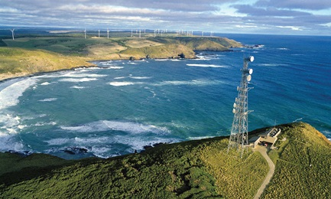](https://www.csiro.au/en/Research/Climate)](https://www.csiro.au/en/Research/Climate)

## [Climate](https://www.csiro.au/en/Research/Climate)

[Climate change is a major challenge for Australia, our region and the world. Find out how our world-leading climate knowledge and services are addressing this challenge, enabling a sustainable, resilient and productive future for Australia.](https://www.csiro.au/en/Research/Climate)

[[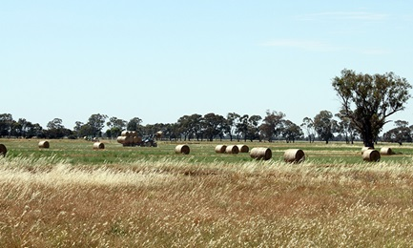](https://www.csiro.au/en/Research/Drought-resilience)](https://www.csiro.au/en/Research/Drought-resilience)

## [Drought resilience](https://www.csiro.au/en/Research/Drought-resilience)

[CSIRO has a range of technologies and capabilities that can improve drought resilience and assist with drought response.](https://www.csiro.au/en/Research/Drought-resilience)

[[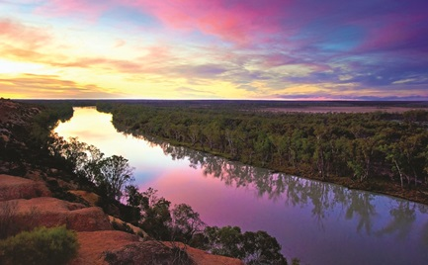](https://www.csiro.au/en/Research/Environment)](https://www.csiro.au/en/Research/Environment)

## [Environment](https://www.csiro.au/en/Research/Environment)

[From our oceans and coasts, landscapes and inland waters, to our atmosphere and climate, CSIRO research is helping to maintain the integrity of our environments and ensure our natural resources are used sustainably.](https://www.csiro.au/en/Research/Environment)

[[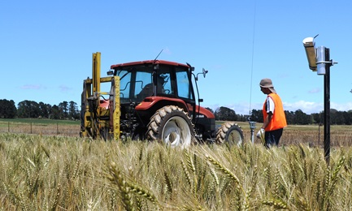](https://www.csiro.au/en/Research/Farming-food)](https://www.csiro.au/en/Research/Farming-food)

## [Farming and food production](https://www.csiro.au/en/Research/Farming-food)

[Our diverse food and farming research ranges from studying the make-up of our crops and animals to the methods and food processing technologies we develop to produce healthier, safer and more sustainable food.](https://www.csiro.au/en/Research/Farming-food)

[[](https://www.csiro.au/en/Research/Health)](https://www.csiro.au/en/Research/Health)

## [Health](https://www.csiro.au/en/Research/Health)

[We're working to prevent illnesses, develop a better understanding of diseases, and improve treatment and recovery in a range of medical conditions to help people live healthier lives.](https://www.csiro.au/en/Research/Health)

[[](https://www.csiro.au/en/Indigenous-engagement)](https://www.csiro.au/en/Indigenous-engagement)

## [Indigenous engagement](https://www.csiro.au/en/Indigenous-engagement)

[Aboriginal and Torres Strait Islander peoples are making extraordinary contributions to Australia across cultural, economic and scientific domains.](https://www.csiro.au/en/Indigenous-engagement)

[[](https://www.csiro.au/en/Research/Technology)](https://www.csiro.au/en/Research/Technology)

## [Information technology](https://www.csiro.au/en/Research/Technology)

[From smartphone apps and robotics, to wearable technology and next gen wireless, we're providing innovative information technology solutions that are helping to secure Australia's digital future.](https://www.csiro.au/en/Research/Technology)

[[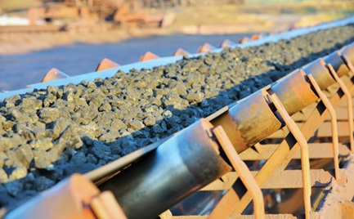](https://www.csiro.au/en/Research/Mining-manufacturing)](https://www.csiro.au/en/Research/Mining-manufacturing)

## [Mining and manufacturing](https://www.csiro.au/en/Research/Mining-manufacturing)

[Mining and manufacturing that is innovative, productive, competitive and sustainable is vital to Australia’s current and future prosperity. This section highlights some of our key advances in the mining and manufacturing sectors.](https://www.csiro.au/en/Research/Mining-manufacturing)

[[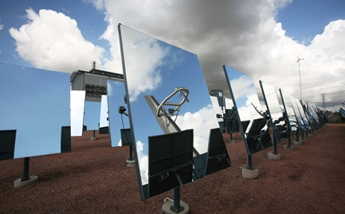](https://www.csiro.au/en/Research/Energy)](https://www.csiro.au/en/Research/Energy)

## [Renewables and energy](https://www.csiro.au/en/Research/Energy)

[Australia’s growth and way of life is underpinned by access to affordable and sustainable energy sources. Find out more about our diverse portfolio of research.](https://www.csiro.au/en/Research/Energy)

[[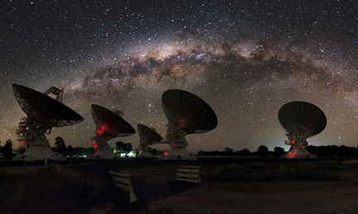](https://www.csiro.au/en/Research/Astronomy)](https://www.csiro.au/en/Research/Astronomy)

## [Astronomy and space](https://www.csiro.au/en/Research/Astronomy)

[We have a long and successful history in the space sector from radio astronomy research, managing complex facilities and observing Earth from above to supporting data and manufacturing supply chains.](https://www.csiro.au/en/Research/Astronomy)

## Browse by Business Unit

[[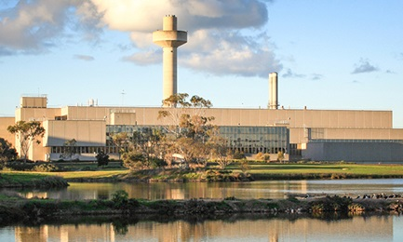](https://www.csiro.au/en/Research/Facilities/AAHL)](https://www.csiro.au/en/Research/Facilities/AAHL)

## [AAHL](https://www.csiro.au/en/Research/Facilities/AAHL)

[AAHL helps protect Australia’s multi-billion dollar livestock and aquaculture industries, and the general public, from emerging infectious disease threats.](https://www.csiro.au/en/Research/Facilities/AAHL)

[[](https://www.csiro.au/en/Research/AF)](https://www.csiro.au/en/Research/AF)

## [Agriculture and Food](https://www.csiro.au/en/Research/AF)

[Our research is helping to improve productivity, profitability and sustainability in cropping, livestock production, aquaculture, horticulture and the food industry.](https://www.csiro.au/en/Research/AF)

[[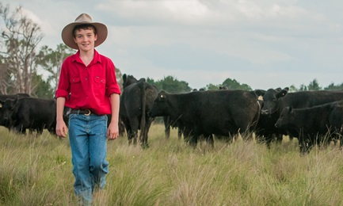](https://www.csiro.au/en/Research/BF)](https://www.csiro.au/en/Research/BF)

## [Health and Biosecurity](https://www.csiro.au/en/Research/BF)

[CSIRO's Health and Biosecurity works to deliver innovation that will help maintain and protect the health and prosperity of Australia’s growing population, the agricultural industries that help sustain us, and the unique environment in which we live.](https://www.csiro.au/en/Research/BF)

[[](http://data61.csiro.au/)](http://data61.csiro.au/)

## [Data61](http://data61.csiro.au/)

[Our world is changing, fast, and data is the basic currency of this new world. Data61 is Australia’s leading digital research network, we’re here to help you create your data-driven future.](http://data61.csiro.au/)

[[](https://www.csiro.au/en/Research/EF)](https://www.csiro.au/en/Research/EF)

## [Energy](https://www.csiro.au/en/Research/EF)

[Pioneering technologies to create a smart, secure and sustainable energy future](https://www.csiro.au/en/Research/EF)

[[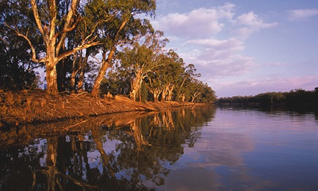](https://www.csiro.au/en/Research/LWF)](https://www.csiro.au/en/Research/LWF)

## [Land and Water](https://www.csiro.au/en/Research/LWF)

[We work with our partners to deliver innovative solutions to the complex challenges that arise from the demands and impacts of human activities on the environment.](https://www.csiro.au/en/Research/LWF)

[[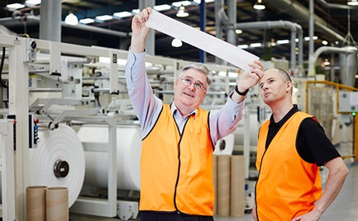](https://www.csiro.au/en/Research/MF)](https://www.csiro.au/en/Research/MF)

## [Manufacturing](https://www.csiro.au/en/Research/MF)

[We're helping Australian manufacturers change focus from heavy industry to high tech products based on sustainable, advanced manufacturing processes.](https://www.csiro.au/en/Research/MF)

[[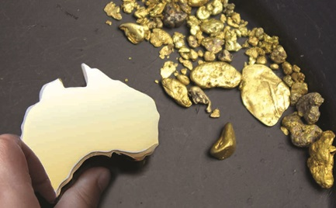](https://www.csiro.au/en/Research/MRF)](https://www.csiro.au/en/Research/MRF)

## [Mineral Resources](https://www.csiro.au/en/Research/MRF)

[We're delivering breakthrough innovation to create a more productive, sustainable and globally competitive mineral resources industry for the benefit of Australia and the world.](https://www.csiro.au/en/Research/MRF)

[[](https://www.csiro.au/en/Research/OandA)](https://www.csiro.au/en/Research/OandA)

## [Oceans and Atmosphere](https://www.csiro.au/en/Research/OandA)

[Oceans and Atmosphere provides the knowledge to manage Australia's marine estate and atmospheric environment.](https://www.csiro.au/en/Research/OandA)

## Facilities and collections

[[](https://www.csiro.au/en/Research/Collections/ALA)](https://www.csiro.au/en/Research/Collections/ALA)

## [Atlas of Living Australia](https://www.csiro.au/en/Research/Collections/ALA)

[As Australia's national biodiversity database, the ALA provides free, online access to a vast repository of information about Australia's amazing biodiversity.](https://www.csiro.au/en/Research/Collections/ALA)

[[](https://www.csiro.au/en/Research/Facilities/AAHL)](https://www.csiro.au/en/Research/Facilities/AAHL)

## [Biocontainment facility](https://www.csiro.au/en/Research/Facilities/AAHL)

[AAHL helps protect Australia’s multi-billion dollar livestock and aquaculture industries, and the general public, from emerging infectious disease threats.](https://www.csiro.au/en/Research/Facilities/AAHL)

[[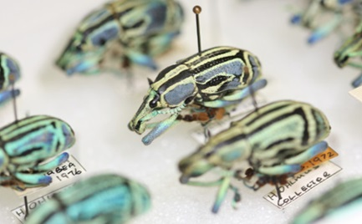](https://www.csiro.au/en/Research/Collections)](https://www.csiro.au/en/Research/Collections)

## [National Collections](https://www.csiro.au/en/Research/Collections)

[We manage a number of collections of animal and plant specimens that provides vital information and resources about Australia's biodiversity.](https://www.csiro.au/en/Research/Collections)

[[](https://www.csiro.au/en/Research/Technology/Scientific-computing)](https://www.csiro.au/en/Research/Technology/Scientific-computing)

## [Scientific computing](https://www.csiro.au/en/Research/Technology/Scientific-computing)

[We’re using high performance computing and eResearch services to tackle big challenges in fields such as atmospheric modelling, satellite data, geoscience and astronomy.](https://www.csiro.au/en/Research/Technology/Scientific-computing)

[[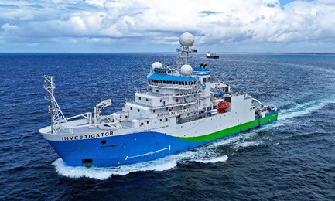](https://www.csiro.au/en/Research/Facilities/MNF)](https://www.csiro.au/en/Research/Facilities/MNF)

## [RV Investigator](https://www.csiro.au/en/Research/Facilities/MNF)

[Australia’s Marine National Facility is a blue-water research capability, funded by the Australian Government and operated by CSIRO.](https://www.csiro.au/en/Research/Facilities/MNF)

[[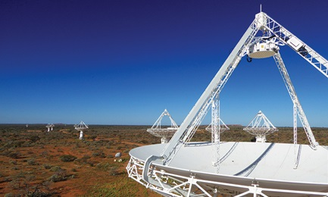](https://www.csiro.au/en/Research/Facilities/ATNF/ASKAP)](https://www.csiro.au/en/Research/Facilities/ATNF/ASKAP)

## [ASKAP](https://www.csiro.au/en/Research/Facilities/ATNF/ASKAP)

[A world-leading telescope in its own right, our new ASKAP radio telescope is also allowing us to test technologies for the much larger Square Kilometre Array.](https://www.csiro.au/en/Research/Facilities/ATNF/ASKAP)

[[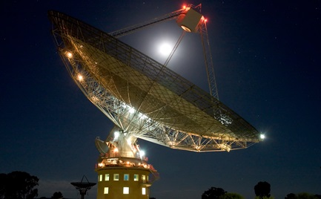](https://www.csiro.au/en/Research/Facilities/ATNF/Parkes-radio-telescope)](https://www.csiro.au/en/Research/Facilities/ATNF/Parkes-radio-telescope)

## [The Dish](https://www.csiro.au/en/Research/Facilities/ATNF/Parkes-radio-telescope)

[Parkes Observatory, just outside the central-west NSW town of Parkes, hosts the 64-metre Parkes radio telescope, one of the telescopes comprising CSIRO’s Australia Telescope National Facility.](https://www.csiro.au/en/Research/Facilities/ATNF/Parkes-radio-telescope)



# Science in our department

<https://www.industry.gov.au/about-us/what-we-do/science-in-our-department>

The government supports and invests in a wide array of science‑related activities.

Our department:

* leads the coordination of science policy across government portfolios, councils and committees
* administers science programs and manages projects
* engages with science stakeholder groups and the community on Australia's science priorities, programs and initiatives

## Our science policies, programs and projects

* [National Science Statement](https://www.industry.gov.au/data-and-publications/australias-national-science-statement): the government’s long-term strategic policy for science in Australia
* [Science and Research Priorities](https://www.industry.gov.au/data-and-publications/science-and-research-priorities): areas of immediate and critical importance to Australia and its place in the world
* [Science, technology, engineering and mathematics (STEM)](https://www.industry.gov.au/strategies-for-the-future/science-technology-engineering-and-mathematics-stem): increasing community-wide participation and engagement in STEM
* [Inspiring Australia](https://www.industry.gov.au/funding-and-incentives/science-and-research/inspiring-australia-science-engagement-in-australia): provides grants, prizes and coordinates national science engagement networks
* [Square Kilometre Array](https://www.industry.gov.au/strategies-for-the-future/co-hosting-the-square-kilometre-array): a collaborative international project to build the world’s most powerful radio telescope
* [National Innovation and Science Agenda (NISA)](https://www.industry.gov.au/strategies-for-the-future/boosting-innovation-and-science): initiatives across departments and agencies to boost innovation and science
* [Funding and incentives for science and research](https://www.industry.gov.au/funding-and-incentives/): measures to support international collaboration and science engagement in Australia

See the full list of activities and strategies in our [Corporate Plan under Supporting science and commercialisation](https://www.industry.gov.au/topic/about-us/what-we-do/corporate-plan/corporate-plan-2017-18/purpose-1-supporting-science-and).

## Our science centres and agencies

Our department is part of the [Industry, Science, Energy and Resources](https://www.industry.gov.au/about-us/our-structure/our-portfolio) which includes science organisations.

* [Questacon](https://www.questacon.edu.au/) is a specialist division of the department that promotes understanding and awareness of science and technology.
* [Australian Nuclear Science and Technology Organisation (ANSTO)](http://www.ansto.gov.au/) conducts research and development across nuclear science and technology activities.
* The [Australian Space Agency](https://www.industry.gov.au/strategies-for-the-future/australian-space-agency) works to transform and grow Australia’s space industry.
* The [Commonwealth Scientific and Industrial Research Organisation (CSIRO)](https://www.csiro.au/) supports industry needs through research activities.
* The [Australian Institute of Marine Science (AIMS)](https://www.aims.gov.au/docs/about/about.html) conducts tropical marine research to inform governments, industry and the community.
* [Geoscience Australia](http://www.ga.gov.au/) provides geoscience information, services and capability to government, industry and stakeholders.
* The [National Measurement Institute](https://www.measurement.gov.au/Pages/default.aspx) is the peak Australian organisation, responsible for biological, chemical, legal, physical and trade measurement.

## Science advisor

We host [Australia’s Chief Scientist](http://www.chiefscientist.gov.au/) who provides high-level independent advice to the Prime Minister and ministers on matters relating to science, technology and innovation.

## Councils and committees

We provide secretariat support to the:

* [National Science and Technology Council](https://www.chiefscientist.gov.au/national-science-and-technology-council/): provides strategic advice to government on science and technology issues
* [National Climate Science Advisory Committee](https://www.industry.gov.au/about-us/what-we-do/national-climate-science-advisory-committee): provides strategic direction for Australian climate science research

## Science policy coordination

We work with departments across the government on science-related issues and policy, including the:

* Department of Agriculture, Water and the Environment
* Department of Defence
* Department of Education, Skills and Employment
* Department of Foreign Affairs and Trade
* Department of Health
* Department of the Prime Minister and Cabinet, including the Office for Women

We coordinate with science agencies, including the:

* Australian Bureau of Agricultural and Resource Economics and Sciences
* Australian Research Council
* Bureau of Meteorology
* Defence Science and Technology Organisation
* National Health and Medical Research Council

# Co-hosting the Square Kilometre Array

<https://www.industry.gov.au/strategies-for-the-future/astronomy/co-hosting-the-square-kilometre-array>

The Square Kilometre Array (SKA) is a global big-science project to build the world’s largest and most capable radio telescope. During its more than 50 year lifetime, the SKA will expand our understanding of the universe and drive technological developments worldwide.

The project is in the pre-construction phase.

## A global collaboration

Australia and South Africa will each host SKA telescopes. The [SKA Organisation](https://www.skatelescope.org/) leads the global project. It is headquartered in the United Kingdom and comprises organisations from 13 countries.

The [Australian SKA Office](https://www.industry.gov.au/about-us/what-we-do/australian-ska-office) coordinates Australia’s involvement in the SKA project through the [Australian-New Zealand SKA Coordinating Committee](https://www.industry.gov.au/strategies-for-the-future/australia-new-zealand-ska-coordination-committee).

Find out more or [read the transcript](https://www.industry.gov.au/data-and-publications/video-the-ska-a-new-observatory-to-explore-the-universe)

## Hosting the SKA

The [Murchison Radio-astronomy Observatory (MRO)](https://www.csiro.au/en/Research/Astronomy/ASKAP-and-the-Square-Kilometre-Array/MRO) will host the low frequency part of the telescope, [SKA-Low](https://www.skatelescope.org/australia/). South Africa will host the mid frequency component, [SKA-Mid](https://www.skatelescope.org/africa/). The Commonwealth Scientific and Industrial Research Organisation (CSIRO) operates the MRO. The SKA-Low will be spread across an area spanning 65km and will consist of 130,000 antennas.

The SKA site is:

* located in remote Western Australia, around 800km north of Perth
* situated on part of the ancestral lands of the Wajarri Yamaji people
* ideally positioned in the [Australian Radio Quiet Zone WA](https://www.industry.gov.au/strategies-for-the-future/co-hosting-the-square-kilometre-array/the-australian-radio-quiet-zone-wa) to protect the SKA from radio interference from electronic devices

Take a [virtual tour of the Australia SKA site](https://www.icrar.org/outreach-education/mrovt/).

The Wajarri Yamaji have played an important role in enabling Australia to co-host the SKA. The Australian SKA Office and CSIRO are working with the Wajarri Yamaji to negotiate a land use agreement to access the site and realise the SKA Project on Wajarri Yamaji country.

## Designing the SKA

Groups from all around the world are working together to design and deliver the telescope infrastructure.

The [Global Design Consortia is tasked with designing specific components](https://www.skatelescope.org/skadesign/) of the telescope.

SKA [precursor telescopes](https://www.skatelescope.org/precursors-pathfinders-design-studies/) are testing technologies and informing the design of the SKA:

* CSIRO operates the [Australian SKA Pathfinder telescope (ASKAP)](https://www.csiro.au/en/Research/Facilities/ATNF/ASKAP?ref=/CSIRO/Website/Research/Astronomy/ASKAP-and-the-Square-Kilometre-Array/ASKAP).
* An international collaboration of universities and research institutions, led by [Curtin University](https://astronomy.curtin.edu.au/research/mwa/), operates the [Murchison Widefield Array](http://mwatelescope.org/).

These are powerful telescopes in their own right and are already making discoveries.

## SKA science goals

The SKA aims to answer some of the biggest questions in astronomy. Its unparalleled sensitivity, resolution and scanning speed will enable scientific discoveries in key areas:

* Galaxy evolution, cosmology and dark energy - why is the universe expanding?
* Gravity in pulsars and black holes - does Einstein's general relativity hold in the most extreme areas of the universe?
* The cosmic dawn - what did the young universe look like?
* Life beyond earth - if life is out there, what does it look like?

Read more about [SKA science goals on the SKA Organisation website](https://www.skatelescope.org/science/).

## Driving new technologies

Radio astronomy has led to the development of new technologies with applications in important fields such as computer science, medical imaging, and advanced manufacturing. Similarly, the SKA is expected to generate spin-off technologies with broad applications.

Astronomers will analyse SKA data to realise the SKA science goals. The unprecedented flow of data from the antennas will require supercomputing power surpassing today’s best technology. The [Pawsey Supercomputing Centre](https://www.pawsey.org.au/research/the-square-kilometre-array/) in Western Australia will house the facility.

Read about [SKA technology on the SKA Organisation website](https://www.skatelescope.org/technology/).

## Australian investment in science infrastructure

Government investment in next-generation science infrastructure is ensuring Australia continues to make world-class discoveries and collaborates on major international science projects.

The government [announced $294 million for the Square Kilometre Array](https://www.minister.industry.gov.au/ministers/pyne/media-releases/agenda-transform-australian-economy), as part of the National Innovation and Science Agenda (NISA) in December 2015.

## Case studies from Australian companies

Australian companies have contributed to the design of the SKA, construction of precursor telescopes, or engaged in spin-off applications of existing infrastructure.

Read the cases studies:

* [Astronomers and Silentium Defence are using the MWA to detect and track satellites and space junk](https://www.industry.gov.au/data-and-publications/ska-precursor-helps-track-objects-in-australian-skies) to evaluate the risk of collisions.
* The [International Centre for Radio Astronomy Research (ICRAR) is investigating Cloud computing](https://www.industry.gov.au/data-and-publications/cloud-computing-for-square-kilometre-array-data) for SKA data storage and processing capabilities.
* [Balance Unity Solutions is working to deliver the power requirements](https://www.industry.gov.au/data-and-publications/powering-the-ska-low-frequency-aperture-array) for the Low Frequency Aperture Array component of the SKA.
* [Innovation Composites and CSIRO designed receiver casings](https://www.industry.gov.au/data-and-publications/designing-receiver-casings-ska-pathfinder) for Australia’s SKA Pathfinder telescope that are lighter and more cost-effective the previous designs.
* [CSIRO worked with Puzzle Precision to produce circuit boards and major components](https://www.industry.gov.au/data-and-publications/producing-components-for-australias-ska-pathfinder-digital-systems) for Australia’s SKA Pathfinder digital systems.
* [CSIRO worked with Thermacore, via local agents, to prototype a groundplane](https://www.industry.gov.au/data-and-publications/prototyping-a-groundplane-for-the-australian-ska-pathfinder) for maintaining a low and stable temperature for the ASKAP Phased Array Feed.

## Read more

* [Read SKA project news and astronomy updates](https://www.industry.gov.au/square-kilometre-array-project-news)
* Find astronomy jobs on the [SKA head office job board](https://recruitment.skatelescope.org/) or [European Southern Observatory recruitment portal](https://recruitment.eso.org/)

## Connect with us

* Subscribe to our [Astronomy in Australia Newsletter from Astronomer-at-large Fred Watson](https://www.industry.gov.au/strategies-for-the-future/astronomy/subscribe-to-astronomy-updates)
* Follow us on Twitter [@SKA\_Australia](https://twitter.com/SKA_Australia)
* Join the [Australasian Square Kilometre Array Industry Cluster for project updates, networking and other opportunities](https://www.industry.gov.au/join-the-australasian-square-kilometre-array-industry-cluster)

## Contact us

Email [ska@industry.gov.au](mailto:ska@industry.gov.au)

## See also

* Read how we are [transforming the optical astronomy sector](https://www.industry.gov.au/strategies-for-the-future/astronomy-and-space-projects/optical-astronomy-in-australia)
* [Australia’s National Science Statement](https://www.industry.gov.au/data-and-publications/australias-national-science-statement) sets a long-term approach to achieving a strong science system.

## Related news

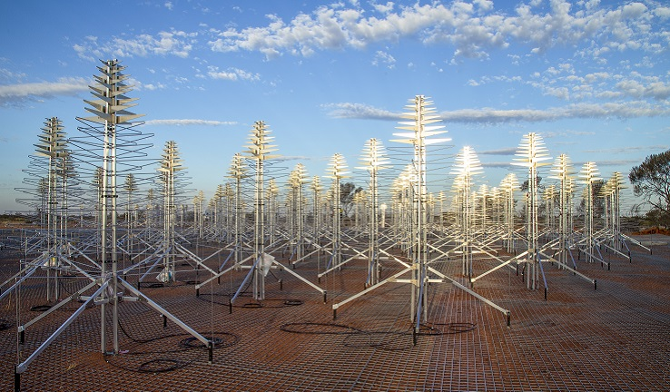

[SKA Project Director's Update - March 2020](https://www.industry.gov.au/news-media/square-kilometre-array-project-news/ska-project-directors-update-march-2020)

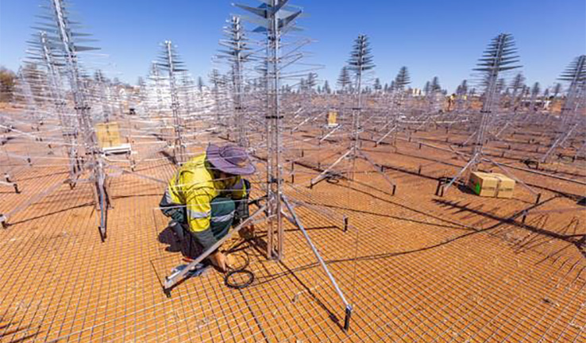

[Australian SKA Project Director's Update – December 2019](https://www.industry.gov.au/news-media/square-kilometre-array-project-news/australian-ska-project-directors-update-december-2019)

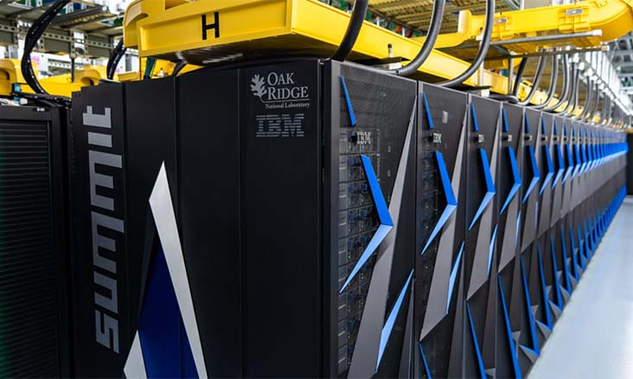

[SKA gathers speed](https://www.industry.gov.au/news-media/square-kilometre-array-project-news/ska-gathers-speed)



Last updated: 16 April 2020

# Boosting innovation and science

<https://www.industry.gov.au/strategies-for-the-future/boosting-innovation-and-science>

Embracing innovation, technology and science is critical to powering our economy to provide jobs and high living standards for all Australians.

The National Innovation and Science Agenda (NISA) sets a focus on science, research and innovation as long-term drivers of economic prosperity, jobs and growth. The [Minister announced the NISA on 7 December 2015](http://www.minister.industry.gov.au/ministers/pyne/media-releases/agenda-transform-australian-economy), committing $1.1 billion over four years to 24 measures. The NISA complements a broader government investment in science, research and innovation.

## National Innovation and Science Agenda report

[Read the full Agenda report](https://www.industry.gov.au/national-innovation-and-science-agenda-report) to find out more about the policy and research underpinning the Agenda.

The Agenda focuses on four key pillars:

* Taking the leap: backing Australian entrepreneurs by opening up new sources of finance, embracing risk, taking on innovative ideas, and making more of our public research.
* Working together: increasing collaboration between industry and researchers to find solutions to real world problems and to create jobs and growth.
* Best and brightest: developing and attracting world-class talent for the jobs of the future.
* Leading by example: the Australian Government will lead by example; embracing innovation and agility in the way we do business.

## Initiatives

* [Advancing quantum computing technology](http://www.cqc2t.org/)
* [Assessing the engagement and impact of university research](https://www.arc.gov.au/nisa-measures)
* [Attracting talent through reforms to Employee Share Schemes](https://www.ato.gov.au/General/Employee-share-schemes/)
* [Biomedical Translation Fund to commercialise promising discoveries](https://www.business.gov.au/assistance/venture-capital/biomedical-translation-fund)
* [Business Research and Innovation Initiative](https://www.industry.gov.au/funding-and-incentives/business-and-start-ups/business-research-and-innovation-initiative)
* [Changes to Venture Capital Limited Partnerships](https://treasury.gov.au/national-innovation-and-science-agenda/new-arrangements-for-venture-capital-limited-partnerships/)
* [CSIRO Innovation Fund to commercialise early stage innovations](https://www.csiro.au/en/news/news-releases/2018/csiro-innovation-fund-boosts-jobs-and-innovation)
* [CSIRO ON accelerator programme](http://oninnovation.com.au/)
* [Cyber Security Growth Centre](https://www.industry.gov.au/strategies-for-the-future/growth-centres)
* [Data sharing for innovation](https://www.pmc.gov.au/resource-centre/public-data/australian-government-public-data-policy-statement)
* [Data61: Australia’s digital and data innovation group](https://www.data61.csiro.au/)
* [Digital Marketplace](https://marketplace.service.gov.au/)
* [Embracing the digital age](https://www.education.gov.au/support-science-technology-engineering-and-mathematics)
* [Global Innovation Strategy](https://www.industry.gov.au/strategies-for-the-future/increasing-international-collaboration)
* [Improving insolvency laws to encourage innovation](https://treasury.gov.au/consultation/national-innovation-and-science-agenda-improving-bankruptcy-and-insolvency-laws/)
* [Increasing access to company losses](https://treasury.gov.au/national-innovation-and-science-agenda/increasing-access-to-company-losses/)
* [Incubator Support initiative](https://www.business.gov.au/assistance/entrepreneurs-programme)
* [Innovation and Science Australia](https://www.industry.gov.au/about-us/our-structure/office-of-innovation-and-science-australia)
* [Innovation Connections: connecting industry to innovation infrastructure](https://www.business.gov.au/Assistance/Entrepreneurs-Programme/Innovation-Connections)
* Innovation in agriculture and regional areas
* [Inspiring all Australians in science, technology, engineering and mathematics](https://www.education.gov.au/support-science-technology-engineering-and-mathematics)
* [Inspiring Australians - Science Engagement Programme](https://www.business.gov.au/assistance/inspiring-australia-science-engagement)
* Intangible asset depreciation (this measure is not proceeding)
* [Linkage Projects scheme: faster industry-research collaboration grants](http://www.arc.gov.au/linkage-projects)
* Maintaining world class research infrastructure through the [National Collaborative Research Infrastructure Strategy (NCRIS)](https://www.education.gov.au/national-collaborative-research-infrastructure-strategy-ncris), the [Australian Synchrotron](http://www.synchrotron.org.au/) and the [Square Kilometre Array (SKA)](http://www.ska.gov.au/Pages/default.aspx)
* [Making it easier to access crowd-sourced equity funding](http://asic.gov.au/about-asic/media-centre/find-a-media-release/2017-releases/17-321mr-asic-facilitates-crowd-sourced-funding-by-public-companies/)
* [New research funding arrangements for universities](https://www.education.gov.au/research-block-grants)
* [Opportunities for women in science, technology, engineering and maths](https://www.business.gov.au/Assistance/Women-in-STEM-and-Entrepreneurship)
* [Supporting innovation through visas](https://www.homeaffairs.gov.au/Trav/Visa-1/188-)
* [Tax incentives for investors](https://treasury.gov.au/national-innovation-and-science-agenda/tax-incentives-for-early-stage-investors/)

# ****The state of Australia: science innovation and research****

May 12, 2014 Matthew Bailes receives funding and or equipment from the Australian Research Council, Intel, Nvidia, and is helping design the Square Kilometre Array via a Federal grant. He works for Swinburne University of Technology.

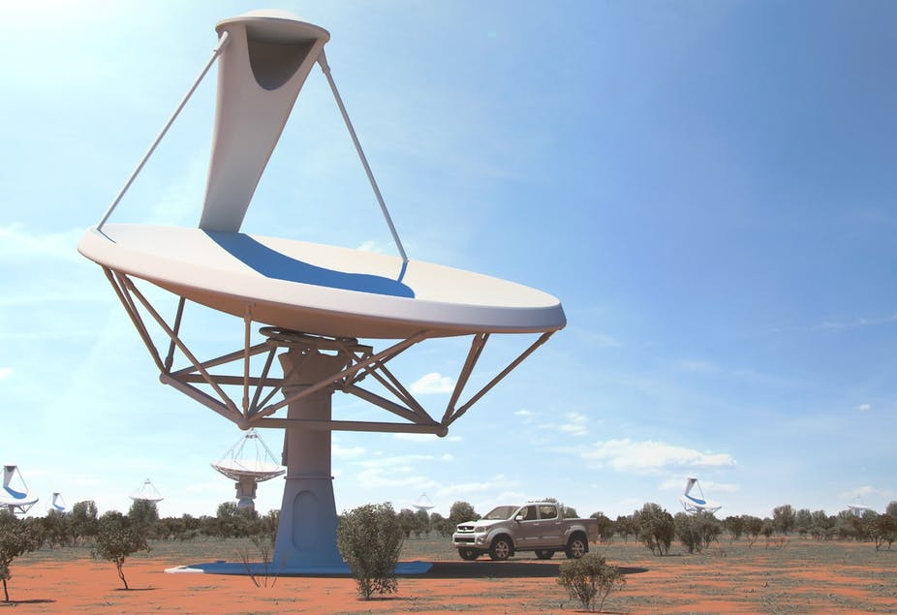Australia playing its part in the world of science with the planned SKA Australia survey telescopes to be located in Western Australia (artist image). [SKA Organisation](https://www.skatelescope.org/multimedia/image/category/the-sites/australia/)

In the lead up to the budget, the story of crisis has been hammered home, but there’s more to a country than its structural deficit. So how is Australia doing overall? In this special series, ten writers to take a broader look at the State of Australia; our health, wealth, education, culture, environment and international standing.

Australian higher education institutions are nervously anticipating this week’s federal budget that in the [words of the Prime Minister](http://www.pm.gov.au/media/2014-04-29/address-sydney-institute) threatens to “shift” university funding and give them “more freedom to innovate”.

But what will this mean?

## How we’re doing now

Currently Australia is an excellent place to conduct fundamental research.

The [Office of the Chief Scientist](http://www.chiefscientist.gov.au/2013/02/benchmarking-australian-science-performance/) says Australian research in several key areas of science performs above a European average, based on a study of citation rates for journal articles.

[[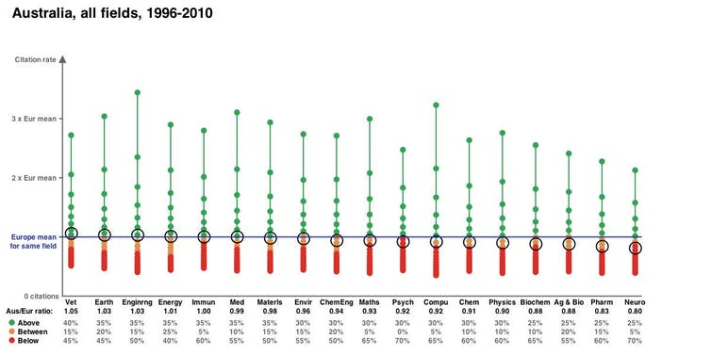](https://images.theconversation.com/files/48127/original/7fd947wf-1399608048.jpg?ixlib=rb-1.1.0&q=45&auto=format&w=1000&fit=clip)](https://images.theconversation.com/files/48127/original/7fd947wf-1399608048.jpg?ixlib=rb-1.1.0&q=45&auto=format&w=1000&fit=clip)

The black circle shows Australia’s position and how it compares against the European averages in a selection of science disciplines. [Office of Chief Scientist](http://www.chiefscientist.gov.au/2013/02/benchmarking-australian-science-performance/)

Australia is also third in the region (behind Japan and China) in the [Nature Publishing Index for the Asia-Pacific](http://www.natureasia.com/en/publishing-index/asia-pacific/by-country), although one can always find a ranking system that compliments your nation/institution is you search through enough of them!

In my own sub-discipline of astronomy we are blessed by access to world-class infrastructure such as the telescopes owned and operated by the [Anglo-Australian Observatory](http://www.aao.gov.au/) and [CSIRO](http://www.csiro.au/en/Outcomes/Understanding-the-Universe/Operating-our-radio-telescopes/ATNF-overview.aspx).

We are also playing a leading role in developing the [Square Kilometre Array](http://www.ska.gov.au/) and [Giant Magellan](http://www.agmt.org.au/) telescopes, both billion dollar projects and the former to be partly housed here.

I know that my students and postdocs can compete internationally and find good jobs both here and abroad, with last four to leave Australia going to the [Jet Propulsion Laboratory/Caltech](http://www.caltech.edu/content/jet-propulsion-laboratory), the [Max Planck Institute](http://www.mpg.de/institutes) and two to [Harvard](http://www.harvard.edu/).

And yet there are issues, the most fundamental being funding uncertainties and lack of planning at the federal level. The funding for research infrastructure is a case in point.

There is no plan.

State and federal governments are often keen to fund the construction of iconic pieces of equipment but steadfastly refuse to provide running costs.

The [Australian Synchrotron](http://www.synchrotron.org.au/) is the most painful and obvious example. Rather than being built as part of a national strategy it was [claimed by Victoria](https://theconversation.com/australian-synchrotron-scientific-marvel-political-puzzle-1177) to thwart Queensland’s desire to host it and it now [struggles to remain open](http://www.smh.com.au/business/victorian-synchrotron-funding-veers-off-beam-20140328-35oi8.html).

[[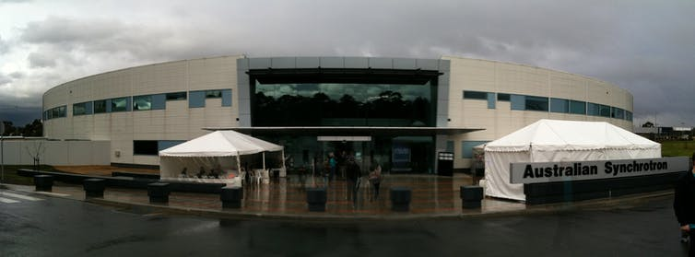](https://images.theconversation.com/files/48146/original/h4cph9tb-1399614885.jpg?ixlib=rb-1.1.0&q=45&auto=format&w=1000&fit=clip)](https://images.theconversation.com/files/48146/original/h4cph9tb-1399614885.jpg?ixlib=rb-1.1.0&q=45&auto=format&w=1000&fit=clip)

The Australian Synchrotron - should have been part of a national strategy. [Flickr/Tom Paton](https://www.flickr.com/photos/tom-paton/4892746183), [CC BY-NC-SA](http://creativecommons.org/licenses/by-nc-sa/4.0/)

Competitive research funding needs urgent reform but the Australian Research Council ([ARC](http://www.arc.gov.au/)) is burdened with providing meaningless statistics back to the government at the expense of our researchers with only about [21.9% of applications](http://www.theage.com.au/national/more-scientists-likely-to-miss-out-on-government-funding-for-research-20140109-30kod.html) being successful.

There are [concerns](https://theconversation.com/what-about-science-in-the-commission-of-audit-report-26181) too following the recent Audit of Commission report on [research and development funding](http://www.ncoa.gov.au/report/phase-one/part-b/8-2-research-and-development.html) which recommends abolishing the Cooperative Research Centres.

## How we got here

In the good old days there was the group of eight universities and CSIRO. The former trained research students and the latter concentrated on areas of research thought to aid our national priorities.

CSIRO budgets were largely consistent from year to year and university researchers looked almost solely to the ARC for their research funding.

Then, as the nation prospered we rapidly grew the higher education sector and encouraged more students to gain tertiary training and greatly expanded the number of universities. But the ARC budget didn’t expand at the same rate as the sector and researchers got grumpier as success rates declined.

Meanwhile CSIRO was told it had better earn 30% of its own income and to make it more “efficient” it would have its budget cut by 1% per annum.

It introduced [an unpopular matrix management](http://cpsu-csiro.org.au/2013/10/18/staff-survey-slams-csiro-matrix/) and other confused policies that left scientists and engineers doing menial tasks instead of research. Many CSIRO scientists departed and there are still [concerns over further cutbacks](https://theconversation.com/scrimp-now-pay-later-csiro-cuts-could-stifle-long-term-research-25591) to the organisation.

Our politicians have realised that research infrastructure spending has no electoral value. Their main verbal slanging matches seem to revolve around petty issues such as compulsory student unionism, as if they were still the presidents of the Young Liberal and Young Labor on campus, not dictating a coherent strategy for our research future in our federal parliament.

## The next ten years

The only way for Australia to remain a research innovator is to invest in, and have a long-term plan for the sector. But this is unlikely to happen when the budget is in deficit.

Ironically our economic prosperity and budget future will depend upon the research investments we make now, but this will only hurt the budget more, so the government is faced with some unpalatable choices.

It seems almost certain that our children will [face higher fees](http://www.theguardian.com/world/2014/may/01/students-to-shoulder-greater-cost-burden) and larger debts to help fund the sector. But [avoiding taxation reform](https://theconversation.com/raising-hecs-why-not-some-more-ssecs-for-education-25948) to hit graduates seems somewhat “un-Australian” to me.

Asking students to pay higher fees is not the answer. [Flickr/Michael Coghlan](https://www.flickr.com/photos/mikecogh/5605440885) , [CC BY-NC-SA](http://creativecommons.org/licenses/by-nc-sa/4.0/)

I’d like to believe that we invest in our youth and they repay their debt via the taxation system when they’re at the peak of their earning powers, not as they struggle to buy their first home and cot.

A national research infrastructure plan performed in conjunction with the state governments and research institutions is a must. This must look at the total cost of ownership and operation of a facility.

Universities need their red-tape cut so we can invest more in research than reporting on it. We need to scrap stupid bean-counting exercises such as the Higher Education Research Data Collection ([HERDC](https://education.gov.au/higher-education-research-data-collection)) and just fund research infrastructure based on simpler metrics that don’t require an army of support personnel and the game-playing associated with [ERA](https://theconversation.com/strength-in-numbers-do-era-rankings-add-up-for-universities-7493).

Research grant applications need to be simplified and be for longer duration to avoid boom and bust cycles that cripple researcher morale and their teams.

The [freedom to set fees](https://www.universitiesaustralia.edu.au/news/media-releases/Universities-respond-to-Commission-of-Audit#.U2xii62Sz-Q) may make some institutions richer and able to fund better research leading to a Darwinian survival of the fittest scenario but might have some unexpected outcomes.

But should we really care about having an institution in the top ten in the world if it means the total number of Australians educated falls? These are not easy questions to answer.

Research and innovation should not become a political football, it should be a matter of national pride. Politicians should respect what research is telling us – about our health, our environment and our climate – and they should not denigrate scientists when they tell them what they don’t want to hear.

Finally, programmes to allow research and innovation to diffuse into the private sector will ultimately be to our nation’s benefit, enabling future governments to invest more back into higher education and research.

This is one area in which we can learn extensively from the US where there is a greater connection between universities and the private tech sectors when it comes to technology and innovation. In Australia there is still too large a gulf between industry and university researchers, with the latter often having an unhealthy disdain for companies and entrepreneurship.

**Excellence in Research for Australia (ERA)**

<https://www.arc.gov.au/excellence-research-australia>

The ARC is responsible for administering Excellence in Research for Australia (ERA), Australia’s national research evaluation framework. ERA identifies and promotes excellence across the full spectrum of research activity in Australia’s higher education institutions.

Through ERA the ARC is tasked with identifying excellence in research, by comparing Australia's university research effort against international benchmarks, creating incentives to improve the quality of research and identifying emerging research areas and opportunities for further development.

The first full round of ERA occurred in 2010 and the results were published in early 2011. This was the first time a nationwide stocktake of discipline strengths and areas for development had ever been conducted in Australia. There have been three subsequent rounds of ERA in 2012, 2015 and 2018. The reports from each ERA round are available online in [ERA Reports](https://www.arc.gov.au/excellence-research-australia/era-reports).

The ERA ratings for fields of research at each institution are available via the [ARC Data Portal](https://dataportal.arc.gov.au/Landing).

In 2019–20, the ARC will be reviewing ERA (and its companion exercise the Engagement and Impact Assessment) to ensure it continues to reflect world’s best practice in research evaluation and respond to the needs of the university sector.   
  
The next round of ERA will take place in 2023.

**ERA National report 2018**

<https://dataportal.arc.gov.au/ERA/NationalReport/2018/>

Manufacturing

# ****Does manufacturing have a future in Australia?****

<https://theconversation.com/does-manufacturing-have-a-future-in-australia-3098?gclid=EAIaIQobChMIz8uLx-_z6AIVIp_CCh0QAASkEAAYASAAEgLYd_D_BwE>

August 30, 2011 • [Roy Green](https://theconversation.com/profiles/roy-green-3866)

Dean of UTS Business School, University of Technology Sydney

• [Phillip Toner](https://theconversation.com/profiles/phillip-toner-4013)

Honorary Senior Research Fellow Department of Political Economy, University of Sydney

Does manufacturing have a future in Australia?

This question has now been brought sharply into focus, as industry leaders and unions [pressure](http://www.abc.net.au/news/2011-08-30/govt-rejects-manufacturing-probe/2861888) the Federal Government to consider new measures to safeguard Australia’s struggling manufacturers, and a [pessimistic outlook takes hold](http://www.smh.com.au/small-business/manufacturers-struggling-to-pay-the-bills-20110829-1jhr7.html).

In addition, recent downsizing and closures of major facilities such as BlueScope’s export operations at Port Kembla raise the further question of whether a amanufacturing decline matters to us anymore.

The current squeeze on manufacturing is seen by the Productivity Commission, Reserve Bank and financial market commentators as inevitable [“structural change”](http://www.apo.org.au/research/australias-mining-boom-whats-problem) by which productive inputs are reallocated to the resource sector to achieve a higher return.

However, this misunderstands the role of manufacturing in the economy as a producer and user of advanced technologies, and the long-term consequences of decline.

Manufacturing is certainly becoming more globalised, more knowledge-intensive and more interdependent with value-adding services, such as design, engineering, computing and marketing.

But its future remains important for at least two reasons: first, manufacturing drives innovation and technological change – key elements of our productivity performance – and second it contributes to our external trade balance.

On the first point, Australian manufacturing allocates $4.5 billion each year to research and development, or one quarter of total private sector expenditure.

This is directed to adapting existing technologies and developing new ones, increasingly as part of an advanced services economy. And even more is spent on “non-R&D” innovation, such as new business models, systems integration and high performance work and management practices, with diffusion effects throughout the economy.

Even in the car industry, for every $90 spent on inputs such as parts and steel, a further $10 goes to external engineering, scientific and computing expertise.

And in some other industries, the production process is becoming integrated within a constellation of activities designed to enhance the customer experience, but which are not counted as manufacturing in the national statistics.

Second, without a manufacturing base, Australia would need to import more consumer and capital goods, exacerbating our chronic inability to run a positive trade balance. Even with record highs in our currency, terms of trade and commodity export volumes, our export revenues are barely sufficient to pay for rising volumes of imported manufactures.

In recent years, the trade deficit has represented up to a half of our current account deficit, and simultaneously [our productivity performance has stagnated.](http://www.treasury.gov.au/documents/1421/PDF/04_International_comparison_industry_productivity.pdf)

In this context, borrowing to import manufactures together with the repatriation of resource profits expose serious vulnerabilities in our external position. Before the global financial crisis, conventional wisdom regarded the current account deficit as irrelevant, a view corresponding with the [“efficient markets hypothesis”](http://www.rba.gov.au/speeches/2011/sp-ag-080711.html) put forward by Reserve Bank of Australia assistant governor, Guy Debelle.

Since then, however, [economic opinion](http://www.imf.org/external/pubs/ft/sdn/2011/sdn1103.pdf) has switched as financial markets have savaged those countries excessively dependent on foreign borrowings.

The evidence suggests that the developed economies emerging most strongly from the downturn are those such as Germany with a dynamic, competitive manufacturing sector.

Accelerating deindustrialisation results in countries going backwards technologically with a diminished capacity for innovation. Other industries cannot substitute for this loss in capacity.

While in Australia the resources sector has recently increased its research and development spending to match that of manufacturing, [the Australian Business Foundation and Lateral Economics](http://www.lateraleconomics.com.au/outputs/BERD%20in%20the%20Hand%20ecopy.pdf) has shown that this is directed mostly at tax minimisation rather than technology maximisation. Current changes to the research and development tax concessions are intended to reduce these loopholes.

Domestic high tech manufacturing and services supplying the resources sector are also small. According to the Australian Bureau of Agricultural and Resource Economics, annual sales of consulting and software services and equipment to the local and overseas mining industry amount to just 2.2% of total annual manufacturing sales. The resources boom is not going to save or substitute for a robust manufacturing sector.

Looking to the future, [manufacturing directly employs one in five engineers](http://www.engineersaustralia.org.au/da/index/getfile/id/9360), and many more indirectly as consultants.

Without a solid manufacturing base, Australia faces the prospect of losing scientific, engineering and computing expertise that has taken generations to nurture in research and production. These skills, at both university and vocational level, will be critical to new growth industries such as biotechnology and renewable energy.

The skills developed within manufacturing are core infrastructure skills upon which every modern economy depends.

Many people initially trained in manufacturing move to other industries. Where will the engineers, technicians, welders, maintenance fitters and machinists come from to install and maintain our telecommunications, power stations, water plants, transport and defence systems?

Tom Karmel and John Rice from the [National Centre for Vocational Education research](http://www.australianapprenticeships.gov.au/documents/NCVERReport4.pdf) write that the resources sector does not train for these skills, but rather “buys them in”.

How long will the taxpayer support billions of dollars each year spent by universities and public research agencies into solar energy, aerospace, micro-electronics, advanced materials, nano-technology or biotechnology when the industries that can use these high level skills to innovate and make new products have disappeared?

The Productivity Commission has already questioned public support for science and engineering when the benefits of the resulting knowledge accrue increasingly to other nations?

The transfer of Australian solar panel technology to China, from whom we now source production, is a case in point.

Clearly, the knowledge and skills required to import, install and maintain imported manufactures and technologies are much less than those needed for design and manufacture.

Just consider the scientific, engineering and technical inputs for the production of a solar panel, motor car, jet engine or plasma TV compared with the relatively modest skills required for their installation and maintenance.

Recent experience should be sufficient to dispel the myth that advanced economies can offshore their manufacturing base and retain “high value” design and marketing. Asian firms that started as cheap no-name makers of western-designed and branded products have quickly become global design, brand and innovative manufacturing leaders.

Manufacturing is changing the world and is itself changing as the prime source of transformational products and services.

Australia’s commodity boom is an opportunity to build this transformational capacity, especially in new and emerging industries, not to let it slip away in the name of a “black box” economic model which fails to recognise the significance of innovation and technological change.



<http://www.ausinnovation.org/publications/vision-2020/advancing-australia/manufacturing-in-australia-does-it-have-a-future.html>

Craig Milne Executive Director, Productivity Council of Australia

# Manufacturing in Australia; does it have a future?

Manufacturing has, from the earliest times, made an important contribution to Australian economic development. By the centenary of British settlement a thriving manufacturing industry had grown up, producing a range of goods sufficient to supply most domestic needs. Federation established a borderless national market and tariff protection, enabling Australiaâ™s small-scale manufacturing sector to embark on a period of growth which would, within a few decades, transform the nation into a fully-fledged industrial state.

The opening of the Newcastle Steelworks in 1915 established the Australian steel industry. The building of the Ordnance Factory at Maribyrnong added an interchangeable part mass production facility in 1924 and, in the same year, Holden Motor Body Builders built a modern automotive body plant at Woodville. In 1936 the Commonwealth Aircraft Corporation was established at Fishermenâ™s Bend. During the war that shortly followed, these substantial investments in industrial capability paid great dividends; Australian manufacturing geared up for national defence, expanding its output and capability at an astonishing rate. In the peace that followed, new industries flourished and the golden era of Australian manufacturing ensued. By the late 1950s manufacturing accounted for 29% of Australian GDP.

By the 1960s, however, Australian manufacturing had begun to stagnate, as growth and productivity faltered. By the 1970s it was in decline and, forty years on, reduced by global economic changes and government policy, manufacturing accounts for less than 10% of Australian GDP, the lowest level since early colonial times.

The external cause of the collapse of Australian manufacturing has been the adoption and mastery of western-style manufacturing by a succession of Asian nations. These entrants, from Japan at the beginning to China in the present, have applied mercantilist ideas to the conduct of their trade policies. The mercantilistâ™s policy is to achieve trade surpluses, while holding down the value of the national currency to prevent the loss of competitiveness that would normally follow from such a policy. Mercantilism uses state power to suppress wages and force the rate of savings. It is protectionist and seeks to influence the structure of the nationâ™s industries, rewarding entrepreneurs whose endeavours align with national policy. Mercantilist regimes use their domestic firms as hammers to forge their nationâ™s future.

The internal causes of Australian decline are several and well known. The most important is that Australia is a high wage country, and has been since the 1820s. The initial causes were an abundance of land, a shortage of labour, the absence of a rentier class, low taxes, gold discoveries and generous British investment. After Federation, high wages were cemented in place by liberal reformers and trade unions. Australian governments were among the first to grant age pensions and other welfare benefits, the costs of which inevitably reposed on the productive sector. Australian manufacturing was rendered permanently uncompetitive against nations whose firms carried lighter burdens.

Another problem for Australian manufacturing was a small and dispersed national market. British colonies were strung around the Australian coast to exclude imperial rivals that might have chanced a settlement on the far side of the world, a policy which gifted Australia with a continent under a single national jurisdiction, but at the price of widely separated population centres. A small national market, fragmented into regions, made the acquisition of scale economies and labour-replacing technologies difficult to achieve.

Without exceptional technical and entrepreneurial talent, or a cultural tradition of producing highly esteemed goods, a nation with high wage and welfare costs and a small domestic market will struggle to make a success of manufacturing.

The stasis afflicting Australian manufacturing from the 1960s coincided with an era of social change, conflict and rejection of received values. A distaste for the discipline and drudgery of factory life, and a preference for white collar jobs, worked against manufacturing. Trade unions played a disruptive and divisive role through the pursuit of unreasonable claims, political campaigning and the subversion of productivity. Protectionism had encouraged the proliferation of sub-scale, inefficient firms. An excessive reliance on foreign direct investment had put too many branch offices of foreign corporations in command of key strategic sectors. The problem of Australian protectionism was that it was necessary to keep manufacturing afloat, but robbed it of vitality, enterprise and the pulse of innovation.

The policy responses needed to resolve these issues would have taxed the wisdom of Solomon. The Australian governing class tinkered, but was not equipped for the task. Instead, it found a handy alternative in the form of new mineral discoveries and a growing demand for resources by emerging Asian industrial nations. This offered a much easier pathway to riches than the grinding, competitive struggle of manufacturing. Australians wouldnâ™t have to do any of the hard, head-scratching stuff that other people did any more; they could shovel coal and iron ore into ships instead. Too easy. It was the line of least resistance and the governing class followed it.

Australian policy thus entered the era of âœeconomic reformâ, the essence of which was to abandon a century and a half of industrial development in favour of mining. Although the reformers spoke of a re-energised Australian manufacturing sector, responding to tariff cuts with an outward re-orientation that would stimulate innovation and boost productivity, this proved to be fanciful. Australian manufacturing went into precipitous decline instead.

Manufacturing has been reduced to a remnant. The firms that are left are those that have found specialist niches, those that need either little labour or a lot of energy, those whose customers require proximity or immediacy, the defence contractors, and the automotive assemblers and suppliers hanging on by their fingertips.

Given the continuation of current policy, further decline in manufacturing is assured. The conventional view is that this doesnâ™t matter; Australiaâ™s future lies in mining and services. This is a foolish choice; Australia already has too many eggs in the commodities basket for its strategic good. More than that, the sanguine reliance on services is mistaken. It falsely implies that the migration of jobs from manufacturing to services is a movement to a âœhigherâ stage of economic development. Services donâ™t thrive in Australia because they represent more productive allocations of labour and capital, they thrive because most service outputs are consumed at the point of production and are therefore highly protected. The form of this protection is the close regulation of the right to enter and work in Australia. Manufacturing is now exposed to least cost competition but most services, as part of the largest sector of the economy, enjoy an impenetrable level of protection.

There are strong arguments for Australia staying in manufacturing, and being prepared to pay a high price to do so. Manufacturing is the sector that contains and advances the skills and capabilities that prescribe membership in the ranks of the advanced nations of the world. For research and innovation, manufacturing provides the essential ground from which future streams of products and incomes can emerge. Whatever form the economy of the future may take; manufacturing will provide the enabling foundation for it.

Economic reform has not worked as well for Australia as its protagonists have claimed. For manufacturing, the most important sector of the economy of any technologically advanced nation, economc reform has been a disaster. Itâ™s time that the dominant policies of the last forty years were re-considered; the nationâ™s future depends on it.

# The Future of Australian Manufacturing

<https://www.hubaustralia.com/future-australian-manufacturing/>

Jens Goennemann is the Managing Director of [The Advanced Manufacturing Growth Centre](https://www.amgc.org.au/), one of several growth centres launched by the government in 2015.

The 12-person AMGC team has been a resident of Hub Hyde Park for over a year, and has found it more suitable for their diverse working styles and collaborations.

Jens spoke to the Hub team about the future of Australian manufacturing and why coworking at Hub Hyde Park was the perfect solution for their team!

### How would you describe the role of the Advanced Manufacturing Growth Centre (AMGC)?

The purpose of the Advanced Manufacturing Growth Centre is to transform the Australian manufacturing sector to be more globally competitive and create demand for jobs. So how do we do that?

Australian manufacturing is a story that requires a mindset to change. We need to get our heads around that manufacturing has changed. It has moved on and we cannot be wedded to the way it was or be nostalgic.

Australian manufacturing has become broader and more than production alone – it’s something that happens before and after production.

###### If you have a holistic view of manufacturing, we are employing over 10% of the workforce in Australia, 1.27million people.

##### Read more: [Coworking Comes to Melbourne’s Historic ICI House](https://www.hubaustralia.com/coworking-ici-house/)

 Do you think the perception of Australia’s car industry “winding down” has negatively affected the industry more than the actual closing of the spaces?

The perception doesn’t match reality. But, perception perpetuates itself in the minds of teachers and parents who give their children or students the wrong recommendations.

Making complex things is the future and a massive opportunity for our younger generation. We need to put the record straight and show the opportunities manufacturing has to deliver.

If you want an example, the internet of things will always need a ‘thing’, and the thing needs to be manufactured. Like many other sectors, manufacturing is on the journey to digitise – digitised manufacturing that embraces the internet of things is something that Australian manufacturing has underutilised so far, and that’s where the opportunities are.

### What initiatives do you have to encourage the future of manufacturing for the next generation?

We started by doing highly respected research which sets the direction for manufacturing in Australia, and tells us that manufacturing is much bigger than we think and is most successful when we are better, not cheaper.

We demonstrate the research by doing joint projects with industry and investing in innovative projects that help Australian manufacturing companies on their journey for commercialisation, for innovation and commercialisation.

We’re also in the process of launching a nationwide awareness campaign to make everybody, manufacturing and non-manufacturing, aware of the opportunities so Australia doesn’t miss out on it as a source of higher paying, skilled, and sustainable jobs.

##### Read more: [Fox & Hare are Changing the Face of Finance](https://www.hubaustralia.com/fox-hare-changing-finance/)

### Do you see more things becoming automated and Australian manufacturing becoming majority high skilled versus traditional physical labour?

Automation allows us to be cost competitive in production and assembly, and hire qualified workers to manage and oversee the automation, to oversee and program robots. That transformation is interesting because both go hand in hand.

This is why we’re doing projects to demonstrate how we can bring production work from China back to Australia, through automation because we can do it for the same price or cheaper. Plus we can make a more sophisticated product with a higher integrity of the product being produced and manufactured on-shore and exported worldwide.

### Do you see the future being exporting of Australian produced products versus Australian owned and produced?

The whole Growth Centre idea, including but not limited to manufacturing, is about focusing on what Australia is already good at and taking it globally. Rather than doing everything to a small scale,  we’re focusing on sectors such as manufacturing and participating in global supply chains and becoming better than everybody else.

Not NSW being better than Victoria or Queensland, but Australia becoming the best in the world. We apply ourselves to niches of excellence to get on the path of entering a new global market.

The whole growth centre idea goes back to McKinsey in 2014, with a brochure called [Compete to Prosper](https://www.mckinsey.com/featured-insights/asia-pacific/compete-to-prosper-improving-australias-global-competitiveness).

###### Compete to Prosper said to be better, not cheaper, and to focus.

We have growth centres focused on:

* oil and gas
* mining technology and services
* agriculture and food
* pharmaceuticals and med tech
* advanced manufacturing
* and cybersecurity.

Six areas of excellence where we’re punching above our weight!

### Hub Australia

Hub Australia is home to a wide range of businesses, from tech startups to large creative agencies and government organisations like AMGC. If you want to work alongside the best businesses in your city, [contact](https://www.hubaustralia.com/contact) Hub Australia today.

# About Advanced Manufacturing

<https://www.amgc.org.au/our-purpose/about-advanced-manufacturing/>

Every Australian manufacturer has the potential to be advanced.

Manufacturing is undergoing a dramatic transformation, worldwide. Manufacturers are creatively diversifying their focus across different stages of the manufacturing process, both before and after goods are produced. As production activities are gradually being outsourced to developing countries offering cheap labour, more Australian manufacturers are recognising the need to compete on value rather than cost. Most commonly, this involves contributing innovative products, components or services within global supply chains.



#### Advanced manufacturing is not about what you make, but how.

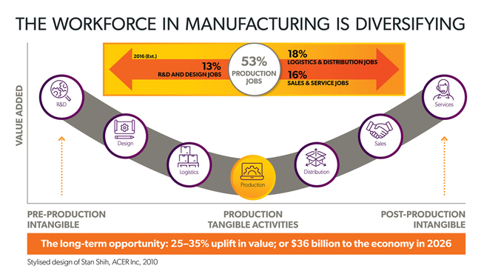

AMGC finds that the most competitive manufacturing companies around the world were to have similarities in the way they succeed. These successful features include:

**Advanced knowledge**: continuously innovate with a high degree of R&D investment.

* See AMGC project [High-Strength Aluminium Alloy](https://www.amgc.org.au/project/high-strength-aluminium-alloy/) on example of advanced knowledge

**Advanced processes**: focus on using state-of-the-art technology, become familiar with digitalisation.

* See AMGC project [Customised Orthotics](https://www.amgc.org.au/project/customised-orthotics/) on example of advanced processes

**Advanced business models**: offer niche solutions, often highly customised and highly valuable.

* See AMGC project [Remote Monitoring Software](https://www.amgc.org.au/project/remote-monitoring-software/) on example of advanced business model

Today, over 75 per cent of global trade is now in intermediate goods, for example, components and research. As a result, there is a growing market for advanced manufacturers that not only create finished products, but add value at every stage of and within the global supply chain.



## The purpose of AMGC is to transform Australian Manufacturing to be more globally competitive and generate the demand for jobs

[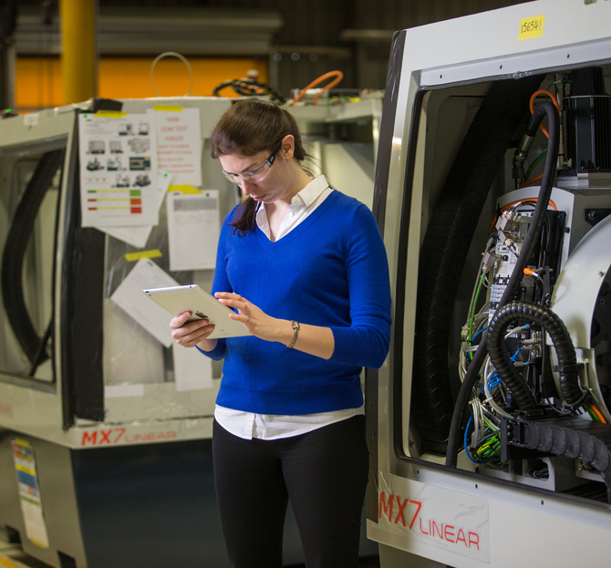](https://www.amgc.org.au/our-purpose/about-advanced-manufacturing)

[](http://www.aamc.org.au/)

## The Future of Australian Manufacturing

<http://www.aamc.org.au/the-future-of-australian-manufacturing/>

Thank you for the opportunity to speak with you this afternoon, it is a pleasure to be here.

I would particularly like to thank Tim Welsh, Chair of the Chemicals and Plastics Network Advisory Board, for his generous introduction.

Tim also represents PPG Industries on the Leaders Group of the Australian Advanced Manufacturing Council.

I see from your list of Network industry members that we have a number of other members in common.

## **Innovation and chemistry**

And this makes perfect sense: Because innovative chemistry and materials science is at the core of many advanced manufacturers.

The term Advanced Manufacturing is getting a lot more media coverage these days – but just what makes manufacturing “advanced”?

One way to distinguish it is by the rate of technology adoption and creation – and the ability to use that technology to remain competitive and add value.

Technology adoption and creation: that means thinking differently. It means, among many other things, thinking collaboratively. It means getting more PhDs into industry – and ensuring our world-class research is developed and, crucially, that it is commercialized.

Your Network and Training Program is well ahead of the game in understanding how vital this is. Collaborations between industry and research that lead to commercial outcomes are key to our manufacturing future.

Australia’s chemicals and plastics industries directly employ over 50,000 people and represent almost 10 per cent of total Australian manufacturing activity. This is significant.

But your work is also helping to power the rest of industry. New materials, new solutions and new applications are enabling manufacturers to remain competitive in a global context – and that is where your greatest impact is.

Manufacturing in Australia and across the world is going through a period of transformation; I want to share with you some success stories – and explain the changing paradigm of manufacturing in terms of the shift towards what some are dubbing “Industrie 4.0”.

But first a little background on the AAMC. More than three years ago, a series of meetings were held – under the auspices of the Australian Industry Group – to discuss the formation of a **CEO-led coalition of advanced manufacturers**.

The CEOs involved knew then that Australia’s industry policy did not reflect the needs of contemporary, globally competitive, manufacturing.

Our national responses did not reflect the fact that many Australian manufacturers had successfully evolved – and were world-leaders.

These manufacturers are not constrained by the domestic market. For them, the market is the world.

We knew that Australian manufacturing needed an image makeover.

And we knew that government policies needed to shed old frameworks – frameworks that were no longer applicable. We wanted manufacturing policy to be about success, not failure, and about the neo natal unit not palliative care – about winning not about asking for handouts.

Policies needed to be relevant to the fast changing dynamics of high-value, knowledge-intensive global business. They needed to recognise that change and innovation were keys to success not threats.

Prior to the last election – in June 2013 – the Australian Advanced Manufacturing Council was launched.

Our members are from across industries – they represent mining equipment manufacturers, the medical technology sector, aerospace and defence, high value engineering and instruments, chemicals and agribusiness. We also have strategic partnerships with the Ai Group and CSIRO and in fact are fortunate enough to occupy offices here at CSIRO’s Clayton Campus.

Over the past 18 months we have actively engaged with relevant Ministers at both the Federal and State Level.

We urged a greater understanding of the importance of research and industry collaboration, the importance of the three legs of the innovation tripod – industry/research/government – in building a stronger economy and ensuring future growth.

We urged policies that reflected and encouraged Australia’s comparative advantages; that promoted excellence (not dependence).  
And we were pleased to see these thoughts and recommendations strongly reflected in the Federal Government’s 2014 innovation agenda – in the establishment of five Industry Growth Centres, in the promotion of greater industry-research links and in the focus on better commercialising our world class research.

The Government’s more recent National Innovation and Science Agenda – which builds on the previous work – is a substantive public policy agenda; a cogent recognition of the culture and settings that need to be encouraged for true innovation to flourish. And it is well worth a read – there is a lot in it.

Prime Minister Malcolm Turnbull’s new Ministry has focused national – and international – attention squarely on Australia’s future, with unprecedented emphasis on Australian innovation, technology, and leveraging our research excellence to build a strong economy.

## **Our changing world**

Right now significant changes are occurring in manufacturing.

This audience will be well aware of technology shifts and the implications for your businesses.

Technological innovations suggest both danger and opportunity – as BASF’s Ross Pilling once aptly described it.

The commercial applications for artificial intelligence and machine learning are expanding, we see robotics entering a new phase – likewise nanotechnology, 3D printing, genetics, biotechnology and materials science, among others.  
In your sector, you will be aware of the advent of **Flow Chemistry**, and the work being done by CSIRO and others to enable its commercial application.  
While conventional batch processing methods for chemicals are effective, the equipment and storage can be very expensive, limiting industry’s capacity for product development and scale-up.  
Batch and other traditional methods are also resource dependent and generate large volumes of waste.  
Flow chemistry is a cleaner, more cost-effective method. In recent applications, the process doubled the yield and reduced energy and waste by 90% for high-value photo-chromatic dyes.  
Some of the world’s leading capability for flow chemistry happens right here in Victoria.  
These exciting changes are opening up opportunities for Australian businesses.

Indeed, if 2015 was supposed to be a tough year for manufacturers in Australia, a number of our forward-thinking companies appear to have missed the memo.

The past 12 months were a chance for many in the AAMC, for example, to make an even bigger mark in global circles.

Between them, these companies broke sales records, signed landmark contracts and brought world-first technology to the market.

The Australian manufacturing sector expanded for a seventh month in a row in January, according to the Australian Industry Group’s Performance of Manufacturing Index.

Of course we had a falling Australian dollar, low interest rates and inflation, and there were other factors in play.

There is no doubt we are in a good position – but we cannot afford to sit back down again and relax.

## **Industrie 4.0**

We hear quite a bit about “Industrie 4.0” or the 4th industrial revolution.

Many companies are asking: What is it? Do I need to know more? Can’t I keep working the way I have been working, and still be competitive?

Understanding what is occurring internationally is vital to being able to really answer this.

Industrie 4.0 is the German term for what some people are calling the 4th industrial revolution.

* This is where the 1st industrial revolution was mechanization.
* The 2nd revolution was electrification.
* The 3rd was automation and IT integration. This transformation is still going on in Australia.
* And the 4th industrial revolution is about the merging of the cyber and the physical worlds, resulting in the ‘smart factory’

The term Industrie 4.0 was first used in 2011 at the Hannover Fair.

It is a prediction of the ways things are headed – and an actuality.

The basic principle of Industrie 4.0 is that by connecting machines, work pieces and systems, businesses are creating intelligent networks, along the entire value chain; networks that can control each other more or less autonomously.  
One recent German study identified six so-called “design principles” of Industrie 4.0 which help explain not only the concept but I hope also some of the opportunity – and, dare I say it, the danger to our global competitiveness.

These principles are described as follows:

### 1. Interoperability

This is the ability of cyber-physical systems (i.e. workpiece carriers, assembly stations and products), humans and Smart Factories to connect and communicate with each other via the Internet of Things and the Internet of Services.

### 2. Virtualization

This is where a virtual copy of the Smart Factory is created by linking sensor data (from monitoring physical processes) with virtual plant models and simulation models.

### 3. Decentralization

With these advances comes the ability of cyber-physical systems within Smart Factories to make decisions on their own.

### 4. Real-Time Capability

This is the capability to collect and analyse data and provide the derived insights immediately.

Machines are able to predict failures and trigger maintenance processes autonomously or trigger self-organized logistics.

### 5. Service Orientation

This is the offering and customization of products and services via the Internet; a strong, needs-oriented, individualized, and customer-specific production operation.

### 6. Modularity

Meaning flexible adaptation of Smart Factories to changing requirements by replacing or expanding individual modules.

The basic principle of Industrie 4.0 is that by connecting machines, work pieces and systems, businesses are creating intelligent networks along the entire value chain that can control each other autonomously.

Industrie 4.0 can be seen as characterised by vertical networking and horizontal integration.  
Vertical networking is the use of smart production systems, as mentioned – such as smart factories and smart products, and the networking of smart logistics, production and marketing and even smart services, with – as I said – a strong, needs-oriented, individualized, and customer-specific production operation.

Horizontal integration is the integration of business partners and customers, and new business and cooperation models across countries and continents.

* Today there are twice as many devices, physical objects or machines, connected and communicating with one another via networked systems – as there are humans on the planet.
* Supply chains are becoming more sophisticated and dynamically connected – with rapid response times now possible – and expected.
* This fact – of increasing integration across supply chains – is especially important for small and medium sized companies in Australia, a point I will come back to.
* A recent study by Tata Consultancy Services, a leading global IT services firm, surveyed 795 executives from large multi-nationals about the impact of “Internet of Things” technology on their businesses.
* The study found an average increase in revenue as a result of IoT Initiatives of 15.6 per cent.
* Market leaders in IoT reported 64 per cent revenue increases.
* There is a sense that the opportunity for advanced manufacturers and service providers alike is significant – and on the flip side – that clinging to out-dated methodologies and approaches will render some companies and modes of production irrelevant when it comes to participating in global supply chains.
* Last year, I visited Germany – and the UK – where I saw companies and government/industry/research collaborations embracing new technologies with open arms.
* I would encourage you, if you have the opportunity, to see as much as you possibly can of what is happening elsewhere – in the US, the UK and Germany in particular – and even in other sectors and technologies.
* Precision agriculture, for example, has been made possible by combining GPS and geographic information systems.
* These technologies enable the coupling of real time data collection leading to more efficient farm planning, yield mapping, soil sampling, tractor guidance and so on.
* The same sorts of precision processes are re-shaping manufacturing.
* Germany is a powerful reminder of what Australian manufacturers and other industries need to do to be part of global high value industries of the future.
* The only difference between Germany, the US, the UK and Australia is that they have been investing for a longer period of time and on a scale that we haven’t. There is no difference in our fundamental capabilities.
* Between now and 2020, German industry will invest €40 billion annually in Industry 4.0 applications.
* Industrial firms will invest, on average, 3.3 per cent of their revenues in digitisation solutions over the next five years. This corresponds to nearly 50 per cent of all planned capital investments.
* As you might expect, German success in manufacturing has not been by accident.
* A recent McKinsey report on Japanese productivity compared Japan to Germany – and the data reveals how one can never rest on your laurels.
* Japan’s high value manufacturing sector – including automotive, industrial machinery, and electronics – has eroded over the past 15 years in the face of global competition.
* At the firm level, Japanese auto companies have remained excellent performers, but the biggest names have shifted much of their production outside of Japan to lower cost countries.
* In the Japanese consumer electronics industry, there are many subscale companies and plants focusing on products with declining margins.
* The major Japanese conglomerates have spent the past decade fighting for profitability. In some cases, they made unfortunate bets on technologies that did not win out in the marketplace.
* Samsung, LG, Xiaomi, Huawei, and Lenovo have grabbed market share for products such as TVs, PCs, and smartphones—often at the expense of Japanese firms.
* Downward pricing pressure is a worldwide phenomenon and does not explain the German and US success stories.

## Global supply chains

* The McKinsey study argues that countries and companies need to aggressively adopt global best practices, starting with redirecting formidable R&D capabilities to higher-value spaces.
* It’s important, as you think about the application of technologies to your own business, that you consider the size of the investment you are prepared to make into supplying and applying those technologies.
* In an era of rapid-fire technology breakthroughs, there is enormous potential to create entirely new goods and services—not to mention applying innovation to management and production practices – and to efficiencies and connectivity in global supply chains.
* Globalisation represents a significant opportunity for Australian industry at all levels.
* 70 per cent of global trade now is in intermediate goods and services and capital goods – not in finished goods.
* In fact, components trade – and trade in research – are two of the fastest growing forms of international trade.
* Both these trades are underpinned by sophisticated supply chain management systems and cheap communication platforms.
* What this tells us is that our companies can benefit a great deal from studying the strategic pathways of the global giants.

## **Definition of Advanced Manufacturing**

* I mentioned a defining element earlier of advanced manufacturing. Let me expand a little.
* Advanced manufacturers – in general – share the following characteristics:o Advanced manufacturers sell to a global market and compete on distinctive qualities. The domestic market is not a constraint.  
  o These manufacturers constantly innovate to remain competitive. They leverage the latest thinking in technology.  
  o Advanced manufacturers tend to be engaged in collaborations with universities, the CSIRO and other research institutes.  
  o They tend to have a high Intellectual Property component; a high knowledge base  
  o The only public sector support needed is at the Research & Development phase through tax credits or leveraging public/private partnerships.  
  o They produce high margin products.  
  o And they have smaller capital and labor footprints but are higher paying, and provide higher quality work.

In Australia, as in other advanced economies, we do not want to compromise our high standard of living, quite rightly. We therefore must compete on distinctive qualities and consider the global opportunities.

All of this means – Looking ahead 25 years and beyond – that a successful manufacturing sector will depend on cutting edge research and technology – and a highly skilled, technologically advanced workforce. The market and the competitive landscape is now the world.

The fact of the existence of the council I chair – the Australian Advanced Manufacturing Council – is itself an indicator that there is a growing awareness we must set about correcting the imbalances that have emerged.

Few people will say that the auto exit is in itself a good thing.

But there are many who believe the automotive sector was hampered by significant limitations – the most significant being its domestic focus.

I am fiercely proud of our Australian-grown successes – and believe we have what it takes to build competitive industries unconstrained by the size of our domestic market.

## **Success stories**

We have a growing number of Australian success stories.

A Deloitte and Austrade project mapping Australian capabilities to meet international MNC demand estimates that 10,000 Australian SMEs are “internationally ready”.

About 2500 companies were identified as producing high value, innovative solutions across 4 sectors including aerospace, Mining Equipment, Technology and Services, oil and gas, and infrastructure.

These are companies that are turning their focus to new areas of growth and tapping into multinational supply chains. They are making their mark on the world stage – not as Australian companies – but as global companies.

I am going to share with you a few stellar examples – Anatomics, Cochlear, Marand Precision Engineering, Textor Technologies, CSL and Boeing Australia. What you will note from all of these is that their success has been made possible by science – particularly, in a number of examples, by chemistry.

Now you may argue that Boeing is an American company, and you would be right – but with a significant portion of the company’s global supply chain – and 3000 employees here – Boeing Australia can rightly be described as an Australian – slash – global company.

### Unique Australian successes in advanced manufacturing Anatomics

Anatomics is a relatively new Australian-owned medical device company that has been manufacturing and marketing surgical products to surgeons locally and internationally for approximately 10 years.

Anatomics is a world leader in its field, having developed technology whereby medical scan data from anywhere is used to manufacture an exact plastic replica (a BioModel) of a particular anatomical structure.

Surgeons then use these replicas to assess abnormalities, plan surgery, and communicate to patients and colleagues. From this, custom implants can be created – transforming the lives of people who have suffered major trauma either through accidents or cancer.

Recently the company was in the media when it developed, with the CSIRO, the world’s first 3D printed titanium heel bone – for an older gentleman who was otherwise going to lose his leg. In another wonderful example of collaboration, the company created a titanium sternum and rib cage implant for a patient, using the 3D printing facilities of CSIRO’s Lab 22.

The company’s products are manufactured in Australia – and sold to the world.

### Cochlear



Cochlear, makers of the bionic ear, is a global biotechnology company, employing 2700 people. I recently had the opportunity of visiting Cochlear’s plant and facilities co-located with Macquarie University in Sydney – highlighting the emphasis the company places on continuous collaboration with the research sector.  
You may know that the Cochlear designs, manufactures and supplies the Nucleus cochlear implant, the Hybrid electro-acoustic implant and the Baha bone conduction implant.  
Last year, Cochlear posted record sales, thanks in part to its latest speech processor Nucleus 6, and a range of wireless accessories linked to it that dramatically improved hearing for its users.  
**95 per cent** of Cochlear’s sales are outside Australia.  
A majority of its research and development, and the majority of its manufacturing, takes place in Sydney, Australia.  
**70 per cent** of its global taxes are paid in Australia.  
And Cochlear invests 15 per cent of its revenue in R & D.  
The CEO of this company, and other companies like Cochlear – wake up every day concerned about how to ensure their businesses are globally competitive.

### Marand



Marand Precision Engineering is a privately owned company, a leading global supplier of high-quality precision tooling, machine tools and highly engineered automated production solutions.

Marand’s customer base includes Boeing, Lockheed Martin and Rio Tinto.

Originally a big supplier to the automotive industry, Marand took a long term view, investing substantial resources into a complex international engineering manufacturing project through the F35 combat jet program.

The SME did this with the full knowledge that profits would not flow through for a very long time.

Marand’s Managing Director David Ellul now firmly believes Australian manufacturing can survive the closure of the car industry.

### CSL Limited



 CSL was originally the Commonwealth Serum Laboratories – now it is a $30 billion global manufacturer of vaccines and plasma protein biotherapies.

The company researches, develops, manufactures and markets biotherapies to treat and prevent a range of human medical conditions.

CSL invests heavily in research and development, significantly in the areas of immunoglobulins, specialty products, haemophilia products and breakthrough medicines.

Headquartered in Australia with substantial operations in the United States, Germany and Switzerland, CSL employs over 11,000 staff and operates in more than 20 countries.

The company continues to conduct a great deal of its research out of Australia.

### Textor Technologies



Textor Technologies was originally a traditional textiles manufacturer that has transformed itself into a global supplier of high tech fabric that traps and transfers moisture.

It now supplies the global nappy industry at scale.

The company invested in the latest machinery and has worked closely for a number of years with the CSIRO in developing its world-beating fabric. I would not be surprised if you had already heard of them: they are a model of the transformation that is possible with science and strong invested management.

### Boeing



So my final example is Boeing.  
Boeing Aerostructures Australia is Boeing’s largest manufacturing operation outside of North America.  
They produce flight control surfaces for large commercial aircraft from advanced composite materials.  
Boeing Australia is the sole supplier of moveable trailing edges to the 787 Dreamliner program.  
This is Australia’s largest aerospace contract, valued at $5 billion over 20 years.

## Follow the Customer – or cracking global value chains

Today’s discussion has focused on technology – how technology adaptation and innovation is necessary for ensuring our global competitiveness – and it is VITAL for ensuring access to sophisticated global supply chains.  
Some of the biggest opportunities for business growth for many of our small and medium sized enterprises will come from supplying large multinational companies’ global value chains.

We know from our members, including companies like the South Australian based mining equipment supplier, Korvest, that by leveraging relationships with customers, smaller companies can enter new markets more easily.  
The dominance of SMEs in Australia means some of the biggest opportunities for growth lie in this opportunity.  
SMEs that are not involved in exporting can quickly gain a footing in new countries by “Following the Customer”.  
The Australian Industry Group has given a great deal of welcome support to encouraging a better understanding of the value of this approach to growth.  
We can do much to facilitate Australian entry.  
The AAMC has urged a stronger emphasis, for example, on “country to company” trade facilitation, for example, as opposed to the more traditional country to country missions.  
Australian businesses would benefit enormously if Government trade and investment strategies took this approach.  
Companies would have an opportunity to truly understand the significance of global MNC value chains.  
They could find out exactly what the world needs and wants – and then supply it.  
Where are these companies expanding? What are the new sectors, new technologies, new markets they are focusing on? What are the problems they are trying to solve?  
Really understanding this will give Australian companies an edge.

# In conclusion

What we know is there is a new breed of transformative manufacturing company in Australia. These companies are often lean in operations, nimble and creative.  
They employ engineers, scientists, emphasise collaboration in research and innovation, are export-focused and are some of the most innovative in the world.  
How the smart factory of the future will look is yet to be entirely realized. What we do know is that whilst they will be able to be autonomous to a degree, production processes will still need to be managed at a higher level in order to, for example, set deadlines, environmental goals and other objectives. Having a highly skilled and highly educated workforce will be an imperative.  
With targeted policies – around developing our STEM skills, around building strong connections and collaboration between our industry and our research community, and around trade and business facilitation, I know we will see many more examples of success.  
AS I go around speaking to companies – and to policymakers – there is a message that I want them take away – and that is:

1. I ask that they recognize that we do have a thriving advanced manufacturing sector – that is participating in global supply chains – and that you look for those successes and understand them;
2. I ask that they look at what is occurring in North America, in Europe and locally. Digital technologies are transforming design and engineering processes – and creating game-changing possibilities.
3. And I ask that companies investigate working with our world-class research sector and find ways to develop their own IP or collaborate on generating new IP that will differentiate their products and/or your processes and open up new markets for them – and for Australia.
4. I ask that they recognise and embrace the fact that the industrial world is changing and that embracing these developments provides huge potential for the future of manufacturing in Australia.

**John Pollaers**  
February 9, 2016

#### Australian Advanced Manufacturing Council

The Australian Advanced Manufacturing Council is a CEO-led private sector initiative pursuing Australian success in advanced manufacturing. The AAMC brings together industry leadership to drive innovation success and resilience in the Australian economy. The AAMC is managed by the Australian Industry Group.

**THE MANUFACTURING SECTOR IS CRITICAL TO AUSTRALIA’S FUTURE**

02-10-2019 by

Brendan O'Connor in Industry Politics

<https://www.industryupdate.com.au/article/manufacturing-sector-critical-australia%E2%80%99s-future>

The latest data from the Australian Bureau of Statistics paint a fairly sombre reflection of the Australian manufacturing industry, begging the question: what is the Morrison Government’s plan to help manufacturers to grow and become globally competitive?

Each day that passes, it is becoming more apparent that either there isn’t a plan or if there is, it’s not working.

The data for the August quarter reveal a record low number of Australians holding a job in the manufacturing industry and a record low number of people employed full time in the manufacturing industry, down 100,000 in 12 months.

This, from an industry with a history of decent full-time jobs, is concerning.

There are some bright spots, with the Ai Group’s, Performance of Manufacturing Index for September showing strength in the food and beverages, and machinery and equipment sectors of the industry.

However, for the past six years, I have been struck by an abundance of rhetoric but an absence of urgency from this government to strengthen industry conditions.

Just last month, Labor reignited calls for the Minister for Industry, Science and Technology, Karen Andrews, to act and stop local vitamins and mineral supplement manufacturers being stripped of their ability to use the iconic Australia Made logo.

The government’s inaction on this issue has threatened an industry worth $5 billion to the Australian economy and put close to 30,000 jobs at risk.

It was only following pressure from industry and Labor that the government presented an interim regulatory change; however, no details have been made public on a timeline for properly fixing this issue.

The grim manufacturing statistics I mentioned are not specific to the manufacturing industry, in fact there are slowing economic conditions nationally – a struggling jobs market and low wages growth.

More than 1.8 million Australians are underemployed and there are at least three unemployed Australians for every job vacancy.

Business confidence and conditions have deteriorated under the Morrison Government, according to the NAB Monthly Business Survey for August 2019, with a decline in business conditions across industries.

The RBA cut interest rates again to 0.75 per cent in an attempt to drive down the unemployment rate.

The Liberals’ lack of an economic plan is leaving Australia, and particularly manufacturing, dangerously exposed to turbulence in the global economy.

Australia has a future as an advanced manufacturing nation with capacity for major growth. An advanced economy needs an advanced, innovative and highly skilled industrial base. This requires strategic leadership from government as well as a partnership with business and workers.

It doesn’t require a reduced investment in research and development, which impacts Australia’s capacity for innovation, economic diversity and new jobs.

We are witnessing the continuation of an overall downward trend in R&D under this Government’s watch.

Business R&D spend has hit 0.9 per cent of GDP, falling below 1 per cent of GDP in the previous data (2015-16).

As a recent Australian Institute of Company Directors report noted, Australia’s total gross domestic spending on R&D is currently ranked 21st within the OECD and that while the global trend is for national business expenditure on R&D to grow, Australia’s has fallen.

As such, Australia’s investment levels below countries such as South Korea, Israel, Sweden, Denmark, Finland, Iceland, Norway and Singapore.

Research and development is fundamental to Australia’s future industries. That’s why Labor set a goal of increasing the share of gross domestic product devoted to research and development to the last election.

If the Morrison Government was serious about helping manufacturers to grow, become competitive globally and develop new technologies they would be investing in R&D.

Labor took a comprehensive plan to support local manufacturing firms and jobs to the last election. While all of our policies are under review, it is worth remembering some key initiatives, such as the $1 billion Advanced Manufacturing Future Fund, the Australian Investment Guarantee, the Local Projects, Local jobs plan that would see more government procurement and investment in major projects spent on local businesses and local jobs, to name a few.

We also committed to lifting research and development investment to 3 per cent of GDP per annum by 2030, to ensure manufacturing has the best scientific and research expertise available.

Australia’s manufacturing industry is facing challenges, but what it needs is a government willing to back them. Not one that says we can’t afford a manufacturing industry.  
As the new Shadow Minister for Industry and Employment, I want Australia to be a successful advanced manufacturing nation.

Lifting skills to ensure the workforce is prepared for the jobs of the future is crucial to future employment security and better wages. It requires bipartisanship and collaboration, none of which can be achieved without leadership, a plan, and vision from the current government.

There is no doubt in my mind that a strong, diverse and agile manufacturing sector is critical to Australia’s future.

**Published in Magazine**: October 2019

# What does manufacturing look like in 21st century Australia?

<https://www.smh.com.au/business/small-business/what-does-manufacturing-look-like-in-21st-century-australia-20170331-gvahr5.html>

##### James Pearson Updated March 31, 2017

There aren't many issues on which more than four in five Australians agree, but Australia's manufacturing future is one of them.

The recent finding from the Political Person Project was stark. In the survey [released last month](http://www.theage.com.au/victoria/manufacturing-proves-the-political-issue-that-brings-together-australians-20170204-gu5oti.html), more than 82 per cent of respondents said they wanted Australia to manufacture more.

But what does a prospering manufacturing sector in 21st century Australia look like?

### Look for competitive edges

Let's start by recognising that the days of low-value mass production in Australia are nearly at an end. Any form of manufacturing where labour is a significant proportion of the total cost will move to a place with low labour costs, such as the developing countries of Asia – if it hasn't already.

A worker at the Creswick Woollen Mills in central Victoria, which is thriving with its natural fibre products designed to suit Australian conditions. *Credit:*John Woudstra

Instead we need to think about the areas [where Australia has competitive edges](http://www.smh.com.au/small-business/resources/third-generation-manufacturing-shows-australia-still-in-the-game-20160907-grakd3.html), and find ways to leverage them.

For starters, Australia is close to the booming economies of Asia, which between them are home to nearly 3 billion people, including hundreds of millions in the consumption-hungry middle class. Australia has a stable political environment and a strong legal environment that respects intellectual property. And we are home to some of the world's top 100 universities and have a skilled and educated population.

These advantages mean Australia is well-placed to lead the world in certain types of manufacturing.

Take products that depend on excellence rather than volume. This is achieved through an investment in intangible assets: product design, strategic planning, business models and brand image. When these are applied well, the products that result can command a premium price from customers keen for quality.

An extension of this strategy is niche manufacturing, which involves the production of small batches of specialised products. Take the example of Creswick Woollen Mills, near Ballarat. Where most textile producers have gone offshore, this 70-year-old company is thriving with its natural fibre products designed to suit Australian conditions. One major product is the personal protection blanket used by country fire services in Victoria and New South Wales, which need to meet exacting safety requirements.

We need to make the most of our natural resource allocation. Canada and parts of Scandinavia are rich in energy resources and have developed high-tech manufacturing activities to make the most of this abundance. But Australian manufacturing is still strongly oriented towards lower-technology production, giving us plenty of scope for focus on high-tech industries.

And there is great potential from "manu-services", which combine advanced manufacturing with a range of services, reflecting the reality that modern manufacturing involves more than just making things.

Manu-services will prompt us to rethink how we define a manufacturing job. No longer will these jobs be associated just with the pure production process, such as fabrication and assembly. A growing share of employees in manufacturing will undertake services-related roles, including engineering, financial management and legal advice.

Any form of manufacturing where labour is a significant proportion of the total cost will move to a place with low labour costs, such as the developing countries of Asia – if it hasn't already.

Australians can be at the forefront of connected manufacturing, which couples manufacturing with digital technology to improve speed, efficiency, accuracy and customisation. Bosch, the German manufacturer, has embraced technologies such as connected assembly lines, predictive maintenance, and self-aware machines. This has helped it achieve a 20 per cent annual increase in productivity and $1.4 billion in additional sales.

### Policy changes

If we accept that this is where our manufacturing future lies, what are the policy changes we need to get there?

Rather than treating services and manufacturing as rival sectors of the economy, we should see them as complements. Our education system – both universities and vocational education – needs to reflect this. That means that graduates gain skills from across disciplines: we need production workers with customer service skills, engineers with financial nous and designers who understand marketing.

Australia invests heavily in R&D in lower-tech industries, such as fabricated metal products and food and beverages, but only a small fraction of what other OECD economies are investing in high-tech industries such as pharmaceuticals. Through better-targeted investment in R&D – from business, government and universities alike – we can develop greater capacity for commercially successful innovation.

A stable energy policy can create the right circumstances for technology with an environmental focus. The production of goods or services designed to deliver an environmental benefit is nearly three times as manufacturing-dependent as the overall economy.

Energy demand is likely to increase with population growth and industrialisation, so improved resource efficiency will become even more important. Greater energy efficiency coupled with increased labour productivity can contribute to the competitiveness of manufacturing by attracting investment.

Done right, these policies can create a virtuous cycle. Greater productivity and capital efficiency will make labour costs less important, curbing the incentive to move activities to low-labour-cost regions. This will save Australian jobs and create others. If we encourage high-tech manufacturing in Australia, then the growing manufacturing sector can create a strong incentive for the rest of the economy to develop new technologies and embrace overseas expertise.

For the sake of all of us who want a strong, globally competitive manufacturing sector in Australia, and the jobs that flow from it, we need to take action to make this a reality.

James Pearson is the chief executive of the Australian Chamber of Commerce and Industry.

**Follow MySmallBusiness on** [**Twitter**](https://twitter.com/mysmallbusiness)**,** [**Facebook**](https://www.facebook.com/mysmallbusinessau/) **and** [**LinkedIn**](https://www.linkedin.com/company/mysmallbusiness)**.**

# POWERING UP - Australia’s green manufacturing future

April 16, 2020

<https://amtil.com.au/cleantech-renewables-amtil/\>

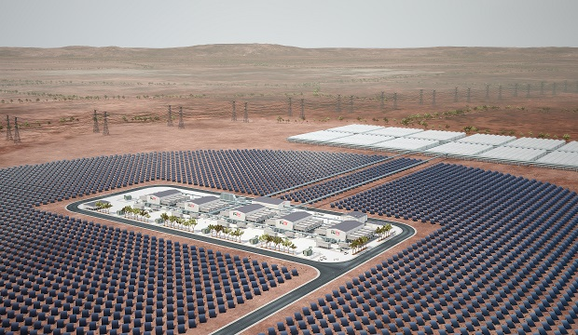

## Interest in renewable energy and clean technologies is at an all-time high amid growing public concern over our changing climate. How can Australian manufacturing capitalise on the opportunities this shift represents? By William Poole.

It’s been an eventful summer. While the bushfires dominated the headlines, Sydney faced widespread flooding following its heaviest rains in three decades, while Canberra was battered by hailstones the size of golfballs. The Great Barrier Reef is reportedly on the brink of further major coral bleaching, and drought conditions persist across much of the country.

Meanwhile, schoolchildren abandoned classrooms to join nationwide Climate Strike demonstrations, and police battled protesters outside a mining conference in Melbourne. New research revealed that Australian summers are now on average 31 days longer compared to half a century ago. And Shane Warne voiced concern about how rising temperatures might impact cricket.

Recent opinion polls indicate that more than three-quarters of Australians are now concerned about climate change, with a strong majority wanting stronger government leadership in addressing the issue. Business attitudes are shifting too, with the the Australian Climate Roundtable – whose members include the AiGroup, the Business Council of Australia (BCA) and the Australian Energy Council – calling for “deep reductions in Australia’s net emissions”.

There’s something in the air.

Except, perhaps, inside the ‘Canberra bubble’. At federal level, energy and emissions policy remains a long-favoured political football.  In February, when Anthony Albanese committed to a target of net-zero emissions by 2050, there was justified scepticism over the lack of detail on how Labor would meet this target. However, the Coalition’s criticism, that Labor had not presented costings for the plan, carried a distinct impression of opportunistic point-scoring. Given the frequency of cost blowouts in much shorter-term government projects, forecasting for a 30-year timeframe seems ambitious. And the Government doesn’t exactly have a clear set of policies in this area either.

Moreover, the net-zero target is hardly controversial. Most state and territory governments – Liberal and Labor alike – have already signed up for it (South Australia is on track to reach net-100% renewable power by 2030), as have the BCA, and several major corporations including Telstra, BHP and AGL. Around 80 countries and 400 cities have adopted the target, in a charge led by British Prime Minister Boris Johnson – not exactly your typical tree-hugging “greenie” radical. Indeed, the Government arguably already took on the target in 2016 when Malcolm Turnbull ratified the Paris Agreement on climate change.

But the continued political skirmishing over emissions and energy has consequences that are felt throughout the country and the economy. According to the Clean Energy Council (CEC), new investment in large-scale renewable energy projects slumped by more than 50% between 2018 and 2019, from 51 projects worth $10.7bn, to 28 projects worth $4.5bn. Kane Thornton, Chief Executive of the CEC, cited policy uncertainty, along with regulatory risks and under-investment in transmission, as key drivers behind the fall, adding that this has implications for the reliability and affordability of energy supplies.

“A continued slow-down in new investment will put greater pressure on reliability and power prices as Australia’s old coal-fired power stations continue to close,” Thornton said. “New investment is critical to replacing these coal-fired power stations and delivering on Australia’s emission reduction targets.”

The collapse in investment reflected earlier findings from the CEC’s latest Clean Energy Outlook Index, released in November, which showed a drop in confidence in clean energy investment over the preceding six months.

“Without strategic and holistic reform of the Australian energy market, we are going to continue to see confidence in new clean energy investment continue to fall,” said Thornton. “Australia has abundant natural resources and huge potential for renewable energy generation, but the industry has been plagued by policy and political uncertainty at the federal level for several years and we are now starting to see the impact of this.”

Despite these setbacks, however, there are still Australian companies out there developing innovative new clean technologies and embracing the opportunities these create for the manufacturing industry in this country.

**Capricorn Power – An engine for opportunity**

The story of Capricorn Power begins with former CSIRO scientist Dr Noel Barton AM. Having long recognised the challenge posed by global warming, Dr Barton set about finding ways to tackle it after retiring from the CSIRO. The area where he realised he could make a difference was heat engines.

“Most people haven’t heard of heat engines, but over 75% of the world’s power comes from them,” say Mike Hodgkinson, CEO of Capricorn Power. “And yet 72% of the electricity generated by heat engines is wasted. They’re not all that efficient. So Dr Barton went out to create the world’s most efficient heat engine.”

Dr Barton took his concept to some angel investors, who initially thought it too good to be true, so they hired award-winning Geelong-based engineering company Austeng to independently assess it. Not only did the concept hold up, but Austeng liked it so much they took an equity stake and became Capricorn’s manufacturing partner. Formally established in 2017, the company began work on a prototype; in a nice case of Australia’s manufacturing past laying the ground for its potential future, testing was conducted using engines from second-hand Holden Commodores.

“In early 2018 we won a Regional Innovation Grant, which allowed us to build the first prototype,” Hodgkinson continues. “We successfully tested it at a customer site as well as in the factory. Then we designed the commercial engine. We lost a bit of time raising capital, then at the end of last year we finally raised investment through crowd-sourced funding and got a grant from the the Advanced Manufacturing Growth Centre (AMGC), which means we’re now actually in the final stage of detailed design for a demonstration in October.”

Capricorn today operates as a lean, light-on-its-feet start-up, working out of office space within the University of Melbourne. Barton remains involved as the company’s Chief Technology Officer (CTO), with four permanent employees bolstered by a rolling line-up of contractors who come onboard for particular projects, bringing the total head count to around 16.

“I expect we’re about to hit the fast-growth period where you double the head count every year, which is a very exciting time,” adds Hodgkinson.

Capricorn’s technology has applications across a range of areas encompassing energy efficiency and renewable energy. The Barton engine can essentially be deployed with any heat source exceeding 300 deg.C – for example, furnace waste, landfill gas, exhaust heat or waste incineration – and generate electricity.

“The analogy is that people use solar panels on their roofs at the moment to generate electricity,” says Hodgkinson. “We attach a container to your waste heat source, and generate on-site electricity. And that’s a lot more electricity. We’ve got a footprint of less than 0.5% of solar PV panels per kilowatt-hour, so we generate with a much higher power density. And just like solar PV, anything you don’t use can be exported onto the grid.”

Compared with similar technologies already in operation, the Barton engine offers several advantages. For example, the most widely used process, the Organic Rankine Cycle (ORC) engine, generates a fraction of the electricity and is limited in the settings where it can be installed. Moreover, Capricorn’s system is compact, versatile and scalable, delivered ready for installation in a standard 20-foot shipping container.

Eventually Capricorn’s technology could be deployed in energy utilities or in heavy manufacturing operations such as BlueScope Steel. Initially, though, Capricorn is targeting small and medium enterprises (SMEs) where it can offer clear energy efficiency gains. One early customer is Victorian manufacturer Furnace Engineering, which saw an opportunity to use Capricorn’s system coupled with thermal storage to load-shift the heat it creates overnight for electricity generation during the day.

Hodgkinson sees enormous export potential for his product: “I like to call it one of the biggest market opportunities in the history of markets, because the electricity market is large and growing. As the world’s population grows, it’s driving a desperate search for sustainable energy.  Water-free energy as well. The Loy Yang Power Station uses about 20% of Melbourne’s water supply. As water becomes more scarce, that’s not sustainable. Our technology is water-free. So does this have export potential? Absolutely. If we can keep control of the intellectual property in Australia, this could be very big in terms of exports overseas.”

Keeping that IP in the country is, according to Hodgkinson, one of the big challenges in developing innovative products and bringing them to market – a challenge he partly attributes to difficulties in raising early-stage investment: “There’s a real problem in Australia in terms of raising early stage investment, so it’s a pressing issue to keep IP in Australia. A lot of companies end up having to take on investment from overseas, which then draws them overseas.

“The biggest challenge for commercialising products is that it’s not enough to be right about something. You’ve got to be right at the right time. And more important than creating a great product, you’ve got to have customers that want to buy it.”

Looking to the future, the team at Capricorn is currently heavily focused on October, when the first commercial engine is due to be demonstrated. After that, once the system’s reliability is proven, Hodgkinson anticipates the business will be able to ramp up quickly. One area that is gaining momentum is in the bio-energy space.

“We’ve got a partnership with a pyrolysis provider,” Hodgkinson explains. “Pyrolysis is taking waste, particularly green waste, and turning it into heat and biochar. This is a form of carbon capture and storage, because the biochar locks up the carbon for hundreds of years. So it’s almost an agribusiness play, because you can use the biochar for feedstock and enhancement of soil for agricultural production. And we take that heat and turn it into electricity. And our technology enables that to happen at relatively small scale. We’ve got a few projects we can host at landfill sites or other suitable locations, so it’s these distributed smart energy hubs that we can hook in. Wherever there’s green waste, we can put one of these systems in. And of course, those are manufactured systems as well.”

Indeed, Hodgkinson sees great opportunities for Australian manufacturers in renewable energy and right across clean tech: “The clean tech space is enormous; it is an absolutely huge opportunity. There’s no reason why innovative Australian companies can’t make the most of that. It’s like a frontier opening up at the moment and people should grab it while they can, or obviously other companies around the world will take it instead. Australia certainly has world-leading ideas. Our challenge is commercialising them and taking full advantage of them globally.”

**1414 Degrees – Hot prospects**

Based in Adelaide, 1414 Degrees specialises in large-scale energy storage systems. The company was first established in 2009 by a group of investors who recognised that the rise of renewables would create a need for storage to shore up the intermittency of electricity supplied from renewable sources. However, unlike electro-chemical batteries of the kind marketed by Elon Musk’s Tesla, 1414 Degrees’ devices store energy as heat in silicon, which can then be used either as a direct heat source, or to drive turbines and generate electricity.

“Our device is not a battery,” says Dr Kevin Moriarty, CEO at 1414 Degrees. “We do use electricity to charge it, but we store it thermally, recover that energy as thermal energy, and then we can use it to drive turbines or to provide heat – in the same way that conventional power stations are often positioned next to industry to provide heat for industrial processes.

“When you charge or discharge lithium-ion or lead acid batteries, it causes a chemical change. We’re not making any chemical changes to the silicon. It’s like water freezing and melting and then refreezing, we do the same with silicon. Pure silicon melts at 1414 degrees Celsius – hence our name.”

While working at such high temperatures requires some specialised engineering, Moriarty maintains that 1414 Degrees’ device is relatively simple, likening it to “a giant esky” – albeit with an extremely strong steel shell. Moreover, while minerals required for batteries, such as lithium, are comparatively rare, silicon is the second-most abundant element in the Earth’s crust. Silicon also has close to the highest latent heat of any element. And while the chemicals used in batteries eventually become depleted and can be difficult to recycle, the silicon in 1414 Degrees’ machines remains unchanged and can be reused in perpetuity.

“Batteries are lovely things,” says Moriarty. “But they are good for short-term supply, not the industrial scale we work at. Our devices are built to be cycled as often as possible, preferably at least once a day, and they don’t degrade in performance or capacity. In fact, they’re most efficient when kept working around the clock.”

Batteries are also direct current machines, whereas 1414 Degrees’ systems are based on alternating current. This means they don’t need to be close to an energy generation source, be that a wind or solar farm, or a conventional power station. Indeed, the devices are designed to be positioned around the electricity grid.

“We’ll probably position most of our storage out around the grid because we want to supply heat to industries. We’re positioning and building devices for a bunch of industries that have come to us saying ‘We want a solution for our heat. Electricity also, but batteries can’t do heat, and we want to lower our heating costs.’ So, our technology is currently being driven by industries – many of them, very large industry.”

Today 1414 Degrees employs a team of 23, most of whom are engineers. One of its devices has already been operating for 12 months at SA Water’s wastewater treatment plant in Glenelg. Biogas produced by the plant had been burnt off using gas engines. However, by-products of the gas include hydrogen sulphide, which was becoming sulphuric acid, and abrasive compounds that damaged the engines. SA Water figured that 1414 Degrees’ system could cleanly burn off the gas without the need to service or replace engines. The heat generated would sustain the microbes needed to break down the sewage in the process vats, and the accompanying energy could be stored and time-shifted to when power prices are high on the grid.

“SA Water asked us to test whether our device could replace or augment their biogas generation,” says Moriarty. “They asked us to put in a pilot machine, which we’ve done, and it operated – to everyone’s very pleasant surprise – instantly. It’s a 10MWh device, roughly the size of a shipping container, and it’s operating very satisfactorily.”

Another project in the pipeline has seen a feasibility study undertaken on installing an electrically charged device at the Stone & Wood brewery in Murwillumbah, New South Wales, later this year to replace the facility’s current LPG-fired boilers. And the company recently purchased SolarReserve Australia II, as part of a plan to install its technology at the Aurora Solar Energy Project near Port Augusta and deliver stable power to the grid.

Moriarty sees a significant breadth of industries where the technology could be implemented: “Everybody from packaging manufacturers to breweries, through oil refineries, food processing, especially large ones… We’re mainly interested in the big end. And power stations, even coal- or gas-fired ones, have been looking for ways to even out the big variations in power prices on the grid. They think it might be good to store the energy and then regenerate it.”

It has been a lengthy undertaking getting 1414 Degrees and its innovative products to its current position, and Moriarty emphasises the need for a dedicated team: “As with any new technology, you might have the right idea, but you’ve got to actually come up with a device and get it working. You do need engineers and investors who are all prepared to invest the time and money in a relatively uncertain outcome. You need people driven by an understanding of the need for something new, people with a certain amount of what I call ‘relentless optimism’ that you’re going to come up with something that works.”

Nonetheless, he anticipates substantial interest in 1414 Degrees’ products, both in Australia and overseas: “There is huge demand. We haven’t had to do any marketing to potential users or customers of our systems. They want to reduce costs, but in many cases, it’s been driven by two things: to have a reliable supply of heat and electricity, and to reduce emissions.”

It all seems to spell out a lot of positives for Australia: a groundbreaking clean technology, developed locally, using an element highly prevalent in the Earth’s crust, in a country with a strong record of digging stuff out of the Earth’s crust. Moriarty says most of the silicon will be sourced from smelters in Western Australia. But what about opportunities for Australian manufacturers?

“Well we already use them,” he says. “There were about 100 different suppliers for the biogas test, which we manufactured here in our own workshop in Adelaide. Everything from electrical components through to steel fabrication. There’s a lot of stuff that was made in Australia, manufactured to our specification, and a lot of specialised expertise from companies.

“Down the road, we’re going to get big fast, so there’s going to be a big demand for everything. We’ll effectively create a new supply chain for building these silicon storage modules, thousands of tons of containment. There’s going to be a lot of manufacturing activity associated with that.”

**Grasping the potential**

What’s striking about both Capricorn Power and 1414 Degrees is that neither of them are working in areas typically associated with renewable energy or clean tech. Thinking about those sectors might conjure images of wind turbines or solar panels. But these two companies are instead developing innovative, high-value products and technologies that occupy very specific niches, providing solutions to very specific problems. Both companies are engaged in a very Australian kind of innovation, and they tick a lot of the boxes usually cited as defining characteristics of the type of business that will provide the foundation for advanced manufacturing in Australia in the future.

Perhaps that’s the problem that has dictated the political and commercial response to climate change up to this point: there’s been an overwhelming focus on the cost of addressing the problems, rather than the opportunities that flow from finding those solutions.

It’s a point not lost on Professor Ross Garnaut. An economist and professorial research fellow at the University of Melbourne, in 2008 he produced the Garnaut Climate Change Review for the Federal Government , examining the impact of climate change on the Australian economy and outlining potential policy responses; he provided an update for the review in 2011. Last November he published Superpower: Australia’s Low-Carbon Future, a book detailing how Australia could become an economic superpower in a future post-carbon world.

At a launch event for the book, Garnaut described how renewable energy costs have fallen far faster than he had forecast in his reviews: “I had to make assumptions about how rapidly the cost of renewable energy would fall – by about 3% per annum. In the decade after that, costs for solar fell by 85%, which is much greater than 3% per annum. We’ve also had very rapid reductions in the cost of storage of power. So in the best locations, with the richest renewable energy resources, it’s now substantially cheaper to produce power from new sources than from a new coal or gas power station.”

Moreover, the world’s richest renewable resources, in terms of wind and solar, are in Australia – “by a very wide margin”, according to Garnaut. “So in a world in which we’ll be producing everything with zero emissions, as we have all agreed to do (under the Paris Agreement), in Australia we’ll have some special advantages. We’ll be the low-energy-cost country in the world if we make good use of these resources.”

Garnaut sees all sorts of possibilities flowing from this for Australia, from exports of zero-emission industrial products such as ammonia, to transmission of electricity to Asia via high-voltage cables. He sees a parallel opportunity in our abundant forests and woodlands for sequestering atmospheric carbon in the soil, potentially generating much needed income for rural Australia through the sale of carbon credits.

One particularly promising area is in metal exports. Australia is already the world’s largest exporter of aluminium and iron ores, which are processed into metals overseas, often to then be sold back to us. Garnaut envisages Australia becoming a global hub in the manufacture of zero-emissions aluminium and iron – the latter using green hydrogen.

“If we turn one-tenth of our exports of iron ore, and one-quarter of our exports of aluminium exports into metal, then that will produce more income and jobs and exports than all of our coal and liquefied natural gas exports.”

In an article he wrote recently for The Conversation, Garnaut outlined some of the policy steps the Government should adopt to realise this opportunity. But he also stresses that events elsewhere will dictate the pace of change, as other countries move quickly to decarbonise their economies and industries

“Movement will come gradually, initially with public support for innovation; then suddenly, as business and government leaders realise the magnitude of the Australian opportunity,” Garnaut wrote. “The pace will be governed by progress in decarbonisation globally. That will suit us, as our new strengths in the zero-carbon world grow with the retreat of the old. We have an unparalleled opportunity. We are more than capable of grabbing it.”



## The Australian Manufacturing Technology Institute Limited (AMTIL) is the peak national body that represents the interests of manufacturing technology suppliers and users within the precision engineering and advanced manufacturing sector.

<https://amtil.com.au/about/who-is-amtil/>

## Future of Australian manufacturing relies on producing high-quality products

<https://adepteconomics.com.au/future-of-australian-manufacturing-relies-on-producing-high-quality-products/>

Adept Economics

In mid-February 2020, Greg Sheridan wrote in [The Australian](https://www.theaustralian.com.au/commentary/we-lack-the-will-to-have-a-manufacturing-industry/news-story/04a38e7f1e257bdb1b0a5cd6a8a2df92) that Holden’s recent shut-down should be considered a “cultural tragedy” for Australia, and reflective of the quality of Australia’s misinformed environmental and free-market economic policies over the past few decades. But are things really that bad?

What about the success stories in Australia? [Røde Microphones](https://www.youtube.com/watch?v=7SBKi9W7JM4), for example, has experienced sizable growth since it was founded in 1967, and is now considered a global leader in the microphone manufacturing industry. [Peter Freedman](https://www.australianmanufacturing.com.au/9372/microphone-manufacturer-proves-the-australian-manufacturing-industry-is-not-yet-dead), owner of Røde, currently employs over 250 highly skilled workers and when asked about his decision to retain his manufacturing base in Australia, he responded: “I was in China three weeks ago and you see them operating quite old gear with five people on it, earning very little money and I laughed because my gear has got nobody running it”.



The Røde PodMic

Quality products can come at a higher price initially, but their true value will prevail over time. This is why the Australian manufacturing industry outlook may not be as gloomy as people think.

In his article, Greg Sheridan cited a recent [Harvard Kennedy School of Government study](http://atlas.cid.harvard.edu/) that ranked Australia’s economy eighth in terms of wealth, but 93rd in terms of the complexity of its exports. Complexity was measured by looking at the mix of exported products and their destinations. The lack of economic complexity, Sheridan explains, is largely due to Australia’s top 10 exports – coal, iron ore, gas, education, tourism, gold, aluminium ores, beef, crude oil and copper – relying too heavily on a thriving Asian market and not enough on uniquely specialised technology (education is the only export considered hi-tech in the study).

A diverse range of product exports allows economies to handle adversity, and there is no doubt that it should be valued. The novel coronavirus, Covid-19, could make Australia’s over-reliance on its Asian counterparts abundantly clear. But to claim that the passing of Holden is a “catastrophic loss of capacity, complexity and competence across our economy, a dumbing down of our society, a needless limitation on our potential and a serious dent in our national security” is excessive.

## Current state of things

[ABS](https://www.abs.gov.au/AUSSTATS/abs@.nsf/DetailsPage/5206.0Sep%202019?OpenDocument) data shows that the Australian manufacturing industry has contracted over recent years, with gross value added and employment numbers decreasing quite steadily. But the industry still produced $105 billion in gross value added and employed 912,500 people in November 2019.

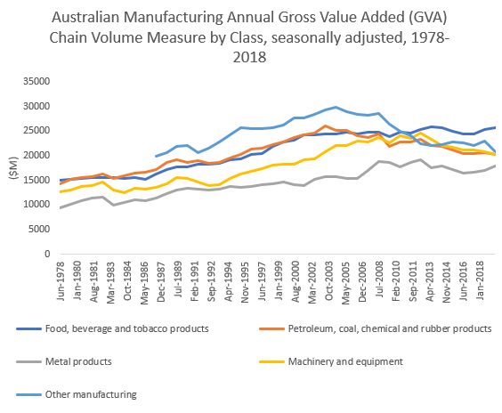

Source: ABS

Yes, the Australian manufacturing industry has contracted in terms of employment and GVA and is being overshadowed by the resources sector. But this is arguably what we would expect to see based on the economic principle of comparative advantage. As the celebrated Heckscher-Ohlin Theorem states:

A nation will export the commodity whose production requires the intensive use of the nation’s relatively abundant and cheap factor and import the commodity whose production requires the intensive use of the nation’s relatively scarce and expensive factor.

Dominick Salvatore, *International Economics* (1995: Prentice-Hall International), 118.

Over-reliance on a limited number of commodities and trading partners may raise eyebrows, but we should not be shying away from where our advantages lie for the sake of complexity.

## Challenges for Australian manufacturers

It is true that Australian manufacturers face a particularly harsh set of conditions. According to the [Queensland Productivity Commission](https://qpc.blob.core.windows.net/wordpress/2018/04/Manufacturing-Final-Report.pdf), conditions which have affected Australia’s manufacturing industry negatively over recent decades include:

* fluctuating input costs (due largely to a volatile exchange rate),
* energy costs,
* labour costs,
* strong international competition,
* changing markets and consumer preferences,
* relative remoteness market, and
* integration with global value chains.

Even relative to other advanced economies, Australia is considered a high-cost location for manufacturing. This was reflected in the [Boston Consulting Group Cost Competitiveness Index](https://www.bcg.com/publications/2014/lean_manufacturing_globalization_australia_manufacturing_cost_competitiveness.aspx), which placed Australia last in terms of location desirability in a study of 25 different economies. BCG attributed this lack of cost competitiveness to the resources and infrastructure boom, which contributed by “driving up wages and the Australian dollar… by drawing away capital”.

## Looking forward

To compete internationally, many successful Australian manufacturers are demonstrably differentiating themselves through producing and marketing superior products – the so-called “Australian made” brand. Although certain costs such as intensive R&D and wages for a highly skilled workforce must be shouldered, consumers are willing to pay a premium for quality in many cases. For example, consider Australia’s pharmaceutical industry, which according to [IBISWorld](https://www.manmonthly.com.au/news/australias-top-100-manufacturing-companies-revealed/) senior industry analyst Liam Harrison is expected to perform in the near future due to “[Australia’s] strict medical standards and regulations”.

Additionally, in the 2018 [*Australia’s Tech Future*](https://www.industry.gov.au/sites/default/files/2018-12/australias-tech-future.pdf) report published by the Department of Industry, Science, Energy and Resources Report, the growing role of digital technologies – such as robotics, artificial intelligence, advanced modelling software, 3D printing, cloud-based tools, and Internet of Things – is modernising business process operations and monitoring. Already we can see that Australia’s manufacturing industry is becoming something very different to what it once was – i.e. factories full of labourers.

[3D printing](https://www.youtube.com/watch?v=xtjFGe-Wf_M) in particular has the potential to radically transform the manufacturing industry and global economy. Since the expiration of a patent in 2009, 3D printing has taken off in start-ups and research labs. Aside from printing usable human body parts, entire rockets and even skyscrapers, the new technology has the potential to seriously disrupt international trade. By cutting production times and reducing transport costs, it has been described as the impetus for the fourth industrial revolution. 3D printing is just one of the groundbreaking technologies that will dictate the future of the manufacturing industry. It is here that the debate should be centred: how can we ensure the most optimal adoption of new technologies to ensure a viable and thriving future for the Australian manufacturing industry?

Despite losing around 55,000 jobs since 2012-13, the Australian manufacturing industry is far from dead. That said, it is changing. To keep up with challenging market trends and a competitive environment, Australian manufacturers must understand the value of their products and shout this loud and clear to consumers. A focus on high-quality products and making best use of a highly-skilled workforce will be the future of Australian manufacturing.

*This article was prepared by Adept Economics Research Assistant Ben Scott and Director Gene Tunny. If you’re in the manufacturing industry, or sell Australian-made products, you may be interested in the Adept Economics video below.*

**The Australian manufacturing industry is not dying, it’s evolving: CSIRO study**

<https://theconversation.com/the-australian-manufacturing-industry-is-not-dying-its-evolving-csiro-study-69398>

November 28, 2016

[Cathy Foley](https://theconversation.com/profiles/cathy-foley-1066) Deputy Director and Science Director Manfacturing Flagship CSIRO, CSIRO

[Keith McLean](https://theconversation.com/profiles/keith-mclean-318305) Director, CSIRO Manufacturing, CSIRO

Despite the [well publicised closure of some manufacturing sectors](https://theconversation.com/does-it-matter-if-australia-no-longer-manufactures-things-25541) in Australia, manufacturing isn’t dying. Instead, like industry around the world, it’s undergoing a period of significant change as new, disruptive technologies and economic realities take hold and new markets emerge.

There is a role for the manufacturing sector in Australia. Through interviews with 56 stakeholders, three workshops and a survey of industry and government organisations, as well as leading researchers, [CSIRO identified major growth opportunities](http://www.csiro.au/en/Do-business/Futures/Reports/Advanced-manufacturing-roadmap) and what the manufacturing sector needs to do to achieve them.

Currently [Australian manufacturing contributes](http://www.abs.gov.au/ausstats/abs@.nsf/mf/5206.0) 6.05% of Gross Domestic Product (GDP), [exports A$96.1 billion](http://www.abs.gov.au/ausstats/abs@.nsf/mf/5368.0) of goods and employs 856,000 people. This has [fallen from a high in 1995](http://www.pc.gov.au/research/supporting/changing-manufacturing/changman.pdf), when it contributed to 14% of GDP and employed more than a million people.

High wages, geographical remoteness and a small dispersed local market [are some of the reasons for these changes](http://www.industry.gov.au/Office-of-the-Chief-Economist/Publications/Documents/AIR2015.pdf). However consumers are also changing what products they buy which then impacts the type of products made.

Major companies like Boeing and General Electric now look to the world using global supply chains for components for their final product, so Australia has to compete globally.

The innovation resulting from science and technology, such as automation, digitisation and new materials, has changed the equation of what it means to be a manufacturer. Manufacturing is no longer a basic industry that employs low-skilled workers.

Over the next 20 years, Australia’s manufacturing industry must transform into a highly-integrated, collaborative and export-focused “ecosystem” that provides high-value customised solutions contributing to global supply chains.

Our research brought up some exciting examples of Australian companies that have already embraced this evolution, setting a standard to follow.

## Customised high-margin solutions

We found that demand for more expensive bespoke products is replacing mass-produced products relying on value from producing a lot for the market. New materials, automation, biotechnology and new chemical processes have driven this innovation in manufacturing.

These new technologies enable a new level of customisation. Products like [personalised medical implants](http://www.anatomics.com/) and [functional foods](http://www.gfrpharma.com/nhp-manufacturer/functional-foods/) and [clothing](https://www.shoesofprey.com/) are already possible thanks to the combination of design services and superior components (such as 3D printing).

Small to medium enterprises (SMEs) make up 97% of Australia businesses. So customisation is an ideal recipe for Australian SMEs to achieve global reach without the need for producing more goods than their competitors.

An example of an Australian company doing this well is [Oventus](http://oventus.com.au/). They produce an O2Vent mouthpiece for those that suffer sleep apnoea. Oventus uses a 3D scanner to map a patient’s mouth, then 3D prints a custom-made mouthpiece that helps stop dangerous pauses in sleep at night. Its custom fit and relative comfort attract a price premium. The company recently listed on the Australian stock exchange and is about to go global.

## Collaboration

Too often Australian manufacturers focus on the rival across the street, rather than the looming competition over the horizon.

Our research shows manufacturers need to partner among themselves, either through business partnerships or increased collaboration. [Nautitech](http://nautitech.com.au/) and [Northern Light Technologies Australia,](http://www.nltinc.com/) for example, were brought together by a mining company to improve underground communications.

These two companies combined hardware from one company and software from the other to provide mobile Wi-Fi coverage for mine sites. It allows miners to monitor worker safety, fleet optimisation, machine performance and also allows autonomous mining and productivity improvements.

## Global supply chain integration

In a global marketplace, Australia cannot stand on its own. The Australian market alone is too small - our population is the size of Shanghai, China.

Australia has few multinational companies manufacturing here. However multinational companies do source components from the best suppliers globally and herein lies the opportunity for Australia.

For example, manufacturer [ANCA Tools](https://www.anca.com/Home) delivers specifically designed parts to Japan. These parts are made using the company’s multi-axis grinding machines.

These machines, designed and built in Australia, are automated and wired up for flexible and precision manufacturing. The components are integrated into Japanese customers’ unmanned, factory-wide automated production systems.

Manufacturers need to integrate into international supply chains; using Australia’s advanced technology industry and research sector, to stand out from the crowd. One example of this highlighted from our research is [Carbon Revolution,](http://www.carbonrev.com/) a company that pioneered the commercial production of carbon composite car wheels. These wheels are made from a single piece of material.

Carbon Revolution is supplying Ford with wheels for the Mustang Shelby GT350R, making it the first company in the world to supply mass produced carbon fibre wheels on standard equipment for a major automaker.

The wheels weigh up to 50% less than conventional aluminium equivalents and reduce carbon emissions by up to 6%. Carbon Revolution is now investigating opportunities in aerospace and industrial markets.

## Increased role for the research sector

Australia’s research sector can play a critical role in the future of Australian manufacturing, providing the significant technological innovation needed to drive future prosperity.

Publicly funded research agencies in Australia are already building stronger industry engagement. In our research, Australian manufacturers have identified the science and technology gaps that need filling.

These companies want to use research results to be able to differentiate, make manufacturing processes more efficient, monitor in real time and drive decision making with data. Australian research institutions need to adapt to these demands.

The establishment of open access hubs such as [Lab22](https://research.csiro.au/metals/add-manufacturing/aus-innovation/), the [Australian National Fabrication Facilities (ANFF)](http://www.anff.org.au), [industry collaboration spaces](http://www.fledge.com.au/) in research organisations, researchers in business, industry PhDs and internships are all examples of initiatives to link the research and manufacturing sectors.

Australia has a high level of education, an excellent research sector, vast natural resources, a reputation for quality, keen SMEs and close proximity to a burgeoning Asia. The strengths far outweigh the weaknesses.

**The future of manufacturing in Australia is smart, agile and green**

July 6, 2015 6.16am AEST

[Alan Finkel](https://theconversation.com/profiles/alan-finkel-95610)

Chancellor, Monash University

[Cathy Foley](https://theconversation.com/profiles/cathy-foley-1066)

Deputy Director and Science Director Manfacturing Flagship CSIRO, CSIRO

[Veena Sahajwalla](https://theconversation.com/profiles/veena-sahajwalla-16348)

Professor and Director of the Centre for Sustainable Materials Research and Technology (SMaRT), UNSW

<https://theconversation.com/the-future-of-manufacturing-in-australia-is-smart-agile-and-green-43645>

his article is part of our series on the [*Science and Research Priorities*](http://www.science.gov.au/scienceGov/news/Pages/PrioritisingAustraliasFuture.aspx) recently announced by the Federal Government. You can read the introduction to the series by Australia’s Chief Scientist, Ian Chubb, [*here*](http://theconversation.com/australias-chief-scientist-on-getting-our-research-priorities-right-43833).

**Alan Finkel**  
Chancellor of Monash University, and Fellow and President of the Australian Academy of Technological Science and Engineering (ATSE)

In a rapidly changing world, attempts to preserve the past will doom the future. The [research priorities](http://www.science.gov.au/scienceGov/ScienceAndResearchPriorities/Pages/ThePriorities.aspx) seek to avoid that trap by identifying the need for our industries to be agile and transformative, to provide high value-add and to recognise their place in a complex global supply chain.

The research priorities also note the importance of seeking to dominate in selected niche product categories where we already have some wins, such as high-performance materials, composites, alloys and polymers.

Not explicitly stated in the priorities, though, is the reality that the efficiency of tomorrow’s industries will be driven by automation and artificial intelligence. More will be achieved with fewer workers.

We must accept that revenue growth in manufacturing will not routinely be accompanied by jobs growth in the manufacturing industry itself. That is not necessarily a bad thing, because as new wealth is created it will be invested in services, health and other industries, with net creation of jobs.

If we are smart about aligning our research to our priorities, there will be ample opportunity for us to develop advanced manufacturing techniques to create, or in some cases, bring back added-value manufacturing in food and resources, and expand our achievements in medical devices.

We will be able to improve quality and productivity, improve scheduling and logistics, and in many cases produce products in Australia more cheaply than we could import products of equivalent quality.

But measuring our success in manufacturing will be confounded by its changing nature. For example, printing and distributing text books is clearly a manufacturing industry. In the future, when textbooks fully transition to online delivery, will that mean that the manufacturing jobs in that sector have been wiped out?

Or should we think of the engineers who develop and maintain the cloud-based delivery systems as the manufacturing workers of the future? We must learn to value our successes in the context of a changing definition of what we are measuring.

**Cathy Foley**  
Deputy Director and Science Director of the Manufacturing Flagship at CSIRO and former President of Science and Technology Australia

The fourth industrial revolution has started! Known as [Industry 4.0](https://en.wikipedia.org/wiki/Industry_4.0), in 15 years time [40% of the jobs we know today will not exist](http://theconversation.com/australia-must-prepare-for-massive-job-losses-due-to-automation-43321), and the way we manufacture products and get them to the consumer will be radically different.

Just-in-time, personalised, agile and adaptive “creator robots and machines” will build a world that is a little like the Jetsons cartoon from my childhood. But this means that, as a country, we have to change our approach to manufacturing too.

Having standalone industrial companies and innovation organisations doing their own thing, competing against one another, simply will not work.

We need to reset our thinking to compete globally and collaborate locally. Australia’s success in Industry 4.0 will pivot on our willingness to shift our currently poor ability to collaborate across sectors – such as from research to industry – and within sectors – industry to industry, and research organisation to research organisation – so that we can move rapidly up the ranks and be a world leader in collaboration.

We currently rank [81 out of the 143 OECD economies](http://www.globalinnovationindex.org/) for innovation efficiency. We have all the components we need to do this: top-class research; great design; well-educated citizens; a strong small-to-medium enterprise community; and a terrific services industry.

We are poised to make that transition. But our focus can’t remain on competing among ourselves, whether it is between academic institutions, states or within local industry sectors.

Can we be a “big” enough country to rise above the local and think global? I think we can.

**Veena Sahajwalla**  
Scientia Professor, and Laureate Fellow and Director, SMaRT Centre, UNSW Australia

Last year, I wrote about the ability of [engineers to build Australia into the future](https://theconversation.com/building-the-nation-will-be-impossible-without-engineers-23191) by fostering invention and innovation. I still believe it will be engineers who can deliver previously unimaginable solutions, like green manufacturing, which is an area that will transform the manufacturing industry.

Australian industries need the flexibility, insight and foresight that comes from thinking creatively, asking critical questions, forming and testing hypotheses and reasoning quantitatively. They also need access to the research and technologies that will add value to manufactured products.

At the Sustainable Materials Research and Technology Centre ([SMaRT](http://smart.unsw.edu.au/)) at UNSW, we are working on green manufacturing in collaboration with industry, using waste and end‐of‐life products as raw materials.

We are rethinking the way we have traditionally done manufacturing and looking at creating new resources from waste. But it is fundamental and applied research that have created the foundations of where we are today.

The ability to produce ferrous alloys from auto waste and copper-based alloys from e-waste is also forcing us to rethink mining, which has traditionally been about extracting raw materials and sending them long distances, with one large processing plant transforming them into usable material.

Not only are natural resources being depleted at an unsustainable rate, industries are beginning to recognise the cost-effectiveness of reusing materials, and the importance of high value-add, small, agile and localised processing facilities.

Silicon from silica in glass, or copper from e-waste, are extremely valuable, so we need to look past the fact that initially they present as waste. This is where science and innovation come in. It’s looking for the beauty within. The future manufacturing scientists and engineers will be creating high-value materials by discovering novel green manufacturing solutions.

I see a huge opportunity for green manufacturing in micro-factories across regional Australia, and new jobs for regional communities that offer economic opportunities in tomorrow’s industries. We believe these new industries can happen on a small scale quite effectively based on new scientific discoveries.

In Australia, where our population is small and the tyranny of distance presents its own challenges, doing it cleaner and smarter, and developing innovations that are good for the environment and sustainable on every level, offers huge economic benefits and a brand new manufacturing sector built around transforming waste into resources.

[Home](https://www.minister.industry.gov.au/front) > [KarenAndrews](https://www.minister.industry.gov.au/ministers/KarenAndrews) > [Media Releases](https://www.minister.industry.gov.au/ministers/KarenAndrews/media_releases) >  Developing advanced capabilities for sustainable manufacturing

<https://www.minister.industry.gov.au/ministers/karenandrews/media-releases/developing-advanced-capabilities-sustainable-manufacturing>

## Developing advanced capabilities for sustainable manufacturing

*11 October 2019*

**Joint media release with the Minister for Education the Hon Dan Tehan and Senator David Van**

New research will drive the adoption of environmentally friendly chemistry in Australian manufacturing that will lead to new products and processes with strong export potential.

New innovations based on green chemistry principles applied in manufacturing will increase the adoption of green and sustainable chemistry practices in manufacturing, and provide technical and professional training for the future research leaders in the industry.

Minister for Education Dan Tehan today announced the Morrison Government would provide $3.6 million to establish the Australian Research Council (ARC) Training Centre for Green Chemistry in Manufacturing at Monash University.

“This new training centre will put Australia at the forefront of using green chemistry, which means another advantage for Australia’s manufacturing industry,” Mr Tehan said.

“The centre will provide postgraduate students and post-doctoral fellows with industry-relevant skills that will give them the confidence to lead the Australian manufacturing industry towards adopting green and sustainable technologies.

“Our Government is strategically investing in partnerships between universities, industry and government to drive the commercialisation of research.”

Minister for Industry, Science and Technology Karen Andrews said a competitive manufacturing industry often relies on good chemistry.

“Chemistry provides inputs for many manufacturing products and processes, as well as representing a global industry in itself,” Ms Andrews said.

“Backing innovation in green chemistry is a sure-fire way to create the jobs of the future.”

Monash University President and Vice-Chancellor Professor Margaret Gardner AO said the new ARC Training Centre would be part of the university’s established international hub driving transformation in Australia’s chemical industries.

“This development provides an engaging and high-tech environment in which students, academics and industry professionals teach, learn and collaborate to enhance the international competitiveness of the Australian industry, and ultimately help make the world a better place,” Professor Gardner said.

Senator for Victoria David Van welcomed the involvement of Monash University and the focus on high-end manufacturing techniques.

“Victorian manufacturers will look to the research undertaken at this training centre to better improve their own processes. This will ensure they are at the forefront of environmentally-friendly technology.”

The training centre will attract a total of $7.7 million in cash and in-kind support and involve collaboration with 28 participating organisations across three countries.

More information is on the [ARC website](https://www.arc.gov.au/grants/linkage-program/industrial-transformation-research-program/industrial-transformation-training-centres).

# ARC Industrial Transformation Research HUB - IH130200025

## Transforming Waste In Cost Effective Green Manufacturing

<http://www.greenmanufacturinghub.org/>

## [Launch of a Research Hub to Transform Waste for a 'Greener' Manufacturing Future](http://www.greenmanufacturinghub.org/)

Representatives of industry, government and science have helped officially launch the $8.8 million Australian Research Council Green Manufacturing Hub, led by UNSW Scientia Professor Veena Sahajwalla. The collaboration between industry partners and researchers at UNSW, the University of Sydney, the University of Wollongong and Monash University is focused on developing new processes to direct waste into industrial production and create valuable commodities.

## [Australia-Korea Joint Sustainability Conference](http://www.greenmanufacturinghub.org/)

Following the signing of an MOU between the Centre for Valuable Recycling (VaRec), South Korea, and UNSW, Sydney Australia this conference brought together researchers, and industry partners, from Korea and Australia to focus on the opportunities...

## [Microfactories: Advanced Manufacturing](http://www.greenmanufacturinghub.org/)

## Revitalising Manufacturing, Creating Jobs and Reducing Waste

The creation of innovative products from waste using the latest modular microfactory technologies from UNSW will result in thousands of new jobs across regional and metropolitan Australia. In collaboration with industry partners, the Hub has developed green manufacturing technologies that turn many types of common waste streams into saleable products.

## Hub Project Summary

This “Green Manufacturing” Research Hub will create a unique opportunity for completely different industries to come together, with a common goal of creating value from mixed plastic and glass waste in manufacturing. Starting with fundamental investigations of the transformation behaviour of waste materials under high temperature conditions, we will develop scalable solutions for our manufacturing partners towards reducing the consumption of primary resources while simultaneously diverting waste streams from landfill. Additionally, the potential of using such transformations to yield improved products such as wear-resistant grinding media and light-weight building materials will be established, thereby enhancing Australian manufacturing.