**What is Carbon Farming?**

Carbon Farming is simply farming in a way that reduces Greenhouse Gas emissions or captures and holds carbon in vegetation and soils. It is managing land, water, plants and animals to meet the Triple Challenge of Landscape Restoration, Climate Change and Food Security. It seeks to reduce emissions in its production processes, while increasing production and sequestering carbon in the landscape.

Carbon Farming can range from a single change in land management, such as introducing no-till cultivation or grazing management, to a whole-of-farm integrated plan which maximises carbon capture and emissions reduction. Carbon Farmers have many practices to choose from to develop their plan, including:

|  |  |
| --- | --- |
| * maximum groundcover (no bare earth) * grazing management * no-till cropping * pasture cropping * mulching * green manure * stubble retention * cover cropping * exhaust injection * controlled traffic * precision application (fertiliser) * natural fertilisers * soil inoculants (probiotics) * soil stimulants * compost * compost teas | * Albrecht soil mineral balance * Natural Sequence Farming * water spreading * Keyline Planning * Subsoil ploughing * Permaculture * Biodynamics * Biochar * Activated clays * Agroforestry * Dung Beetles * Landsmanship * Rumen inoculants * Low methane animal genetics * Methane-reducing feed supplements * Manure management |

The benefits of Carbon Farming include Carbon Sequestration, reduced erosion and soil loss, improved soil structure, increased soil fertility, reduced soil salinity, healthier soils, vegetation and animals, increased biodiversity, buffering against drought and greater water efficiency.

<https://carbonfarmersofaustralia.com.au/carbon-farming/>

# Carbon farming

Carbon farming is the process of changing agricultural practices or land use to increase the amount of carbon stored in the soil and vegetation (sequestration) and to reduce greenhouse gas emissions from livestock, soil or vegetation (avoidance).

Carbon farming potentially offers landholders financial incentives to reduce carbon pollution, but should always aim to achieve multiple economic and environmental co-benefits. The Department of Primary Industries and Regional Development can provide scientific assessments of the technical feasibility and risks, but anyone contemplating participating in carbon farming should seek appropriate legal and technical advice.

## See Also

* [HIR Carbon Farming on Pastoral Lease Lands](https://www.agric.wa.gov.au/carbon-farming/hir-carbon-farming-pastoral-lease-lands)
* [Carbon farming management options](https://www.agric.wa.gov.au/climate-change/carbon-farming-management-options)
* [Carbon farming: an introduction](https://www.agric.wa.gov.au/climate-change/carbon-farming-introduction)
* [Carbon farming and Western Australian agriculture](https://www.agric.wa.gov.au/climate-change/carbon-farming-and-western-australian-agriculture)
* [Carbon farming: the economics](https://www.agric.wa.gov.au/climate-change/carbon-farming-economics)
* [Carbon farming: approved and proposed methodologies for carbon-offset projects](https://www.agric.wa.gov.au/climate-change/approved-and-proposed-carbon-farming-methodologies)
* [Biomass and bioenergy](https://www.agric.wa.gov.au/climate-land-water/biomass-and-bioenergy)
* [How Australia accounts for agricultural greenhouse gas emissions](https://www.agric.wa.gov.au/climate-change/how-australia-accounts-agricultural-greenhouse-gas-emissions)

<https://www.agric.wa.gov.au/climate-land-water/land-use/carbon-farming>

# Investing in our future with the Carbon Farming Initiative

Advertiser content11 Jul 2019, 12:06 p.m.

[Sponsored Content](https://www.theland.com.au/sponsored-content/)

[Aa](https://www.theland.com.au/story/6268936/investing-in-our-future-with-the-carbon-farming-initiative/#!)

This is advertiser content for [Carbon Farmers of Australia](https://carbonfarmersofaustralia.com.au/).

Millions of dollars are being earned from carbon farming, and farmers have a huge opportunity to enter this new and large market, according to Carbon Farmers of Australia (CFA).

The potential for carbon farming to become a significant export industry, and its benefits on a domestic scale, will be among issues discussed at the National Carbon Farming Conference & Expo in Albury from August 5 to 8.

"In the coming years, demand from the international community will be large," CFA director Louisa Kiely explained.

She said Australia's massive area and technological sophistication made it ideal for carbon farming,

"It is also one of the few countries allowing farmers to improve their soil, shade and shelter on their farms and to reduce emissions from beef herds to earn a carbon credit," she said.

"In Australia we have a structure called the Carbon Farming Initiative under which there are various methods for farmers to earn a carbon credit.

"At the conference, the two methods we focus on are soil carbon and tree planting methods.

"Soil carbon increases lead to better water holding capacity and better soil structure - 'into drought later, out of drought sooner' is the potential. We can turn off as many lights as we like, and indeed we need this to happen along with other efficiencies such as solar farms and wind farms, but it's the farmers who really are the VIPs - they are the only ones who can draw down the current load of carbon dioxide out of the air and store it in trees, soils and vegetation - and it's the only way we can reach Paris Agreement climate change targets."

## Questions answered

Louisa said many were interested in and had questions about carbon farming but there were few options to learn about it. To this end, next month's event would be a one-stop shop for information about the industry.

"We have world-leading methods so that farmers can earn a decent 'Carbon Dollar'," Louisa said.

"I get many inquiries from overseas. They say: 'How did you guys get this going? We haven't got anything like it.'

"There's currently no course a farmer can go to learn this info - essentially it's the 'school of hard knocks'.

"We're putting together education here including a field day, a conference with the most up-to-date information and step-by-step processes where farmers show other farmers what they are doing to earn a carbon credit.

"The National Carbon Farming Conference & Expo will bring together all of the major players and project developers. Come along and ask them all the hard questions.

"We have 30 exhibitors all involved in this industry, from the CSIRO right through to companies with solutions for improving your soil carbon and everything else. In the early days, we were told it would never happen, but in disseminating this information at this event in this way we are 'mainstreaming' this industry."

Louisa said there was a perception it was only 'the big players' who could benefit from carbon farming.

"The method we talk about (soil carbon) is suited to 100 hectares and up, and (at the conference) we're going to talk about exactly what these farmers are doing."

Indeed, Victoria was a hotbed of carbon farming activity, Louisa said, with 100 hectares a not-uncommon farm size in that region and ex-dairy farms being used for carbon farming following a challenging period for the dairy industry.

"We need to remember trees provide shade and shelter in the drying, warming trend - climate change - and in light of this, diversification of income is so important. What's also amazing is landholders can sell the product (carbon dioxide) but the benefits stay on the farm as improved productivity."

## Assistance available

All Australian farmers can attend the National Carbon Farming Conference & Expo for half price thanks to an anonymous benefactor who has agreed to underwrite 50 per cent of the cost of all the educational events on the program. CFA had applied for pre-approval for the conference to be eligible for farmers in NSW to receive RAA drought assistance for training, but unfortunately the assistance was not forthcoming.

However, the generous offer by the benefactor means primary producers (those who obtain more than 50 per cent of their income from primary production, including carbon farming) qualify for the reduced rate.

## National Carbon Cocky Awards

The National Carbon Cocky Awards 2019 are open to all those Australians achieving excellence in carbon farming techniques, regenerative agriculture, emissions reduction, carbon trade and associated services. They will be presented at a gala presentation dinner at The Commercial Club, Albury, on Tuesday, August 6.

"We have been amazed at the standard of the applications - these stories will inspire and encourage others," Louisa said.

This is advertiser content for [Carbon Farmers of Australia](https://carbonfarmersofaustralia.com.au/).

<https://www.theland.com.au/story/6268936/investing-in-our-future-with-the-carbon-farming-initiative/>

Case study

# Discovering carbon farming options

Our LOOC-C ('look see’) app will help farmers and land managers discover possible carbon projects for their land and assess whether they can participate profitably in greenhouse gas mitigation and maximise the benefits to the land from carbon markets.

**The challenge**

How to make decisions about carbon farming?

Australia's carbon markets could help farmers achieve best management practices, steward the land and supplement farm incomes. A typical farming enterprise has opportunities to manage or increase vegetation, boost soil carbon, avoid methane and nitrogen emissions, and improve energy efficiency. Individually, Australia's 140,000 farmers are small but collectively results could be large.

However, despite strong interest in carbon markets, and the Government's Emissions Reduction Fund and Carbon Farming Initiative, uncertainty about risk versus value, transactional costs and lack of trust are a deal breaker for most commercial farmers.

**Our response**

Helping the land sector realise their abatement potential

With tools to make informed decisions, lower market barriers and a way to reduce transaction costs, carbon farming could become a significant component of Australia's overall emissions reduction efforts into the future.

Our app will help farmers and land managers discover possible carbon projects for their land

Pronounced 'Look-see', our LOOC-C software tool means land managers can quickly assess eligible carbon project types and greenhouse gas abatement options, including estimates of abatement quantity such as Australian Carbon Credit Units. By assessing specific paddocks or farm areas, LOOC-C helps producers discover and evaluate their options for participating in a project through the Emissions Reduction Fund and other markets.

**The results**

LOOC-C meeting industry needs

Currently a prototype, we expect to release the LOOC-C tool soon. Our next version will include enhancements such as:

* representing possible co-benefits and dis-benefits associated with carbon farming projects
* calculating a baseline of whole-of-farm emissions, broken down by source so that users can identify improvement areas.

We are currently evaluating the LOOC-C prototype with producers and land managers.

<https://www.csiro.au/en/Research/AF/Areas/Digital-agriculture/New-opportunities/Carbon-farming-Digiscape>

# **Carbon farming: how agriculture can both feed people and fight climate change**

February 27, 2019 12.10am AEDT

# Carbon farming: the economics

Page last updated: Tuesday, 5 November 2019 - 3:09pm

Carbon farming activities can achieve multiple economic and environmental co-benefits in addition to, in some cases, emissions avoidance offset income.

The Department of Primary Industries and Regional Dvelopment provides this economic analysis (2013/14) to support farm business managers in their response to a changing climate in Western Australia.

## Economic analysis summary

This analysis provides estimates of the carbon sequestration – expressed as tonnes of carbon dioxide equivalents (tCO2-e) – and potential annual value of carbon offsets for a range of carbon farming activities. We used a range of prices per tonne of carbon dioxideto account for the uncertainties surrounding offset price.

Only returns from the sale of carbon offsets are considered: the value of any additional environmental, productivity or other benefits are not shown. The analysis assumes that [carbon farming methodologies](https://www.agric.wa.gov.au/climate-change/approved-and-proposed-carbon-farming-methodologies) will be developed and approved, although in reality it may be years before some methodologies are developed and there may be costs for project proponents wanting to develop and use project-specific methodologies.

Where there is a substantial establishment cost for a carbon farming project, we recommend an investment or cost-benefit analysis to determine the profitability of the project.

Gross margin analysis, used in annual agriculture, is not suited to long-term carbon farming projects. Gross margins are the cash inflow minus cash outflow. Carbon farming project costs will vary by project type and size, and the level of annual costs and income may be inconsistent.

Because some of the costs associated with project registration and set-up are 'fixed' (Table 6.3), it makes financial sense to aggregate projects to share costs. The high cost of physically measuring carbon stores or emissions also makes it likely that methodologies will use modelling rather than direct measurement where possible.

See Tables 6.1 and 6.2, [Chapter 6 Economic analysis](https://www.agric.wa.gov.au/sites/gateway/files/Carbon%20farming%20in%20relation%20to%20Western%20Australian%20agriculture%20-%20Bulletin%204856%20%28PDF%201.4MB%29.pdf#page=48) in [Carbon farming in relation to Western Australian agriculture](https://www.agric.wa.gov.au/sites/gateway/files/Carbon%20farming%20in%20relation%20to%20Western%20Australian%20agriculture%20-%20Bulletin%204856%20%28PDF%201.4MB%29.pdf) for information on:

* the mean annual value ($/ha/y) of carbon offsets generated from sequestration activities over the period from establishment until equilibrium is reached
* the mean annual value ($/y) of carbon offsets generated from emissions avoidance activities.

<https://www.agric.wa.gov.au/climate-change/carbon-farming-economics>

# Small farms making money from carbon credits

Daniel Pedersen18 Jul 2019, 7:30 a.m.

ONCE the domain of large, marginal areas in far flung parts of the country, carbon farming now has become a viable income stream for smaller farms.

"There's a hotbed of potential now," says Carbon Farmers of Australia director Louisa Kiely.

"Farmers are being paid good money because of the global demand for carbon credits."

The mining, airline and shipping industries are responsible for massive global carbon emissions and are looking to buy their way out of trouble by promoting ways of removing carbon dioxide equivalents from the atmosphere. It's a distinct bid to placate shareholders, whose money enables the companies to scale up.

Enter Australian farmers, who through planting trees and managing cropping and pasture enterprises can create on-property carbon sinks.

The federal government has set a price for an Australian carbon credit unit (ACCU) of about $15, which is sold via the Emmissions Reduction Fund and pans out to about $13.80 per tonne of carbon returned to the earth.

The companies buying the ACCU's can then offset those credits to allow them to reduce their carbon footprint.

For example the North Australia Pastoral Company, which manages 6.1 million hectares in Queensland and the Northern Territory, has declared itself carbon neutral by buying carbon credits while it aligns its business to have less impact on the environment.

But while Australian companies can buy carbon credits on the international market, which are generally much cheaper, Australian farmers cannot sell their CCUs internationally.

Mrs Kiely said government should take the lead on the issue by allowing the global market to set prices, which, she said, would be a logical stance for a coalition government to take.

Corryong, Victoria, organic dairy farmer Stephen Whitsed is now preparing to sell soil carbon credits for what he considers simply improving his farm's productivity.

"If you can increase your soil carbon by 1 per cent, you increase its ability to hold water - by 140,000 litres per hectare," he said.

Mr Whitsed is using a SoilKee renovator on his property.

<https://www.theland.com.au/story/6275716/carbon-a-viable-option/>

# Where are the growth opportunities in Australian agriculture?

## Agribusiness Bulletin

<https://www2.deloitte.com/au/en/pages/consumer-business/articles/where-are-growth-opportunities-australian-agriculture.html>

The optimism over the prospects of Australian agribusiness raises the question – where do the greatest growth opportunities lie?

### The Agribusiness Bulletin

The Agribusiness Bulletin focuses on national and local industry, as well as cross-industry insights and trends. This includes some of the drivers we expect to shape the future of the industry and potential challenges that may arise.

#### Agribusiness Bulletin

[Subscribe here](https://content.deloitte.com.au/20180823-agr-newsletter-agribusiness-bulletin-registration)

Agribusiness was nominated by Deloitte in *Building the Lucky Country:* [*Positioning for Prosperity*](http://www2.deloitte.com/au/en/pages/building-lucky-country/articles/positioning-for-prosperity.html) (BTLC#3) as one of the ‘fantastic five’ industry sectors which has the potential to take over from mining as key drivers of growth opportunities for the Australian economy over time. Of all the sectors in the Australian economy, agribusiness was the sector with the strongest combination of playing most to Australia’s competitive advantages and being a sector producing what the world increasingly wants.

This optimism over the prospects of Australian agribusiness raises a further question – where, within the sector with the greatest growth potential, do the greatest growth opportunities lie?

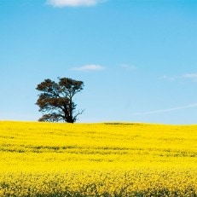

##### Australia's current, next and future waves of growth 2013-33

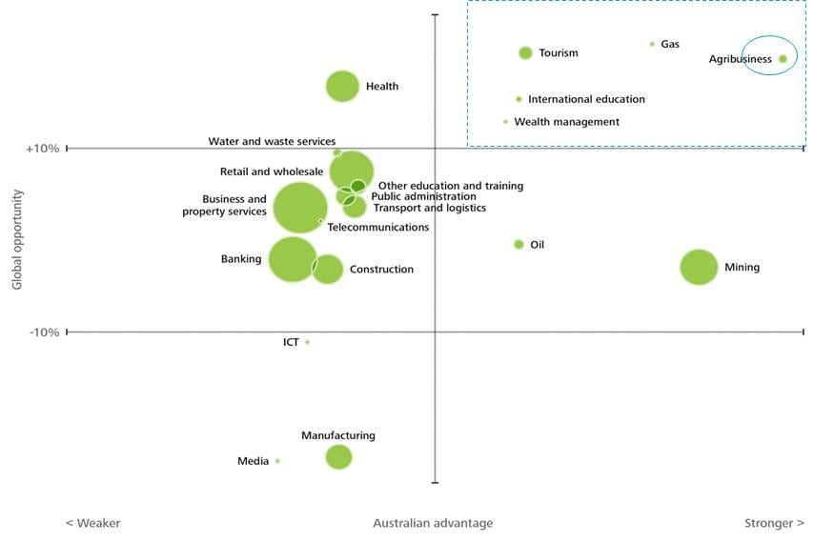

Source: Deloitte Access Economics

By employing the same framework used in BLTC#3 and tailoring for sub sectors of agriculture, Deloitte Access Economics has identified the ‘fantastic five’ of Australian agriculture being beef, lamb, aquaculture, dairy and oilseeds.

##### The next opportunities in agribusiness

##### https://www2.deloitte.com/content/dam/Deloitte/au/Images/inline_images/au-cb-agri-growth-opportunities-300415.jpg

Source: Deloitte Access Economics

This framework includes the agriculture-relevant global ‘demand drivers’ on the vertical axis, such as an increasing global population, increasing wealth of developing economies (increasing demand for higher value food such as protein), increasing ethical considerations in food and fibre production (e.g. animal welfare), and increasing demand for specific attributes of food products (food safety, food security, freshness and health consciousness). All of these demand drivers mean different things to the growth prospects for the different sectors of Australian agriculture.

The agriculture relevant ‘factors of advantage’ on the horizontal axis include themes such as cost of supply (e.g. labour, intermediate inputs, regulatory burden etc.), market access (e.g. trade barriers, spatial proximity), natural resources (e.g. rainfall, soil fertility), innovation and skills (e.g. education, access to technology), the macroeconomic environment (terms of trade) and supply chain efficiency.

Overall, compared to many other countries, Australia’s key advantages lie in its large area of arable land, relatively low land use conflicts (with urban and industrial expansion), its high biosecurity status, relative ease of doing business, technological readiness, high education levels, an innovative culture and its close proximity to export markets. Trade barriers (such as the removal of tariffs under free trade agreements) are also contributing further to Australia’s competitiveness.

Australia’s key disadvantages are its regulatory burden, rainfall, water availability and water reliability, low soil fertility, aged workforce and high labour costs. As with the demand drivers, these advantages and disadvantages have very different implications for different parts of Australian agriculture.

##### Beef, lamb and dairy

The key reasons for the optimistic positioning of the three livestock sectors of beef, lamb and dairy include the high demand for protein as a result of higher incomes particularly in Asia, the premium quality attributes of Australian meat and dairy, and Australia’s reputation for safety and security of supply. In addition, the growing concern for animal welfare should favour Australian livestock overall (compared to other countries) which is more comprised of free range animals than our competitors. Other Australian key advantages in red meat production include lower barriers to entry, and the ability for red meat production to occur on marginal land of Australia of which we have plenty (and can mean a low opportunity cost to red meat production from grazing).

One tempering aspect on demand is the recent decline in red meat domestically. The few disadvantages for Australian red meat production compared to other agriculture sectors Australian beef and lamb businesses are typically smaller operators and are widely dispersed meaning lower economies of scale and economies of density respectively. Dairy businesses, on the other hand, are larger and more regionally clustered meaning spillover effects from innovation are realised more readily and more specialised supply chains are possible.

##### Aquaculture

Aquaculture’s strong global opportunity positioning is due to the; high demand for protein from rising incomes and demand increase from population growth. This is because fish have relatively high input conversion ratios (compared to other animal proteins) and require relatively little land area meaning fish represent a relatively efficient source of protein. Aquaculture also presents as a viable and sustainable alternative to decreasing wild fish stocks with the OECD and Food and Agriculture Organisation (FAO) suggesting that global fisheries growth (of 17% by 2023) is likely to come from aquaculture by which time aquaculture will represent 49% of all fisheries production globally. Furthermore, the widely publicised health benefits of fish appeal to an increasingly health conscious consumer base, particularly domestically. The land and/or ocean area available for aquaculture in Australia is extensive and aquaculture is not as affected by Australia’s natural resource restrictions of soil fertility and lower and unpredictable rainfall. Aquaculture’s regulatory burden, however, is considered higher on average than other agriculture sectors due to the requirement to hold permits, licences or quotas, environmental regulations (e.g. managing waste and spread of disease) and also export controls and food safety.

##### Oilseeds

Oilseeds expected strong global demand is linked to its demand for both food products (from higher incomes) and biofuels (as alternative to fossil fuel sources). Temperate oilseeds are also seen as a more sustainable alternative to tropical oils such as palm oil (which is responsible for deforestation in tropical areas). Consumer health preferences are also likely to shift demand to oilseeds over less healthy animal-based oils or tropical oils. Australia’s key advantages of large land area for broad acre cropping and biosecurity status are highly relevant to oilseeds. In addition, oilseeds production is highly mechanised therefore it is not as affected by Australia’s high labour cost environment as some other labour-intensive sectors.

# **Agriculture in Australia: growing more than our farming future**

July 15, 2014 2.41pm AEST

<https://theconversation.com/agriculture-in-australia-growing-more-than-our-farming-future-22843>

AUSTRALIA 2025: How will science address the challenges of the future? In collaboration with Australia’s chief scientist [*Ian Chubb*](https://theconversation.com/profiles/ian-chubb-5153/profile_bio), we’re asking how each science discipline will contribute to Australia now and in the future. Written by luminaries and accompanied by two expert commentaries to ensure a broader perspective, these articles run fortnightly and focus on each of the major scientific areas. In this final instalment, we examine our agricultural legacy.

Food and agriculture are fundamental to human survival and it was the birth of agriculture and farming that laid down the basis for human civilisation.

Since the first crops were domesticated around 10,000 years ago, advances in agriculture have been intimately linked with human development and the growing world population.

Technology and innovation have underpinned those advances. Since the Green Revolution in the early 1960s crop production has increased nearly two and a half times, from 1.84 billion tonnes to 4.38 billion tonnes in 2007, achieved on only [11% more](http://www.innovation.gov.au/Science/PMSEIC/Documents/AustraliaandFoodSecurityinaChangingWorld.pdf) cropped land.

Agriculture today is a very sophisticated and highly technical industry, and in Australia it has been one of our most innovative and efficient industries. Our farmers have remained competitive in a global food market despite Australia having low levels of subsidies relative to our major competitors.

The ability of this industry to adapt, innovate and form successful collaborations will continue to support a strong and prosperous Australia with sustainable food security.

## Breeding and feeding

For Australia, food security is inextricably linked to the political stability of our region and has the potential to affect our national security.

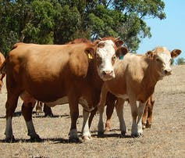[mikecogh/Flickr](https://www.flickr.com/photos/mikecogh/11854392794), [CC BY-SA](http://creativecommons.org/licenses/by-sa/4.0/)

Food security also affects our status as a premier food exporting nation and the health and wellbeing of our population. The likelihood of a food crisis directly affecting Australia is remote given that we have enjoyed cheap, safe and high quality food for many decades and we produce enough food today to feed 60 million people – three times our current population.

Although we account for only about 3% of the global food trade, our food exports are worth more than [A$30 billion](http://www.futuredirections.org.au/publications/food-and-water-crises/28-global-food-and-water-crises-swa/1331-exporting-australia-s-agricultural-know-how.html) annually and we are [one of only 11 countries](http://www.chiefscientist.gov.au/wp-content/uploads/FoodSecurity_web.pdf) that are net food exporters.

While these are comforting statistics and our agricultural products are important, when put into a global context, we produce enough to feed only 2% of the Asian population, so we cannot claim, now or even potentially, to be the “[food bowl of Asia](https://theconversation.com/australian-trade-beats-aid-in-boosting-global-food-security-22546)”.

Addressing the global food security problem will depend upon the development and delivery of technologies that lead to increased food production. But this must be achieved without increasing the area under production, since arable land is now limited, and under conditions where the frequency and severity of climate “shocks” are likely to increase due to the effects of climate change.

## Being realistic about growth

Our previous reliance on water and energy to drive up yields is not an option for the next phase of productivity gains.

Agriculture has an excellent record of productivity growth over the past 50 years, allowing global production to meet the large population increase and, for countries such as Australia, these gains have kept food prices low while keeping farmers in business.

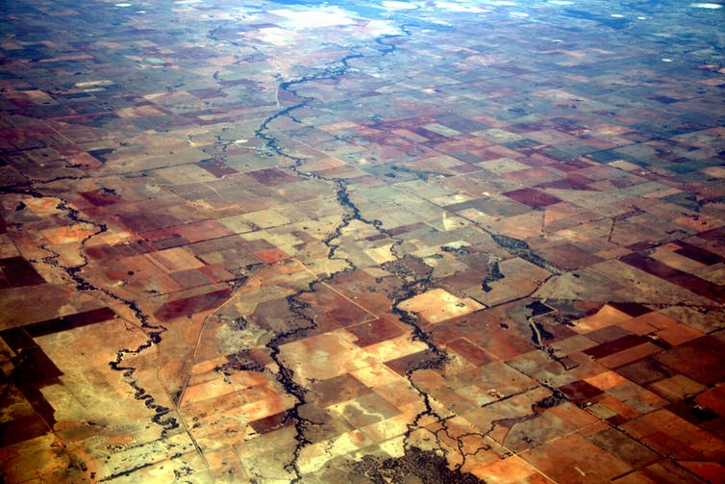Australia’s dryland agriculture. [Wakx/Flickr](http://www.flickr.com/photos/wak1/3218213289/), [CC BY-NC-SA](http://creativecommons.org/licenses/by-nc-sa/4.0/)

Agricultural production has remained important to our economy because we have effectively developed and delivered new technologies through a strong research base and a highly skilled and innovative farming community. In particular, we have been able to maintain our position even though we produce food on the driest inhabited continent, on low quality soils and with continual climate variability.

Our agricultural R&D capability ranks among the best in the world, and more recently Australia has developed a strong capability in climate change research including studies on impacts, adaptation and mitigation. We can now implement this capability to enhance agricultural production both in Australia and in our region.

These strengths provide a solid foundation to catalyse transformation of the agricultural industries to address regional food security. Australia can make a significant contribution to the task because we have extensive experience in dealing with difficult and low input productions systems.

Our record in applying this experience may not have been perfect but we are now making serious attempts to address our past omissions. Indeed, we will have little choice given the predicted impact of climate change on our agricultural production regions.

## Off the farm and into the laboratory

Our future in food production will lie within our current large scale farming systems where we have clear skills and where there is scope for increased efficiency rather than niche foods where high labour costs and low innovation make it hard for us to complete.

Over the next decade we will move to a scene where engineering and biology are intimately linked. [Satellites](https://theconversation.com/a-satellite-to-save-australia-we-should-have-one-of-those-13770) will provide data on crop and rangeland health and productivity. This information will be combined with ground data and used as the basis for farm management decisions.

[EAWB/Flickr](https://www.flickr.com/photos/eawb/44524746/), [CC BY-NC-SA](http://creativecommons.org/licenses/by-nc-sa/4.0/)

We will know the detailed genetic makeup of our farm animals and our crops and will use the association between [genotype](https://theconversation.com/explainer-what-is-a-gene-12951) (the genetic makeup) and phenotype (the physical characteristics) to predict performance under a diverse set of environmental conditions.

This information will feed into the decisions made by breeders to develop new crop cultivars or animal breeds to optimise the use of available resources while minimising the environmental impact of farming.

This move towards the utilisation of more specialist skills in agriculture is evident even today. Nowadays research teams look very different to those of the past.

If you were to set up a team today to develop a strategy to breed wheat with enhanced drought tolerance, your team will need to include software programmers, computer scientists, statisticians, crop physiologists, agronomists, cell biologists, pathologists, molecular biologists and geneticists.

Ideally you would also collaborate with climate scientists to understand the future production environments and help predict how your new varieties will perform.

The expectations of these scientists is also changing: a modern agronomist will need the traditional knowledge of cropping systems, fertiliser regimes, field pathology and so on but will also know techniques for assessing crop health based on analysis of the light reflected from crops and captured on images generated from drones or [satellites](https://theconversation.com/a-satellite-to-save-australia-we-should-have-one-of-those-13770).

Farmers are already using computer models to assess the status of their soils, crops and farming systems to support their decision making.

In the future farmers will also be capturing data from even more diverse sources, linking this to genetic information and predictive climate models and using the result to help them decide when to sow their crops, when to apply fertilisers, how to protect crops from disease and when to harvest.

## Investments and pay-offs

Perhaps our greatest contribution to agricultural innovation will be through developing solutions to global food security challenges and delivering these solutions to partners around the world. Agriculture is so important to human survival that there is huge global investment in research at around [US$40 billion annually](http://www.asti.cgiar.org/pdf/Global_revision.pdf), largely from the private sector.

Although Australia currently accounts for only 1% of this investment, we are frequently sought out as a partner for both the public and private sector overseas. Our agricultural research capability has the potential to become a significant industry in its own right.

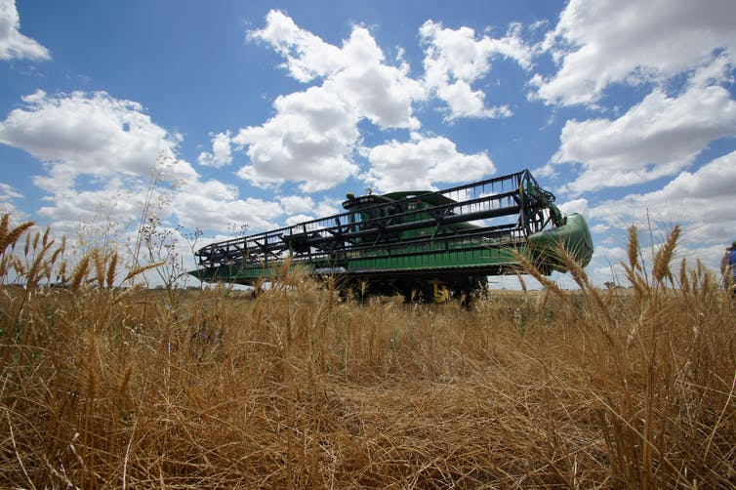[rfsmedia/Flickr](https://www.flickr.com/photos/rfsmedia/6473311075), [CC BY-NC-SA](http://creativecommons.org/licenses/by-nc-sa/4.0/)

Over the next decade we should build management, regulatory and support structures that allow us to capitalise on this international interest and build strong multinational research programs that can not only support food security in our region but also ensure our farmers have access to the latest technologies.

Agriculture is among our most technologically advanced industries, yet most Australians are largely unaware of the revolution that is occurring on our farms.

Many would be both surprised and fascinated to know just how sophisticated agricultural science has become and the role it plays in delivering the strong and prosperous Australia of the future.

## [Michael D'Occhio](https://theconversation.com/profiles/michael-docchio-115746/profile_bio), Professor at University of Sydney

The world is rapidly reaching the boundaries of agricultural land and the sustainable intensification of agriculture has emerged as a necessity to meet the increase in global demand for food. Given the limits to natural resources the world simply cannot afford to sustain the loss of food that is caused by diseases of plants and animals.

Currently, diseases (bacterial, viral, fungal) cause general losses of 20-40% of horticultural crops, 10-15% of grains, up to 50% of aquaculture and more than 20% of livestock worldwide.

Intensification of food production tends to exacerbate the occurrence and impact of diseases, and climate variability and change has introduced another layer of complexity in the emergence and spread of diseases.

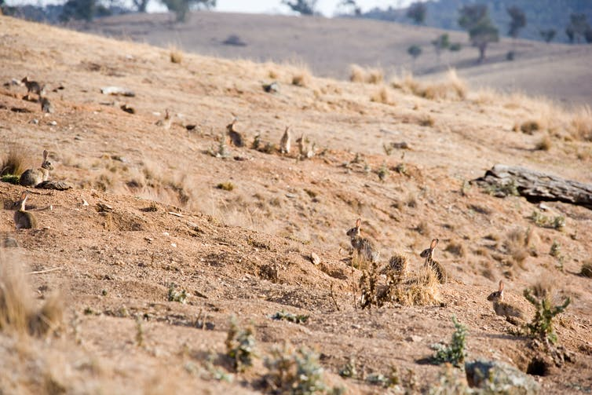Disease and land degradation can impact Australia’s agricultural output. [John Schilling/Flickr](http://www.flickr.com/photos/john-schilling/355224091/), [CC BY-ND](http://creativecommons.org/licenses/by-nd/4.0/)

The success of agriculture in Australia has been due, in part, to the relative freedom from diseases that impact food production elsewhere. Indeed, the high biosecurity status of Australia ensures safe and healthy domestic food and gives Australia preferred status in global food markets. Diseases involve many of the sciences such as immunology, pathology, genetics, epidemiology, public health and sociology.

While Australia is free of many food diseases there is considerable domestic, world-class expertise in the science of animal and plant diseases. This expertise has a very important role in ensuring that Australians continue to have safe, nutritious and healthy food and are protected from animal to human transmission of diseases (zoonoses).

Other important roles are creating new knowledge on diseases to prepare for future challenges and training the next generation of scientists and teachers. There is a broader role in the global community in food and nutritional security and human health, including through partnerships with developing countries in education, training, research and technology transfer.

## [Dana Cordell](https://theconversation.com/profiles/dana-cordell-1041/profile_bio), Chancellor’s Postdoctoral Research Fellow at University of Technology Sydney

An imminent [food boom](http://www.theaustralian.com.au/business/economics/report-hoses-down-unreal-food-boom-expectations/story-e6frg926-1226758546832) to replace the mining boom in Australia is expected to double agricultural outputs to feed growing Asian demand. Much discussion and swift debate about this economic opportunity has ensued in the past 12 months alone at the [GAP Food Summit](http://www.globalaccesspartners.org/think-tanks/growth-summit), Australian Bureau of Agricultural and Resource Economics and Sciences ([ABARES](http://www.daff.gov.au/abares/Pages/Default.aspx)) [Outlook 2014](http://www.daff.gov.au/ABARES/outlook-2014/Pages/HOME.aspx) and [Global Food Forum](http://www.theaustralian.com.au/business/in-depth/global-food-forum), demonstrating our responsiveness and entrepreneurship.

But a longer-term strategy based on genuine scientific inquiry is also needed to answer fundamental questions like where would the land, water, nutrients and farmers come from? The expert knowledge of agricultural scientists can help Australia “[farm smarter, not harder](http://cpd.org.au/2012/10/farming-smarter-not-harder-2/)”.

Unlocking the “soil bank” to access stored nutrients from past decades of fertiliser application can increase agricultural productivity and reduce farmers’ vulnerability to fluctuations in climate and [fertiliser availability](http://www.mdpi.com/2073-4395/3/1/86). This contributes to a prosperous and healthy Australia, and, meets our moral commitment to [food security](http://thecommonwealth.org/history-of-the-commonwealth/perth-declaration-food-security-principles) in the region.

The next generation of scientists may have more complex and wicked challenges to address, but this need not require being born a genius: at a recent [Global Young Scientist Summit](http://www.gyss-one-north.sg/) I attended that brought together 16 Nobel Prize Laureates to share their secret to success, it essentially boiled down to one word: curiosity.

In the words of novelist and professor of biochemistry at Boston University Isaac Asimov:

The most exciting phrase to hear in science, the one that heralds the most discoveries, is not “Eureka!” [I found it!] but “that’s funny…”.

<https://theconversation.com/agriculture-in-australia-growing-more-than-our-farming-future-22843>

# Developing northern Australia

Northern Australia is a very productive part of the country with substantial opportunities for further targeted development. CSIRO's long history in the north has given us a wealth of knowledge and research capacity to guide the continued sustainable development of the region.

<https://www.csiro.au/en/Showcase/Northern-Australia>

## The keys to further unlocking the north

### Economics

There are a range of competitive industries in northern Australia, including agriculture, mining and gas production. Each of these have their own set of economic factors that need to be considered to maximise the development potential of the north.

Expanding agricultural development in northern Australia requires:

* sourcing significant capital investment to cover the high up-front cost of new ventures
* the identification of crops with efficient supply chains that can be cost-effectively and sustainably grown in the northern environment
* the establishment of new and viable export markets where these cannot be simply accommodated by existing global trade.

Our work, in collaboration with partners, provides policy makers with a clear indication of the location and scale of medium and longer term opportunities for agricultural production, and critical supply chain and infrastructure investment issues that may help to foster those opportunities.

[More about our economic work](https://www.csiro.au/en/Research/Major-initiatives/Northern-Australia/Achievements/Food-and-fibre)

# Food and fibre supply chains in northern Australia

<https://www.csiro.au/en/Research/Major-initiatives/Northern-Australia/Achievements/Food-and-fibre>

Our Northern Australia Food and Fibre Supply Chains Study identified markets for irrigated agriculture across northern Australia, and the critical supply chain and infrastructure investments needed to maximise those opportunities.

## Agricultural opportunities in the north

A number of opportunities have stimulated renewed interest in agricultural development for northern Australia. These include:

* proximity to growing Asian markets
* increasing global demand for food and natural fibre
* development of economically sustainable regional communities, particularly as a consequence of expansion of mining and energy extraction developments.

## Challenges for development

Expanding agricultural development in northern Australia presents three direct challenges:

1. Sourcing the capital investment to support the high cost of 'greenfields' agricultural development.
2. Cost-effectively and sustainably growing crops in the northern environment and getting them to market via efficient supply chains.
3. Establishing new and viable export markets for crops that are not simply accommodated by the global commodities trade.

Successfully addressing these challenges is critical to establishing and realising the value proposition for northern agricultural expansion.

## Understanding the opportunities and challenges

We worked with the Australian Bureau of Agricultural and Resource Economics and Sciences (ABARES) to provide policy makers with a clear indication of the location and scale of medium and longer term opportunities for agricultural production across northern Australia, and critical supply chain and infrastructure investment issues that may help to foster those opportunities.

### Stakeholders

The work was supported by a consortium of stakeholders, each with an interest in seeing northern Australia reach its potential. These include:

* the Australian, Queensland, Northern Territory and Western Australian governments
* the Rural Industries Research and Development Corporation (RIRDC)
* and Regional Development Australia (RDA) Pilbara.

### Key messages from this project

1. Irrigated agriculture in northern Australia has the potential to add considerable value to regional economies.
2. Securing water for irrigated agriculture does not guarantee positive financial returns.
3. Supply chains are a significant constraint in some locations.
4. New markets are critical, especially for high value horticultural production.
5. Processing facilities and supporting infrastructure are needed in most regions.
6. There are opportunities to integrate crop production with the beef industry to create a value-add in both sectors.
7. Infrastructure investment needs differ significantly between regions.
8. Investment plans need to be designed to accommodate unexpected shocks.
9. Labour supply and agri-business services are important to achieving successful new agricultural initiatives.
10. Successful agricultural development will depend on understanding the entire system including climate, soils, water resources, pests, agronomy, management, processing, supply chains and markets.
11. Regional economies are projected to expand but changes to national economic welfare are negligible.

# Northern Australia agenda

Main content area

<https://www.industry.gov.au/strategies-for-the-future/northern-australia-agenda>

The Australian Government is growing a stronger northern Australian economy through a long-term agenda of investment and support. The agenda is unlocking the region’s full economic potential as a gateway to global markets, a source of rich resources and a home to pristine environments. We are ensuring the north is an even more attractive place to live and do business.

Our [Office of Northern Australia](https://www.industry.gov.au/about-us/our-structure/office-of-northern-australia) takes the lead on implementing the northern Australia agenda in partnership with state, territory and local government agencies, industry and community bodies. See our [northern Australia advisory groups.](https://www.industry.gov.au/about-us/our-structure/office-of-northern-australia/northern-australia-advisory-groups)

The [Our North, Our Future: White Paper on Developing Northern Australia](https://www.industry.gov.au/data-and-publications/our-north-our-future-white-paper-on-developing-northern-australia) released in 2015, sets out the priorities to drive growth in Australia’s north. It’s a 20-year plan for investment and support to grow the north through 6 key pillars:

* a [trade and investment gateway](https://www.industry.gov.au/strategies-for-the-future/northern-australia-agenda/trade-and-investment-gateway)
* a more [diversified northern economy](https://www.industry.gov.au/strategies-for-the-future/northern-australia-agenda/diverse-economy)
* [Indigenous entrepreneurship and businesses](https://www.industry.gov.au/strategies-for-the-future/northern-australia-agenda/indigenous-businesses-and-entrepreneurs)
* [world-class infrastructure](https://www.industry.gov.au/strategies-for-the-future/northern-australia-agenda/critical-infrastucture)
* [water infrastructure investment](https://www.industry.gov.au/strategies-for-the-future/northern-australia-agenda/sustainable-water-infrastructure)
* [research and innovation](https://www.industry.gov.au/strategies-for-the-future/northern-australia-agenda/research-and-innovation)

# Agricultural development in northern Australia: Opportunities and pitfalls

###### Share Article

Friday, 1 September, 2017

<http://www.ecoaus.com.au/news/agricultural-development-in-northern-australia-opportunities-and-pitfalls>

Over many years there have been several assessments of the potential for developing water resources in northern Australia. They have all identified the importance of groundwater for many northern systems and the critical nature of surface–groundwater interactions. The Northern Australia Land and Water Science Review, prepared for the Australian Government, found that there is great potential for sustainably increasing groundwater use for development. The best development option for agriculture, therefore, might be small cropped areas, irrigated with groundwater, and scattered over the landscape.

The research tells us that development of water resources for use in agricultural enterprises in northern Australia should be based on existing scientific and economic research findings. The Joint Committee on Northern Australia recommends “that the Australian Government gives priority to the development and funding of water resource proposals that have been scientifically identified as being sustainable …”.

Conditions in the north include the stresses of year-round heat, extreme wet and dry seasons, soils of generally low and variable fertility and opportunistic wildlife, both native and feral. Numerous attempts to grow food crops have succumbed to these extreme conditions, with agriculture currently often defaulting to trees crops. Only in a few small areas are limited-demand, high-value food crops being grown with conditions favouring  labour-intensive, adaptable farming practices. Think chia seeds, for example, grown in the Ord scheme in northern WA and mangoes around Darwin. Economies of scale, however, do not compare to schemes in southern Australia. If the entire planned Ord Scheme area were planted out, this would still only provide an irrigation area 3% the size of irrigated land in the Murray-Darling Basin.

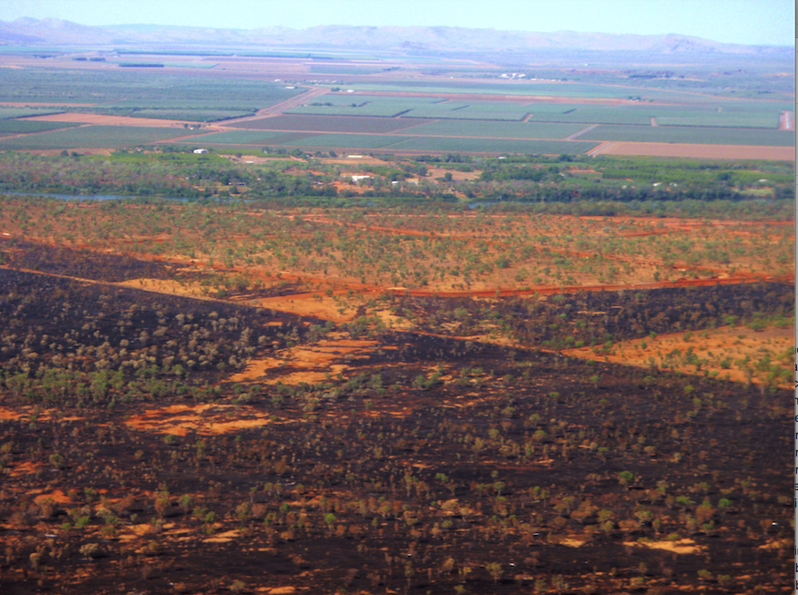

The Ord River scheme in northern WA, and now extending across to the NT, is one example where science – and experience – should be heeded before further developing the north. Too much groundwater is likely to be a concern: Science predicts that irrigation from the Ord River will drain too much water through the landscape! Elsewhere, in contrast, for example in Queensland’s Gulf Country, insufficient recharge means groundwater sources are not sustainable, so dams need to be considered.

The Ord scheme has been in the making for over 60 years and continues to cause concerns both [politically](http://blogs.crikey.com.au/northern/2014/02/13/good-money-after-bad-the-nt-government-and-the-ord-river-irrigation-scheme/) and environmentally. Damming the Ord River certainly generates sustainable hydro-electric power for the Argyle Mine and Kununurra, but the perennial river now provides perfect conditions for the proliferation of Weeds of National Significance. Further, the reduction of major outflows to the Bonaparte Gulf has decimated the coastal prawn fisheries.  The on-going question is whether the Ord can stack up under full cost–benefit analysis

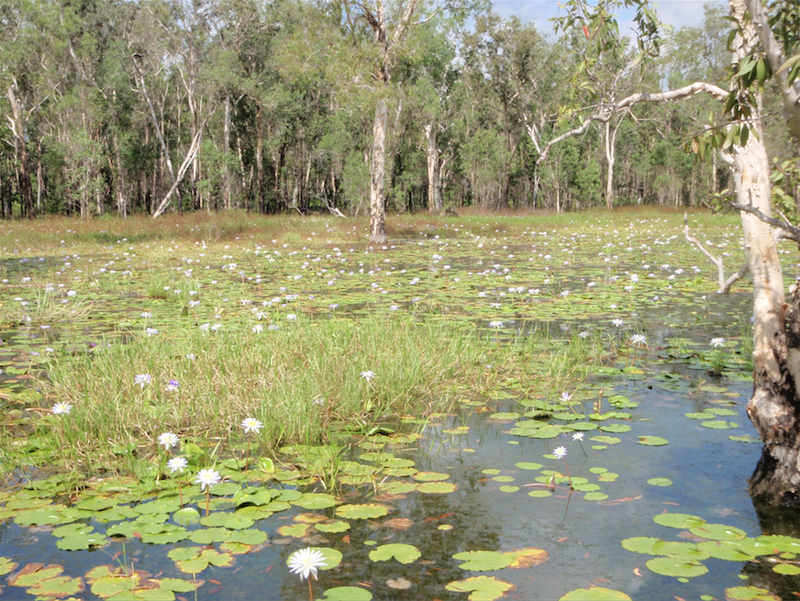

The Joint Committee on Northern Australia recommended “that large-scale extraction of water from the river systems and aquifers in Northern Australia needs to be preceded by thorough scientific evaluation” with priority given to “water resource proposals … with the strongest cost–benefit case, and consistent with National Water Policy”. The question is whether those recommendations are heard and acted upon.

- Dr Richard Cresswell, Principal Hydrogeologist

# Northern Australia land and water science review, 2009

|  |  |
| --- | --- |
| **Author:** | [Northern Australia Land and Water Taskforce.](https://www.worldcat.org/search?q=au%3ANorthern+Australia+Land+and+Water+Taskforce.&qt=hot_author) |
| **Publisher:** | 2010. |
| **Edition/Format:** | eBook : English[View all editions and formats](https://www.worldcat.org/oclc/1011136038/editions?editionsView=true&referer=di) |
| **Summary:** | "The Taskforce commissioned a comprehensive review of Northern Australian land and water science. Referred to as the Northern Australia Land and Water Science Review 2009, the project was coordinated by CSIRO in collaboration with over 80 of Australia's leading scientists working on northern land and water issues. The Science Review represents the most comprehensive and thorough review ever undertaken of  Read more... |
| **Rating:** | (not yet rated) [0 with reviews - Be the first.](https://www.worldcat.org/title/northern-australia-land-and-water-science-review-2009/oclc/1011136038#reviews) |
| **Subjects** | * [CSIRO (Australia). -- Northern Land and Water Science Review 2009.](https://www.worldcat.org/search?q=su%3ACSIRO+%28Australia%29.+Northern+Land+and+Water+Science+Review+2009.&qt=hot_subject) * [National Water Initiative (Australia)](https://www.worldcat.org/search?q=su%3ANational+Water+Initiative+%28Australia%29&qt=hot_subject) * [Land rights -- Water rights.](https://www.worldcat.org/search?q=su%3ALand+rights+Water+rights.&qt=hot_subject) |

<https://www.worldcat.org/title/northern-australia-land-and-water-science-review-2009/oclc/1011136038>

Bottom of Form