**Accommodation and Food Services**

<https://australianjobs.employment.gov.au/jobs-industry/accommodation-and-food-services>

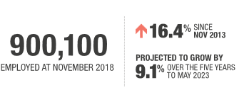

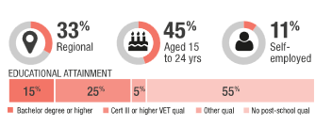

Accommodation and Food Services is a large and fast growing industry, with 127,000 new jobs added over the past five years. Part-time work is common in this industry (60% of those employed).

This industry provides strong entry level opportunities for workers. A large share of the workforce is aged 15 to 24 years and post-school qualifications are often not required. This industry also offers training opportunities, employing 22,900 apprentices and trainees in 2018.

Accommodation and Food Services employment is projected to increase by 9.1% over the five years to May 2023 (above the 7.1% expected growth across all industries). Particularly strong growth is expected in the Cafés, Restaurants and Takeaway Food Services sector (11.9%).