4631.0 - Employment in Renewable Energy Activities, Australia, 2018-19 Quality Declaration
- Latest ISSUE Released at 11:30 AM (CANBERRA TIME) 06/04/2020
https://www.abs.gov.au/ausstats/abs@.nsf/mf/4631.0
Main findings
This publication presents estimates of direct full-time equivalent (FTE) employment in renewable energy activities in Australia, from 2009-10 to 2018-19.
2018-19 overview:
- 26,850 jobs
- 27% increase from 2017-18
- 120% increase over 10 years
Annual direct FTE employment in renewable energy activities in Australia was estimated at 26,850 jobs in 2018-19.
As Figure 1 shows, this was an increase of 5,770 jobs in FTE employment (27%) from the previous year (2017-18) and represents the highest level of FTE employment in renewable energy activities since 2011-12.
Figure 1: Annual direct FTE employment in renewable energy activities in Australia, 2009-10 to 2018-19
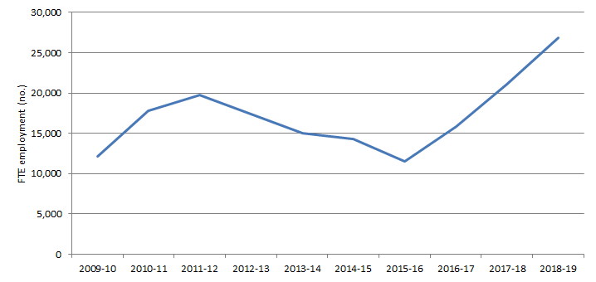
The increase of FTE employment in renewable energy activities between 2017-18 and 2018-19 was driven by an increase in construction activity for roof-top solar photovoltaic (PV) systems (2,880 additional FTE jobs), large scale solar PV systems (1,600 additional FTE jobs) and wind farms (1,220 additional FTE jobs).
Solar energy accounted for over 75% of this increase and the top three renewable energy types (roof-top solar, large scale solar and wind) contributed 99% of the increase in FTE employment in renewable energy. The only renewable energy type to record a fall in employment between 2017-18 and 2018-19 was biomass (down by 70 FTE jobs, or 4%).
Types of renewable energy:
- Roof-top solar PV systems (a) (13,070 jobs)
- Solar PV large (4,740 jobs)
- Wind (3,240 jobs)
- Hydro (3,060 jobs)
- Biomass (1,580 jobs)
- Govt/NPI (1,120 jobs)
- Geothermal (40 jobs)
Footnote(s): (a) Roof-top solar includes solar hot water systems and small scale batteries.
Roof-top solar PV systems remained the largest FTE employer among renewable energy types, comprising 13,070 FTE jobs or nearly 50% of total FTE employment related to renewable energy in 2018-19. While employment in this category has fluctuated over time, it has been the largest single contributor in every year of the published time series. It peaked in 2011-12, when employment in roof-top solar PV made up 72% of total direct FTE employment in renewable energy activities, but the share of renewable energy jobs has declined each year since.
Figure 2: Annual direct FTE employment in roof-top solar activities in Australia (a), 2009-10 to 2018-19
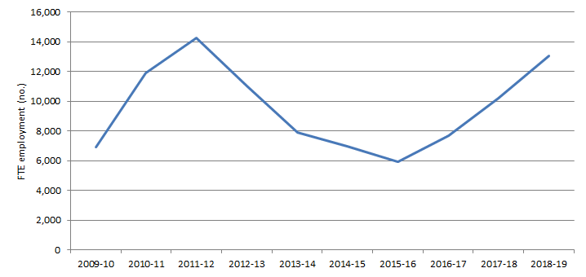
Footnote(s): (a) Roof-top solar includes solar hot water systems and small scale batteries.
Solar PV large (large scale solar) was the second largest contributor to FTE employment related to renewable energy activities (18% of total) after contributing less than 1% in each year between 2009-10 and 2012-13. It experienced the second largest increase in FTE employment of any renewable energy type, by over 50% between 2017-18 and 2018-19, increasing from 3,140 FTE jobs to 4,740 FTE jobs. This is despite an increase in the efficiency of developing large scale solar PV systems.
Wind energy reported the highest growth in FTE employment of 60% between 2017-18 and 2018-19 (2,020 FTE jobs to 3,240 FTE jobs) and more than doubled since 2016-17. This has been driven by the increase in wind farm projects in Victoria.
Hydro electricity (3,060 FTE jobs) and biomass (1,580 FTE jobs) also made large contributions to total FTE employment in renewable energy activities in 2018-19.
Figure 3: Proportion of annual direct FTE employment by type of renewable energy (a)(b), 2009-10 to 2018-19
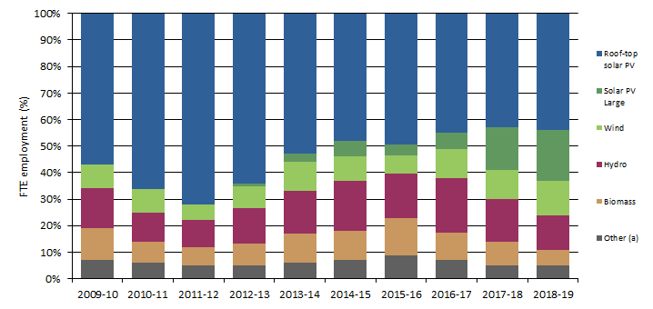
Footnote(s): (a) Roof-top solar includes solar hot water systems and small scale batteries; (b) Other includes hydro plus government and non-profit institutions.
In Australia, hydro and biomass represent mature renewable energy sources, with much of their supporting infrastructure having been in place for some time. Employment in these areas is therefore relatively stable over the reported time series. In contrast, recent employment recorded against wind and solar energy, both roof-top solar and large scale solar, relates predominately to construction activity and is therefore more volatile, reflecting the fluctuation of energy infrastructure capital formation.
States and territories:
- New South Wales (7,750 jobs)
- Queensland (6,330 jobs)
- Victoria (6,090 jobs)
- South Australia (2,560 jobs)
- Western Australia (1,690 jobs)
- Tasmania (1,560 jobs)
- Australian Capital Territory (680 jobs)
- Northern Territory (190 jobs)
All states reported an increase in FTE employment related to renewable energy activities between 2017-18 and 2018-19. Victoria reported the largest increase (up by 2,540 FTE jobs or over 70%), with New South Wales and South Australia reporting an increase of 1,540 (up 25%) and 750 (up 41%) jobs respectively. In New South Wales and Victoria this increase was mainly driven by the construction of roof-top solar PV.
Together New South Wales, Victoria and Queensland accounted for 75% of all FTE employment in renewable energy activities in Australia in 2018-19.
Figure 4: Proportion of annual direct FTE employment by state and territory, 2013-14 to 2018-19
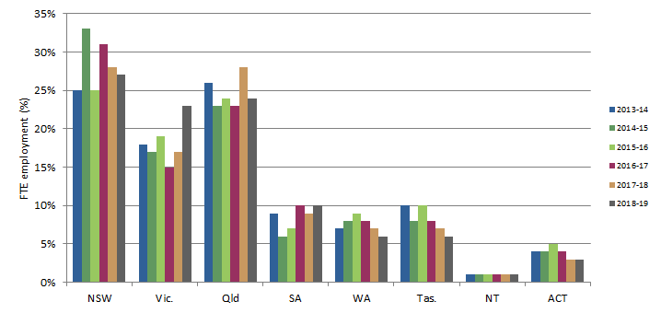
Penetration of roof-top solar PV across Australia:
- 27% of suitable private dwellings with roof-top solar PV
- Over 2.2 million roof-top solar PV systems
Levels of FTE employment supporting the installation of roof-top solar PV systems are influenced by various government policies, including taxes, subsidies, pricing policies and renewable energy targets.
In Australia, 27% of suitable private dwellings were equipped with a roof-top solar PV system as at December 2019.
Data from the Clean Energy Regulator (2020) reports that there were cumulatively over 2.2 million roof-top solar PV systems installed in Australia at the end of December 2019. This can be compared to the 2016 ABS Census of Population and Housing to estimate coverage of suitable dwellings with roof-top solar PV systems in Australia.
A suitable dwelling is defined as a separate house or a semi-detached row or terrace house. Not all types of dwelling structures are suitable for hosting roof-top solar PV systems, for example, caravans, tents and many units and apartments. Some detached houses, terrace houses and townhouses have the structural capacity to host a roof-top solar PV system but are impractical for other reasons, such as a poor solar aspect. It is not possible to separately identify and exclude such dwellings from the total housing stock.
Figure 5: Percentage of suitable dwellings with roof-top solar PV (a), 2017-18
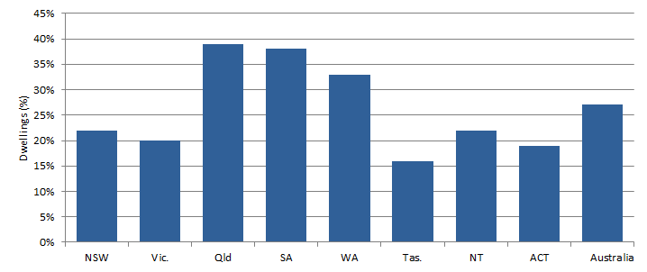
Footnote(s): (a) Roof-top solar includes solar hot water systems and small scale batteries.
The penetration of roof-top solar PV varies across states and territories. Queensland (39%), South Australia (38%) and Western Australia (33%) reported the highest proportion of suitable private dwellings with a roof-top solar PV system. Every state and territory in Australia recorded an increase in roof-top solar PV penetration between 2017-18 and 2018-19.

